:|CIAL INTERNATIONAL PUBLICATION OF THE ASSOCIATED LOCKSMITHS OF AMERICA, INC.

CD

i—i

O  
i

CO

4  
4

4 "Z.

4 <x

4 I— CO

4 CO_J CO

4 IT. 3 O

4 S* CO t-j

4: HZ I  
4 0 0 f-4

4 CD  
4 CO

4 od; o

4 CD COCO  
4 2ca:co  
4 <EUO<E  
4 SE COO  
4 H->--^“

4 Hh CC  
4 THXh  
4 SCCOZ  
4 OCOCl

4 3CO -J

4 uJ Oh" 4 aZOO-CE

Cars

Today

You won't believe what's in there.

Focus** Auto



**CARD INVALID UNLESS COMPLETE DATA IS GIVEN**

You must indicate your locksmithing affiliation below

1. Are you a locksmith or individual involved in locksmithing? Q YES Q NO
2. My position is: Ql Owner/Pres. Q3 Employee Q6 Student Q9 Other
3. Business classification (check one only): A □Locksmith shop B □Hardware

CQ Wholesaler/Distributor D □ Manufacturer

E □Security or Maintenance

1. □ Consultant 3 □ Industrial 5 □ Government
2. □ Commercial 4 □ Institutional 6 □ Police

GQ Architect/Specifier ZQ Other (specify)

1. Are you involved in purchasing or influencing the purchase of locksmith products?

**□yes Qno**

Send payment to: Locksmith Publishing Corp. • 850 Busse Highway • Park Ridge, IL 60068  
Phone: 847-692-5940 • Fax: 847-692-4604 • Website: [www.lpc.simon-net.com](http://www.lpc.simon-net.com)

Pi-pp Infnrm^tinn - Rparlpr ^prx/irp CarH #^f)

Name

Company

Address

CityStateZip PhoneFax

Payment: (us **funds only)** Money Order Charge Card Check #

Complete for Charge Orders Only: VISA Master Card

Account #Exp. Date

Signature

IM7

Please

□ YES!

Ledger International

□ 3 YEARS (includes 36 issues, 3  
USA $90.00

□

□

2 YEARS (includes 24 issues, 2 **FREE** Annual Directory* issues)

USA $64.00 Canada $91.00 International (air) $179.00

International (surface) $119.00

YEAR (includes 12 issues, 1 **FREE** Annual Directory* issue)

USA $38.00

.Canada $52.00

. International (air) $95.00

Comprehensive guide to industry manufacturers, distributors, products and services.

International (surface) $65.00

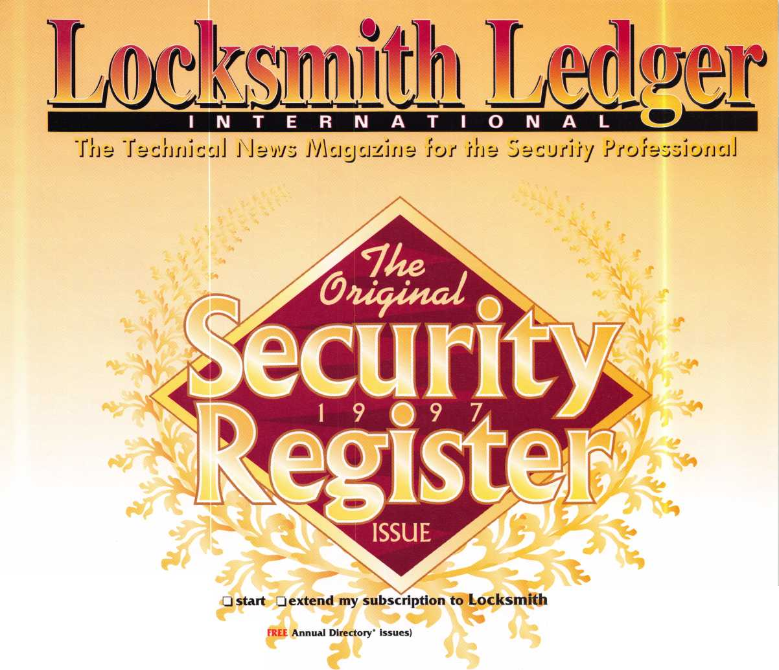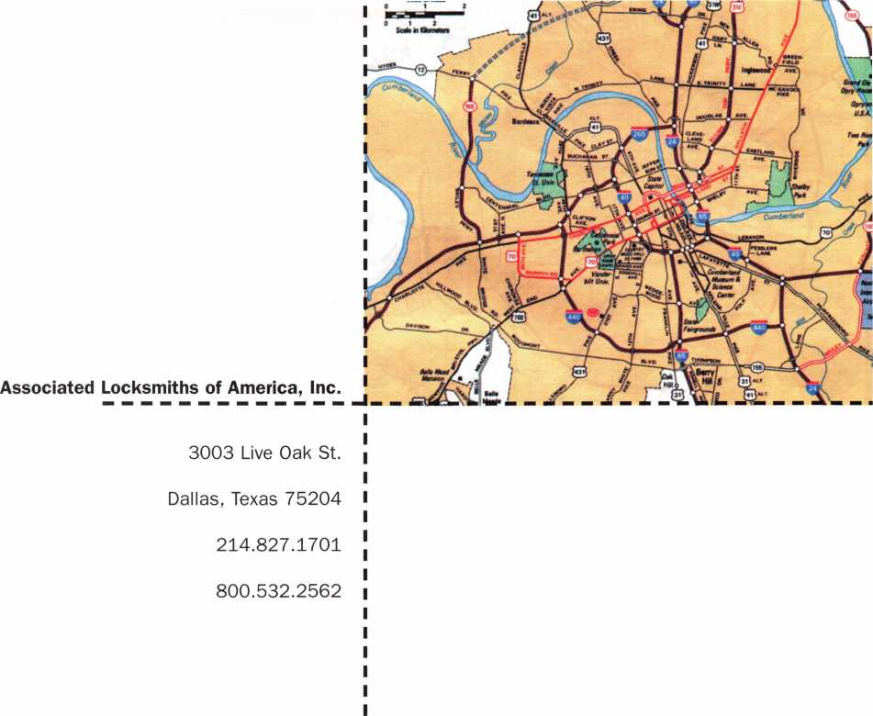

I

ALOA ’98 Convention and Security Expo



**Nashville, Tenn**

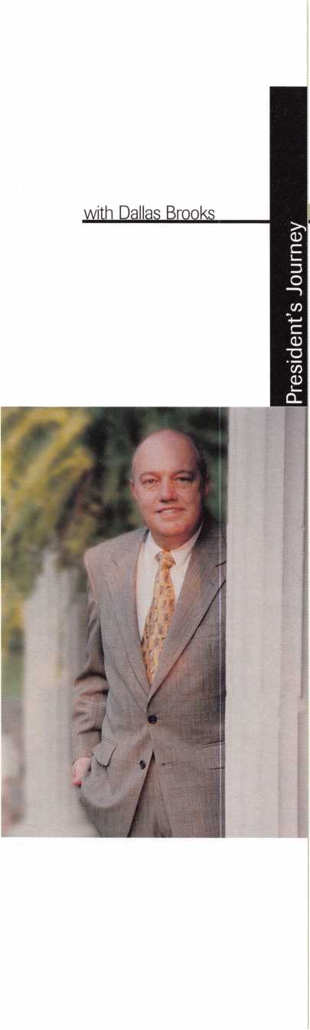

Learning To Fish

There is a Chinese proverb that says: “Give a man a fish and he will live for a day; give him a net and he will live for a lifetime.”

For a long time, ALOA has been like many associations. It has taken care of its members’ needs and expectations one fish at a time ... a monthly magazine, a class here and there, an annual convention. Today, we have reached a crossroads where it’s apparent that what we need to be providing for ALOA members is a comprehensive plan to protect and advance the livelihood of locksmithing for generations to come. We are facing this monumental task at a time when our resources are limited and our challenges immense. Legislation continues to be introduced state-by-state that could seriously damage many of our businesses. Never has the need for education been greater, with the march of electronics and access control, as well as the increasingly sophisticated automotive technology addressed in this issue of Keynotes.

Many friends have come forward to help. Once again we are indebted to members of the manufacturing sector for pledges of support even larger than in the past. Your board of directors and staff will be working harder than ever to accomplish our mission. But the crit­ical ingredient is you. Your active involvement in this process will be the difference between success and failure. For every locksmith that sits back and waits for protection from bad leg­islation to be handed to him, it will take many active ALOA members to turn the tide. For every locksmith who wants quality education, but balks at paying more for dues, it will take other concerned locksmiths to further the cause of learning.

In the coming months, you will hear more about what’s ahead and what you can do to support this progress. Results may not be apparent overnight; we’re making long-term plans. This will take patience and vision. For now, the best contribution you can make to ALOA is to pay your dues promptly this fall so that the association will have sufficient oper­ating capital to make plans for 1998. It’s going to be a long year and, I hope, a good one.



Keynotes

October 1997



|  |  |
| --- | --- |
| Editor | Anne McDonald Davis, ABC |
| Associate Editor | Mike Emory |
| Art Director/Designer | Derek Holiman |
| Advertising Sales | Mary Sadler  Anelia M. Banda |
| Contributing Authors | Jerome V. Andrews, CML  Paul Chandler, CRL  Claire Cohen, CML  Brian Costley, CML, CMS  Bob De Weese, CPL  Ray D’Adamo, CML  Sal Dulcamaro, CML  James Glazier, CML  Wayne Gurnee, CRL  A.J. Hoffman, CML  Ken Holmlund, CRL  Ray Lusk, CML  Mark Ohno  David Parrott  Randy Simpson, CML  Robert Stafford, CPL  Dave Thielen |
| Publications Committee  ALOA Professional Staff | John D. Cannon, CML, Chairman Jerome Andrews, CML  A.J. Hoffman, CML  Leonard J. Passarello, CPL  Randy Simpson, CML  Robert Stafford, CPL |
| Executive Director | Charles W. Gibson, Jr. |
| Office Manager | Mary May |
| Receptionist | Margo E. Vela |
| Comptroller | Kathy J. Romo |
| Financial Assistant | Debra Bradshaw |
| Associate Executive Director | Carmen D. Murphey, CMP |
| Meetings & Education Coordinator | Jessica Vasquez |
| Administrative Assistant | Janelle Vergara |
| Membership Coordinator | Brandon Durrett |
| Mailroom Assistant | Jesse Morales Jr. |

Executive

3oard

Complete address and phone number listings for the ALOA Board and Keynotes authors are available in your membership directory or by contacting the ALOA office at 3003 Live Oak Street; Dallas, TX 75204; (.214)827- 1 701; FAX (214) 827-1810; e-mail aioa@anet-dfw. com; website [www.aloa](http://www.aloa). org

President

Dallas C. Brooks (334] 826-8990

Regional Vice Presidents Southeast

‘Jeffrey S. Nunberg, CML

Chairman: Finance and Personnel

(305] 324-8800

North Central

‘John J. Greenan

Chairman: Legislative Committee

(773] 486-2030

South Central

‘Randy L. Simpson, CML

Chairman: Bylaws Committee

(713] 780-7026

Southwest

John I. Shandy, CML

Chairman: Membership Committee

(303] 443-9740

Northeast

‘James H. Glazier, CML Chairman: Education Committee (301] 831-5454

Northwest

‘Raymond C. Lusk, CM L Chairman: Convention Committee (509] 624-3152

Secretary

John D. Cannon, CML

Chairman: Publications and Public Relations

(703] 960-6413

Trustees:

David M. Lowell, CML, CMS

Chairman: Nominating, PRP and Trustees

(602] 263-7716

Breck H. Camp, CML

(770] 455-6244

Henry H. Printz, CML

(201] 538-2737

Leonard J. Passarello, CPL

(416] 752-7210

Edwin Toepfer, RL

(416] 225-5589

Directors

*These officers also serve as directors.



ission Statement: The Associated Locksmiths of America, Inc. is dedicated to enhancing the professionalism, education and ethics among locksmiths and ose in related sectors of the physical security industry. With approximately 10,000 members in the United States, Canada and the freeworld, ALOA is poised to lip members obtain the knowledge, the strength, and the confidence to perform their role in the physical security field with pride and dignity. But it is only ■ough active involvement and participation that ALOA can fully achieve its potential-and can help members to achieve theirs.

slides: Keynotes® is the official publication of the Associated Locksmiths of America, Inc. (ALOA], Keynotes® acts as a moderator without approving, disap- oving, or guaranteeing the validity or accuracy of any data, claim, or opinion appearing under a byline or obtained or quoted from an acknowledged source, e opinions expressed by the authors do not necessarily reflect the official views of ALOA. Also, appearance of advertisements and new products or service ormation does not constitute an endorsement of products or services featured by the Association. The Association does not accept responsibility for the inac- racy of any data, claim, or opinion appearing in this publication, due to typographical errors on the part of the authors. Association staff or its agents.

Jitor’s Note: This publication is designed to provide accurate and authoritative information in regard to the subject matter covered. It is provided and do­minated with the understanding that the publisher is not engaged in rendering legal or other professional services. If legal advice and other expert assistance required, the services of a competent professional should be sought.

uthors’ Payment: Effective Nov. 1, 1995, payment will be made for original articles submitted exclusively to Keynotes® magazine at a rate of: technical arti- 3S—$75 per page, double-spaced with standard one-inch margins: and business/human interest articles—$50 per page, double-spaced with standard one- ch margins. (If only a portion of an eligible article is published, payment will be made for that portion only.] Authors will be paid $10 for each photograph, art, exhibit or illustration that is utilized for their article. Maximum payment for both copy and photos is $350 for technical articles and $150 for isiness/human interest articles.

yment will not be offered for articles submitted by ALOA employees or members of the ALOA Board of Directors (unless material is of a technical nature], nor ■ articles submitted by a company that promote that company’s products or services. ALOA reserves the right not to pay for articles submitted by an individ- l(s] that promote a particular company’s products or services.

isclaimer: The Associated Locksmiths of America, Inc., (ALOA], reserves the right to refuse any article for any reason. Additionally, ALOA reserves the right edit, amend or modify any article submitted for publication in order to preserve technical accuracy, clarity, fairness or grammatical correctness. ALOA will ake the best efforts to notify the author of any changes. The extent of ALOA’s liability for any article or information contained therein will be a notice of correc- n or retraction in the next possible issue.

ynotes® (ISSN 0277 0792] is published monthly except for the combined July/August issue by The Associated Locksmiths of America, Inc., 3003 Live Oak St., alias, TX 75204-6186. Telephone: (214] 827-1701; FAX (214] 827-1810; e-mail [aloa@anet-dfw.com](mailto:aloa@anet-dfw.com). Subscription rates for members-$15.00 per year. Second ass postage paid at Dallas, Texas. POSTMASTER: Send address changes to: Keynotes, 3003 Live Oak St., Dallas, TX 75204-6186. © Copyright 1997, All rights served. No part of the contents may be reproduced or reprinted in any form without prior written permission of the publisher.

Dana L. Barnum, CML

Chairman: Chapters Committee

(610] 565-9900

Mark E. Blum, CML, CPS

(517] 482-5809

Barry K. Leas, CRL

(610] 272-9292

Anthony J. Ramunno, CML, CPS (330] 782-6204 Robert H. Stafford, CPL Chairman: Grievance Committee (860] 768-7917 William T. Straub, CML (714] 779-0383 Bruce J. Tarbet, CML (601] 924-4184

Chairmen of International Affairs

Laurence P. Mills/Australia

(129] 958-0445

Hans Mejlshede, CML/Europe

FAX (453] 139-1004

Members-at-Large

Jerome V. Andrews, CM L

(860] 621-3601

Steven G. Engel, CML, CPP

Chairman: Strategic Planning Committee

(414] 731-5400

A.J. Hoffman, CML

Chairman: Library/Museum Committee (714] 474-8877 Donald E. Rule', CML (601] 324-2658

Past Presidents

1995-1997 David Lowell, CML, CMS 1993-1995 Breck Camp, CML 1991-1993 Henry Printz, CML 1989-1991 Evelyn Wersonick, CML 1987-1989 Leonard Passarello, CPL 1985-1987 Joe Jackman, CML 1983-1985 Stanley Haney, CPL 1981-1983 Louis LaGreco, CPL 1979-1981 John Kerr, RL 1977-1979 Clifford Cox, CML 1974-1977 Charles Hetherington 1972-1974 Gene Laughridge 1970-1972 William Dutcher, RL 1968-1970 Constant Maffrey, RL 1966-1968 Harold Edelstein, RL 1964-1966 William Meacham 1962-1964 Robert Rackliffe, CPL 1960-1962 Edwin Toepfer, RL 1956-1960 Ernest Johannesen

October 1997

Keynotes



Warn |

October g7

Vo I u m e 43nssu^9

**ontents**



imm-;

_3IL

' ■■■-.



M

*20*

President’s Journey O

Trading a fish for a net.

9

Focus on Education _

Free half-day ACE classes at ALOA ’97 |W

10

Legislative Comment

Historic summit meeting

54

PRP Report

ACE leads to PRP

57

Chapter News

Running a meeting

55

Trade Tips

Ignition servicing tip

6

Mail Box

Changing the annual meetin.

8

Upcoming Events  
Mark June 15-20, Nashville

11

Applicants for Membership

Scheduled for clearance November 1

14

Industry News

Awards and milestones

16

Security Marketplace

New products and literature

59

ALOA Extra

Back Page mystery solved

60

Back Page

48

Associate Members

52

Buyers’ Guide

53

Classifieds

59

Ad Index

D

CD

'g'O

S3

**3**

**3**

CD

3

P*

**C/5**



Keynotes

October 1997

**Advertising**

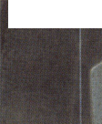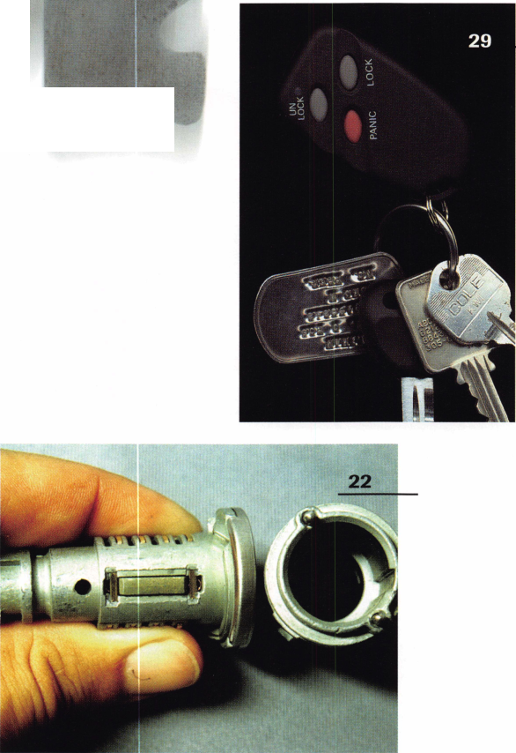

eatured

Cover

**Pop Goes the Airbag**

Opening cars and servicing auto locks used to be child’s play  
for most locksmiths.

No more. How about you? Do you know what’s inside that  
bag of tricks they call a 1998 Lexus? Better find out before  
you have to trade in your Slim Jim for a dunce’s hat. Check  
out this month’s auto overview.

22

**1998 Chrysler Update**

A sidebar lock with eight tumblers will now be found on  
Chrysler ignitions; it appears, however, that the key blank  
will not change.

By Sal Dulcamara, CML

O

a

**1** **Tools for the Electric Locksmith**

(C You Ve invested the time and money in electronic access  
1 training ... maybe even some licensing fees and added insur-  
y ance. Now all you need is a few specialized tools.

By Paul Chandler, CRL

^ **The ABCs of CCTV: “P” is For Position**

Take a closer look.

By Paul Chandler, CRL

CC

0

18

19

20

**Lock Chat (Part 1)**

All you mouse potatoes will want to know the latest details on the ALOA chat room.

By Kim Bowers, CML

41

**Cashing In On Cabinets**

How to turn this time consuming, low profit work into quick, easy profits.

By Tom Seroogy

26

**To OE or Not to OE?**

How important is original equipment? You have to set your own priorities.

By Buddy Logan, RL

29

**Clicker Disease and Other Automotive Maladies**

Aspirin won’t help these headaches.

By Al Davenport, CML

30

**1998 Auto Outlook**

SRS, SIPS, ITS and LEPS. Sound like a foreign language to you? Better become bilingual.

By Tom Gillespie

32

**Auto Locks Tools and Tips**

Treat yourself to this bulfet line of auto information and learn how to do a lot of this type of work without an overly huge investment.

By Sal Dulcamara, CML

46

**Surfin’ the Net**

This Keynotes author was impressed with her browse around the ALOA web page.

By Claire Cohen, CML

40

**Automotive Locksmithing:**

**Quality Counts**

One of the not-so-obvious dangers to locksmiths from the new auto technology is the need for quality parts.

By Fred Kosloske

44

**Let There Be (Inspection) Light**

With all due respect to the book of Genesis, this also is a worthy creation.

By Sal Dulcamara, CML

October 1997

Keynotes



A

Keynotes

Mail Box



Dept]

**If you have an opinion to offer on**

**rthe letter(s) printed in Keynotes each  
month, let us know! Submissions to the  
“Keynotes Mail Box” department are  
printed on a space-available basis.**

**Write to: Keynotes Mail Box;**

**Associated Locksmiths of America, Inc.; 3003 Live Oak Street; Dallas TX 75204; or FAX (214) 827-1810.**

**Thanks to All of You**

Members of ALOA,

Some of you know that I was recently honored with the ACE award. I was very surprised. I feel proud, but humble. I had never given a thought that I might be so honored.

1. have enjoyed each and every class I have instructed. I have always been blessed with some very fine people to work with me in the classes. I consider each of you, who has been in class, to be a friend and hope you feel the same about me.

You have all heard people talk about the problems in our profession. We do have some problems, the same as any other pro­fession. In each class, there are people who have been in the profession for many years, and people who have limited experience. I am sure this is true of any class in any pro­fession and on any subject. By being in the class, each person is demonstrating their desire to improve their knowledge and abil­ity. As long as we have these people attend­ing classes, and I know that will continue forever, we have no problems that can’t be corrected. I am very optimistic about the future of our profession and the future of ALOA.

I want to say “Thank You” to everyone who had anything to do with me receiving this honor. You, the members and the stu­dents, may not have a direct vote, but this would not have been possible without you. Kenneth P. Lee, CPL

**Feedback on Convention**

Dear ALOA,

This was the first membership meeting (ALOA ’97 in Reno) I got to go to, and I was very disappointed in the way it was handled. The topics were laid out in good form, but at the beginning of the meeting, everyone was informed that they would have three minutes to make their remarks.

A light at the front of the room was sup­posed to inform them when time was up, but there were quite few times that no one was working it. When we started the meet­ing, we actually had a great turnout, but as

time progressed, people started to leave. I feel there are some better ways to conduct this meeting. It is very important that the members have a right to voice their opinion, but it should not get turned into a gripe session.

1. The president, speaker, or an individual appointed by the board should have con­trol of all microphones. This way, he or she can have a stop watch and cut the mic. after the set time. Some people might get upset with this, but rules are rules, and all topics can be covered. We did not even get a chance to vote on some important issues.
2. The meeting should be held the morning of the first day of the show. My father informed me, it was done this way, some time ago. If all topics are not covered then another meeting could be called that evening, or the next morning. This would eliminate people having to rush for airlines.
3. A list of all topics and brief descriptions of said topics could be included in each members registration packet. This way, if they arrive the first day of the classes, or the day before the meeting, they have the time to look over the topics. Then, if they have a problem with one of them in particular, they will have time to discuss it with the proper people, and will not have to try to use more than three min­utes during the meeting to argue, com­plain or dispute any one topic.
4. As far as using ballots to vote on, I feel this was a waste of paper, time and peo­ple. If the vote is to be by majority, why shouldn’t all members be allowed to see how everyone else voted? It saves time, people, and money on printing.

3 Nominees from the floor. Many people want to voice their opinion on nominees. This should be allowed, but it should be kept to two minutes max. I saw quite a few people at the mics, telling about diferent nominees. If their time is limit­ed, then more people could voice their opinion.

Well, I will close with this in mind.

After talking to quite a few of the manufac­turers, as well as other locksmiths and hear­ing what had happened in New Orleans, I figured someone would have found a better way to run this meeting. It was very disap­pointing to me, but I will not allow one meeting to deter me from trying to attend the next one. I feel this is where I can speak my mind. Whether anyone listens or not, is besides the point, but it’s my right as a member to be allowed to speak.

You can include my name and address. I am very open minded and would love to hear from others.

Thank you,

James R. Barnhardt #13794

Dear ALOA,

I just got back from my first convention. The PRP test was as always a thrill. The classes were great. A.J. Hoffman’s class on interchangeable cores was the best class I’ve taken. The Saturday members meeting was­n’t what I expected and what I’m left with is a lot of ideas and a lot of questions.

My first impression is sometimes ALOA works and sometimes it doesn’t work. New members aren’t necessarily going to know how this association is run. It may take longer to explain procedures to them. They may talk about stale issues that would best be left for later. They may call for a point of order on a procedure the association has always ignored.

Some long-time members might have personal agendas or gripes that come up. The end result is that more experienced members might find meetings run longer than usual. Is that something members should plan for when they make their travel arrangements? Or is it something the asso­ciation should plan for when creating the schedule? Is this something that hasn’t happened before?

It’s not impressive to see members act like clock watchers. The association is cry­ing about getting more members. The asso­ciation needs active members. Why join, be active, and come to the convention for the

Keynotes

October 1997

meeting if the members meet discussion with “Shut up and sit down! I have to catch a plane!’ ? The association only meets once a year to vote for changes. To someone new, it would appear association business is not that important.

Although it was my first convention, I am not new to the industry. I know educa­tion is important. I know ALOA has been the leader in educating locksmiths.

I know legislative issues are important.

I’m not sure how ALOA will lead in this area. If they do lead, who will follow?

What was the attendance at the legislative meeting? I left another class early to go to it * and everyone was gone! I don’t know the official count, but one member in atten­dance said, “There were about five people besides the legislative committee.” Hello! Is anybody out there?

We heard about Texas law. Was the excitement generated about that just a lot of smoke? Are Texas locksmiths doing what they’ve always done? What is going to wake locksmiths up legislatively? By the way, I just received my copy of the National Lock­smith. Get a copy and read of the legislative problems discussed by Kathy Zaniolo, CPL at the NASIR meeting. We must work together or the legislators will do as they want with us.

What’s it going to take to wake ALOA up? Last year’s meeting had no quomm to vote. This year’s meeting could not keep one. Move the associations incorporation to a state where vote by mail is permissible. It seems that most locksmiths don’t come to the convention to address association busi­ness at the meeting anyway. Voting by mail therefore should not reduce the attendance at the convention. How many members come to the convention? There are just under 7,000 members. How many of those members are business owners? How many are employees? Can employees afford to attend? Who’s going to take care of the cus­tomers if everyone goes to the convention.

Do members who don’t or can’t attend not count?

It’s no wonder membership has declined. Unless you attend the convention, you have no voice. If you attend the convention, no one will listen.

Vote by mail. What discussion takes place on important issues? How are the members involved? The results of the survey ALOA sent out a few months ago were available at the meeting. ALOA received just under 2,000 replies. Of those 2,000 replies, 899 had been to zero conventions in the last five years. Only 576 responded they would definitely attend the 1998 conven­tion. By mail, ALOA is able to get feedback from 2,000. By attendance, the membership meeting held at convention would do well to get half that. Which better represents the members as a whole (not just the shop own­ers)?

Vote by mail. A regular written forum from different viewpoints on subjects that require the members vote should be avail­able in Keynotes. Presentation: If the board is going to propose a change in the bylaws, then that change should be printed in a for­mat that includes the change, an article that supports the change and an article that does not support the change. Discussion: Keynotes could print responses from the members. Conclusion: A date could be set when a vote (by mail) would take place. Result: All members have the opportunity to partici­pate. The security industry is changing at an unprecedented pace. I don’t see how ALOA will survive at the snail’s pace it’s going. Will we wait and see if there’s a quo­rum next year before changes are to be made? I hope not.

Locksmiths need a national voice in the form of a strong ALOA. Old members need to welcome and recruit new members. All members need to participate for ALOA to effectively represent the majority.

Jim Mullins, CPL

**Reply from Dallas Brooks**

In response to both James Barnhardt and Jim Mullins, I would like to first say ‘thank you’ for the input. Every advance made by our association can be traced back to a member who cared enough to say or do something.

Yes, I agree with you both that we need to look for ways to improve how our mem­bers vote on and discuss issues of vital importance to the business of ALOA. The annual membership meeting structure and

Keynotes

Mail Box

timing continue to be examined by leader­ship. We will also try to come up with alternate methods of communicating at other times during the year—such as our spring ’97 opinion survey. That survey, in fact, indicated that many of you would pre­fer some type of mail ballot instead of vot­ing on-site at the annual meeting. We are looking seriously at how to accomplish this so that we can give every member a fair chance to participate in ALOA decision­making—not just those able to travel to the Security Expo. Voting by mail/phone in advance would also leave the annual meet­ing open to more discussion and idea exchanges without the pressure of conduct­ing routine association business on the spot.

We tried to improve the 1997 meeting by holding it on Saturday morning in lieu of the traditional ‘late late’ Friday night ordeal. This experiment did result in an excellent turnout—we may need to allow for more time. But I’m pretty sure whatever timetable we apply to the membership meeting, there will be those with schedul­ing problems. (Maybe this is something we could vote on by mail/phone as well: ‘What day should we hold the annual meeting and how long should it last?’) This past meeting was especially cumbersome with so many offices to fill and the numerous bylaws changes to process—here’s hoping that in the future we’ll have shorter agendas and more time to talk about critical issues face- to-face. (You’re right, Mr. Mullins, legisla­tion continues to merit some serious discus­sion and I assure that you will be hearing much from me concerning this issue in the near future.)

In the meantime, don’t wait for next year’s meeting to speak your mind. On page three of this issue are the names of your ALOA regional vice presidents, committee chairs, directors, past presidents, trustees and members-at-large. Write or call with your problems, ideas and opinions all year long. If you’ve ever had the impression that these individuals don’t have the time or inclination to represent your point-of- view—think again. We plan to get some things done.

Dallas Brooks ALOA President

October 1997Keynotes \

**Upcoming**



[Dept]

Events

October

1. 5

Lou-Miss Locksmiths Assoc.

Fall Convention Baton Rouge, La.

Contact: Randy Benoit (504)447-8128

1. 5

Jo-Van Distributors, Inc. Locksmith & Sec. Trade Show Contact: Joan (888)752-7210

4

Acredited Lock Supply Co.

23 rd Anniversary Trade Show Secaucus, NJ Contact: Norman Koller (800) 652-2835

6-10

MBA

1. Day D.O.D/D.O.E. Combination Lock Training (888) 622-5495

11

Lock Museum of America 25 th Annual Lock Collectors Show

Terryville, Conn.

(203) 869-6260

11/18

Vindicator Training Class Philadelphia/Denver •(512)314-1200 •FAX (512)314-1270 (•ask for other dates/locations)

18

Mas-Hamilton Auditcon 2100 Class Phoenix, Ariz.

Contact: Sarah Coulter (606) 253-4744 ext. 194

21-26

24th Annual Tri-Regional Security Conference Bellevue, Wash.

Contact: Harold Hasfjord (206) 846-1570]

FAX (206) 846-2291

8 I Keynotes October 1997

24-25

Mas-Hamilton X-07 Certification Class Lexington, Ky.

Contact: Sarah Coulter (606) 253-4744 ext. 194

31-Nov1

The Great Texas Antique Pad­lock Show Dallas, Texas (972) 245-2893

**November**

5-9

Yankee Security Convention Education and Trade Show Providence, RI (800) 209-8266

8-9

Mas-Hamilton X-07 Certification Class Houston, Texas Contact: Sarah Coulter (606) 253-4744 ext. 194

15

Mas-Hamilton Auditcon 2100 Class Oklahoma City, Okla.

Contact: Sarah Coulter (606) 253-4744 ext. 194

16-22

ALOA Fall Board Meeting Dallas, Texas (214) 827-1701

17-21

MBA

1. Day D.O.D/D.O.E. Combination Lock Training (888) 622-5495

22-23

Mas-Hamilton X-07 Certification Class Lexington, Ky.

Contact: Sarah Coulter (606) 253-4744 ext. 194

**December**

3-6

Sirius Exhibitions Group/ITE/GIMA Security Brazil ’97 Rio de Janeiro, Brazil (202) 237-1990

13

Mas-Hamilton Auditcon 2100 Class Waco, Texas Contact: Sarah Coulter (606) 253-4744 ext. 194

February *98

10-15

Texas Locksmiths’ Association Convention and Trade Show Waco, Texas Contact: Ken Warden

(210) 379-5923

**March *98**

28-29

GCLA

1. th Annual Midwest Trade Show and Classes

(708) 386-3695 FAX (708) 366-2094

**April *98**

8-13

MLA of Great Britain Convention Birmingham, England Contact: Peter Hall

1. Olive Grove; Burton Joyce; Nottingham. NG14 5FG.

/" **Future Conventions**

1998

ALOA ’98 June 14-20 Nashville, Tenn.

SAFETECH ’98 May 18-23 Valley Forge, Pa.

1999

ALOA ’99 July 25-31 Cincinnati, Ohio

SAFETECH ’99 May 3—8 Las Vegas, Nev.

2000

ALOA 2000 Date TBA Las Vegas, Nev.

SAFETECH 2000 TBA

2001

ALOA 2001 July 15-21 Baltimore, Md.

For PRP dates, see p. 56. For ACE dates, see p. 9. Send in the dates of your organization's activi­ties today!

J

They tell you your kid has spina bifida.

You cry. And you curse. And you clench that tiny new baseball mitt in your hands and vow never to throw it away.

It may take time, but you will play catch with your son.

Hope. That’s what Easter Seals  
is all about. At some point in their  
lives, 1 in 5 Americans will be  
affected by a disability. We  
provide physical, recreational  
and speech therapies to help  
children born with disabilities

live with independence, dignity

and equality. But we  
can’t do it without  
your help. Support  
Easter Seals. Give

ability a chance.

© 1995 National Easter Seal Society

rW'

eEaw£r

Sms



Half-day classes in Nashville will be free to ALOA members who register for Security Expo.

Well, ALOA ’97 Security Expo is now histo­ry and what a history it was. A truly great week of education and trade show with a total of 3,661 attending classes and the show. The manufacturers seemed to be very happy with the turnout as the floor was busy from the opening on Thursday until it closed Saturday afternoon. If you weren’t able to attend, you really missed a good one! But, there is always next year in Nashville from June 14 - 20, 1998. Your Education Committee is already working hard to put together some great classes for this event. Watch this column for news of exciting new classes that will be there.

ALOA ’97 Security Expo had 45 full-day classes, 27 half-day classes and five evening seminars, which were well attended. We had 1,032 members and 688 non-members reg­istered for the functions, with a total of 3,661 people in attendance. Three hundred eighty-one attended the seminars, 762 attended the half-day classes and we had 1,170 students attend the full-day classes. Quite an accomplishment with many off hours enjoying the sights and weather there in Reno, Nev. It is a beautiful city with great weather (dry and cool most of the time). If you missed this one, you certainly do not want to miss ALOA ’98 Security Expo in Nashville, Tenn. It will be even bet­ter than Reno I am sure. Plan now to spend your vacation next year in beautiful Nashville and take some great classes. Great news! The Convention and Education Committee, working with the manufactur­ers have arranged that the half-day classes in Nashville will be free to ALOA members who register for Security Expo. Is that a real deal or not?

Your Education Committee would like to hear from any of you with suggestions on new or improved classes that we might offer next year. I am still chairman with Anthony Ramunno, CML, CPS, as vice chairman. You can reach me at 301-831-5454 or Tony at 330-782-6204 with any suggestions or com­plaints. The other members are Dana Barnum, CML, at 610-565-9900; Mark Blum, CML, CPS, at 517-482-5809, Bruce

**^upcoming ACE Classes**

Central Pennsylvania Locksmith Assoc.

October 5, 1997 Carlisle, Pa.

Contact: Frank Busch, CRL (717) 848-1754 PRP Preparation Class Instructor: William Neff, CML

Grand Canyon Chapter

October 18-19, 1997 Phoenix, Ariz.

Contact: John Ilk [602) 921-0123 Domestic Auto Service Instructor: Ray DAdamo, CML

Central Pennsylvania Locksmith Assoc.

November 1, 1997 Carlisle, Pa.

Contact: Frank Busch, CRL [717) 848-1754 Hands-On Access Control Instructor: William Neff, CML

Master Locksmith Association of New Jersey

March 26-29, 1998 Somerset, NJ.

2908-788-9696 Contact: Charles Green 3 Full Day Classes and Two Evening Seminars

Iy

J. Tarbet, CML at (601) 924-4184. Let’s hear from you, the members on what we can do for you in 1998!

El

the Chairman: James

Glazier, CML, #14240, is a retired police officer and operates Security Plus in Mount Airy, MD. He semes as ALOA’s Northeast vice president. He also serves on the Finance, Convention and Grievance Committees of the ALOA Board.

October 1997

Keynotes



Legislative

:omment

Committee Chairman

***Y Legislative Comment is written by John Greenan on behalf of ALOA’s Legislative Committee. Comments or questions can be directed to him at: Fink Safe & Lock; 2307 N. Western Ave.; Chicago, IL 60647; (773) 486- 2030; FAX (773) 486-4268.***

A single initiative: Stop legislation that is bad for the locksmithing industry.

Big news on the legislative front. This fall a historic meeting was held in Chicago to establish and fund a single initiative: Stop the passage or implementation of legislation that is bad for the locksmithing industry. A position paper resulted that is backed by major players in the manufacturing sector.

Purpose:

The below signers in the security hardware industry believe that no legislative or regula­tory requirements should restrict the access control business in selling, maintaining or servicing electronic security equipment, except those externally monitored security devices requiring the immediate response of public emergency services.

It is the purpose of the industry ...

A. If a state is considering or has licensing requirements in place for the installation,

maintenance or service of electronic secu­rity equipment, then the requirements to obtain such a license should be equally accessible by all service groups and not exclusionary of any group or groups.

B. Any licensing requirement that requires a service company to have a wait time before they have access to the license is unfair, anti-competitive and counter to principles of fair competition.

Larry R. Barnes, Schlage Lock Company

Dallas Brooks, American Lock & Key, Inc. ALOA President

Steve Engel, CPP, CML, Sage, Inc.

ALOA Member At Large

Aaron M. Fish, Chairman of the Board, Ilco/Unican

Tim Layton, President & CEO Medeco Security Locks

John J. Greenan, Fink Safe & Lock ALOA North Central Vice President Howard Johnsen, President Hans Johnsen Company Jeffrey S. Nunberg, CML, Integrated Security Systems

ALOA Southeast Vice President Bill Power, Vice President

American Security Distribution Stay tuned for future developments.

1 About the Chairman: John J.

Greenan represents the fifth generation of locksmiths  
and is vice president of Fink Safe & Lock in  
Chicago, IL. A locksmith since 1985, John also  
serves as ALOA’s North Central vice president. He  
is chairman of the Allied Locksmiths of Illinois.

GIVE THE  
GIFT OF LIFE

Suggest that memorial  
contributions be made to the  
Muscular Dystrophy  
Association and honor a loved  
one by helping a million  
Americans with neuromuscular  
diseases.



Muscular Dystrophy Association

(800) 572-1717

***Keynotes***

October 1997



Applicants

For Membership

**ALABAMA**

Stapleton

027403, William L Brown, A

**ARIZONA**

Globe

027408, Milton W Sloane, A SPONSOR: David Lowell

**CALIFORNIA**

Escondido

027400, Shane A Placzkiewick, AL SPONSOR: David Coleman

Fremont

027360, Paul J Springsteen, A

Livermore

027338, James J Lennon, AP

San Jose

027365, Joseph P Rechenmacher,

A

Santa Barbara

027410, Anthony S Andradez, A

**COLORADO**

Leadville

027357, Robert W Calder, A SPONSOR: Greg Hale

Snowmass Village

027380, William J Bultman, AP SPONSOR: Michael McGilvray

**FLORIDA** Florida City

027376, Frank E Cummins, AP SPONSOR: John Premo

Lakeland

027405, Joseph M Hill, A

Marco Island

027344, Jeffrey S Butcher, A SPONSOR: Mark McCauley

Patrick AFB

027385, Michael C McKinney, AP SPONSOR: Andrew Dennison Tallahassee 027362, Perry M Berry, A SPONSOR: Todd Purvines

**GEORGIA**

Acworth

027378, George H Williams, AP

Atlanta

027424, Frank W Frederick, A 027371, Donald L Garner, AP SPONSOR: Paul Mannen

Grovetown

027402, Printes W Evans, A SPONSOR: Donald Robinett

**ILLINOIS**

Chicago

027370, Tom Lawrey, A 027387, Hollis Veal, A

**KANSAS**

Shawnee

027407, Kevin O Harris, AP

**KENTUCKY**

Covington

027349, Delbert E Price, A SPONSOR: James Price

Henderson

027423, Tony R Cagle, AP SPONSOR: Tony Cagle

**MASSACHUSETTS**

Bridgewater

027359, Robert W Bennett, A

Cambridge

027404, Beth A Leventhal, A SPONSOR: Charles Robertson

**MARYLAND**

Balto

027340, Michael w Walke, A SPONSOR: William Neff

Columbia

027409, Walter N Ussery, A 027401, Gerald M Whitaker, AP SPONSOR: James Glazier

Forestville

027420, Jerome C Wilson, A SPONSOR: Philip Rovenolt

**MICHIGAN**

Shepherd

027422, George G Michaels, A SPONSOR: George Michaels

**MINNESOTA**

Madelia

027399, Cory K Vee, AP SPONSOR: John Heckman

Maplewood

027412, Dale D Bigelow, AP 027339, Loren R Russell, A

**MISSOURI** Kansas City

027354, Joseph M Pfefer, A SPONSOR: Leonard Smallwood

***E***

***The following applicants are scheduled for clearance  
members of ALOA The names are published for  
mber review and comment prior to November 1,***

***1997, to ensure applicants meet standards of ALOA’s  
Code of Ethics. Protests, if any, should be addressed to  
the Membership Department and must be signed. Active  
Membership applicants (A) have worked in the industry  
two or more years. Allied Membership (AL) applicants  
are not locksmiths, but work in a security-related field. ,***

**NORTH CAROLINA** Carrboro

027413, Michael T Traylor, A SPONSOR: Lee Rubenstein

**NORTH DAKOTA** Hettinger

027411, Anthony W Stover, AP

**NEW HAMPSHIRE** Fremont

027355, Eric W Swindell, A SPONSOR: Anthony Calabro

**NEW JERSEY** Bloomfield

027395, Luis G Camacho, A SPONSOR: Kurt Navratil

**NEW MEXICO** Albuquerque

027397, George E Perry, A SPONSOR: Warren Rooks 027398, Robert N Perry, A SPONSOR: Warren Rooks

**NEVADA** Las Vegas

027367, Mace W Hardy, A SPONSOR: Ralph Ring 027381, Donald T Riedell, A

**NEW YORK** Bronx

027389, John F Roschen, A SPONSOR: Carl Campbell

New York

027388, Ronald E Bartash, AL SPONSOR: Ronald Weaver

Rose

027353, Bernard A Taft, AP

**OHIO** Brook Park

027373, David K Hinderman, A

Kettering

027364, Roger E Poplin, AL SPONSOR: James Brickler

**OREGON**

Clackamas

027419, Dennis A Petrin, A SPONSOR: Clyde Williams

**PENNSYLVANIA**

Bristol

027391, John Costanzo, AL SPONSOR: Kevin Savoy

Collegeville

027361, John L Perla, A SPONSOR: J Hood

Reading

027372, Jan R Pluto, A

**SOUTH CAROLINA** Greenville

027379, Thomas D Me White, A

**TENNESSEE**

Knoxville

027350, Ralph J McAllister, AP SPONSOR: Raiford Ball

**TEXAS**

Flower Mound

027390, David D Sowder, AP

Ft Worth

027382, David B Everett, A SPONSOR: Terry Hortman 027377, Thomas F Sanders, AP

Muleshoe

027386, Rod L Springfield, AP

**VIRGINIA**

Alexandria

027369, Shawn E Frensley, A SPONSOR: Joseph Smith

Quantico

027417, Frederick E Becker, A SPONSOR: Edward Miller 027414, Kenneth L Beverly, A SPONSOR: Edward Miller 027416, Wayne A Hairfield, A SPONSOR: Edward Miller 027415, Joseph C Truslow, A SPONSOR: Edward Miller Springfield 027356, Peter L Caton, A SPONSOR: Charles Robertson WASHINGTON Bellingham

027347, Darby A Libby, A

Renton

027406, Bert A Honeywell, A SPONSOR: Douglas Papka

**WISCONSIN**

Antigo

027394, Jeramy Gschwind, A

**CANADA**

**BRITISH COLUMBIA** Vancouver

027348, Chun-Kau Fu, A

October 1997

Keynotes

Applicants

For Membership

**ONTARIO**

Dundalk

027392, Brent W Fox, A SPONSOR: Roger Gagne

Haileybury

027418, C S Woolridge, A

Hamilton

027375, Debbie L Hayward, A SPONSOR: Paul Tadros 027374, Larry A Polmateer, A SPONSOR: Paul Tadros

Ingersoll

027363, LLoyd A Nichol, A

Kingston

027346, Dan H Campsall, A SPONSOR: Leonard Passarello

London

027342, Donald J Lewis, A SPONSOR: Marc Bertrand 027343, Brian W McCarthy, A SPONSOR: Marc Bertrand

Sault Ste Marie

027366, Roy T Greenwood, A

Scarborough

027351, Jason J Belanger, A

Simcoe

027358, John G Lundie, A

Toronto

027368, F J Agnew, A

Weston

027421, Richard I Latorre, A SPONSOR: Leonard Passarello

**CHINA**

Sheung Ping Tung Kun

027352, Li Yiu-Yam, AP SPONSOR: Kwok-kei Leung

**ENGLAND**

Teddington Middlesex

027345, Mark A Mathers, A

**JAPAN**

Ikaruga Ikomagun

027384, Hideo Onishi, A SPONSOR: Takashi Kuwana

Kawasaki, Kanagawa

027396, Yoshiak Nakamura, A SPONSOR: Keizo Takahashi

Shinjuku-ku Tokyo

027393, Tadashige Tani, A SPONSOR: Keizo Takahashi

**OSAKA**

Shijyonawate-shi

027383, Morimoto Yasumitsu, A SPONSOR: Takashi Kuwana

**NORWAY** 4017 Stavanger

027341, Eigil Gjeseth, A

Professional Locksmith Key Tags

**FREE** Printing of Your  
Ad Copy on Front

FRONT SIDE  
is Printed  
with

your copy

ABC LOCKSMITH

"We lock 'em up!"

| 123 MAIN STREET

'f ANYTOWN, US 0000  
• PHONE: 888-777-6666

JaloaI

Tag Colors to choose from: WHITE • NEON GREEN YELLOW • NEON PINK

Key Tags Shown Actual Size

Choose from:  
Chrome Plated Wire Rings  
or

Brass Plated Bead Chains

National Logo's FREE,  
Custom Logo's add $20.00  
and supply clean B&W artwork

SANZO— 1 -800*222-4041

**QUANTITIES 100 200 500 1,000 2,000 3,000 5,000**

**TAGS with CHAINS $26.00 $38.00 $75.50 $104.50 $177.50 $240.50 $359.00**

TAGS with RINGS $24.00 $34.50 $65.00 $84.00 $146.00 $199.00 $299.00

Also available for your key tags

Plastic Protective Sleeves

Stock # PPS10 $7.50 per hundred

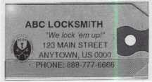

Key Tag Envelopes

**Stock #KTE3 $7.00**

TO ORDER: Choose Quantity, Tags with Chains or Rings, Tag Color and Provide Imprint Copy.

SANZO FREE!

Specialties, Inc. SHIPPING OH

P0 Box 68 - Endicott, NY 13761 ALL 0RDERS

Order Toll Free: 1-800-222-4041

Fax: 1-607-748-0507 (24 Hrs.) (NY&pA

Payment: □ CheckQ Credit Card add saiestax)



Keynotes

October 1997

Reader Service #1

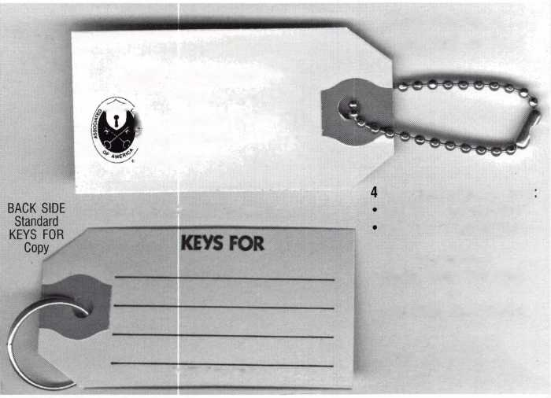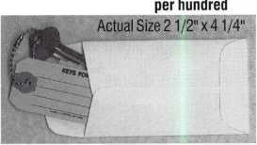

***Do you belong in the***

ALOA

President’s

Club?

How can I join the President’s Club?

You can earn membership in this  
prestigious club by recruiting just  
10 new members for ALOA.

Any ALOA member may participate.*

What do I get?

When you recruit 10 members, you receive a handsome blue blazer with  
a President’s Club crest. For each additional five members you recruit,  
you receive a lapel pin with gold-filled numbers, indicating your  
recruiting successes.

You also get the satisfaction of knowing that

you are helping your association, helping your industry grow, and you  
are helping fellow locksmiths achieve success.

How do I get started?

Contact the ALOA office for a supply of applications (214) 827-1701 or  
FAX (214) 827-1810. One President’s Club credit is awarded for each  
new applicant. Credit is awarded only after the membership application  
is approved. However, the credit will apply for the period in which the  
application is received. Failure to identify yourself as the sponsor on the  
application form at the time it is submitted to ALOA for processing will  
forfeit any credit.

*ALOA Board of Directors not eligible for membership in the President's Club.

PRESIDENT’S CLUB ROSTER

153 Members 013186 Kwok-kei Leung

73 Members 019882 Henry Raymond

67 Members 005354 Stewart Levine, CML

62 Members 012566 Mary Ohmit, CPL

58 Members 022907 Toshihiro Asano

49 Members 022598 Allen Konrath

44 Members 012103 Jack Hobin, CPL

42 Members 006072 Charles Robertson, CML

36 Members 021172 Myeong-Rae Cho

35 Members 011133 Salvatore Dulcamaro, CML

33 Members 008951 William Neff, CML

27 Members 010464 Jeanne Lodge, CML

25 Members 016675 Roy Renderer, CML

23 Members 003296 Danny Rudd, CPL

23 Members 014474 Robert Carroll, CPL

23 Members 015696 Barbara Watt

23 Members 018521 David M A Federico

22 Members 008154 Diana Barnum, CRL

22 Members 019138 Robert DeWeese, CPL

21 Members 004371 John Elliott, CML

21 Members 004475 Larry Warnick, CML

21 Members 007215 Jerome Cohen, CML

21 Members 009049 John Heckman, CML

21 Members 019244 Eugene Altobella

20 Members 023788 Jim Williams

18 Members 007051 D Michael Lee, CPL

18 Members 014144 James Fowler, CML

18 Members 014996 David Harris, CML

17 Members 002501 John Kerr, RL

17 Members 015283 Ronald Heidzig

16 Members 007009 John Dorsey, CPL

16 Members 007012 Joseph Ferrero, CML

16 Members 008168 Charles Cole, CML

16 Members 008617 William Grant, CRL

16 Members 016056 Elvis Hammerschmidt, CPL

16 Members 018691 Brian Reetz

15 Members 001825 Walter Lascar, RL

15 Members 005329 Marian Swann, CRL

15 Members 008361 James Cawby, CML

14 Members 001657 Rex Parmelee, RL

14 Members 003430 Lawrence Smith, CML

14 Members 007129 Thomas Vandersteen, CML

14 Members 018034 Michael Robinson, CRL

13 Members 008916 James Gruber

13 Members 009172 Peter Gauthier, CPL

13 Members 016525 Philip Rovenolt, CPL

13 Members 022358 Russell Fuller, CRL

12 Members 000712 Edwin W Scott

12 Members 004361 Robert Rodocker, CRL

12 Members 009546 Gary Teams, CPL

12 Members 010266 William McElheney, CML

12 Members 010909 Rolando Bouza

12 Members 014825 Yuriko Yanai

12 Members 015305 Lonnie McKinney, CML

12 Members 020496 James Brickler

11 Members 009305 Frank Hartung, CML

11 Members 011316 Robert Duman, CML

11 Members 018805 Robin Horsley

10 Members 004993 Ernest Wright

10 Members 005586 William Wickward, CML

10 Members 009482 Lester Brodsky

10 Members 010602 Herbert Dusenberry, CML

10 Members 013505 Joseph Whitaker, CPL

10 Members 016178 Jon Griswold, CML

10 Members 016726 Dale Knowles, CPL

10 Members 020808 John Engel, CRL

10 Members 022221 Richard Sievers



**MLANJ Officers**

The 1997-’98 officers for the Master Lock­smiths Association of New Jersey were recently announced. They are as follows (from left to right): Treasurer Bill E. Tim-

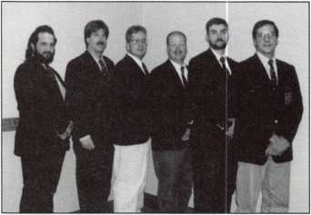

mann, CRL; Chaplain Robert Cornine,

CML; President Daniel F. McGlynn, CML;  
Sergeant at Arms James Green, CRL; Secre-  
tary Joe Lavigne; Vice President Michael  
Ambrosi, CRL.

**Entrepreneur of the Year**

Alan Sefton, Pear-  
point president,  
has been named  
Entrepreneur of  
the Year in the  
technology cate-  
gory by the Entre-  
preneur of the  
Year Institute of  
Ernst and Young

LLP. Sefton founded the company in 1983.  
The privately held company boasts two cor-  
porate headquarters, one in the United  
States and one in England. The foundation  
of the company remains the video pipeline  
inspection systems including the innovative  
explosion proof line, In addition, Pearpoint  
provides video systems for the security and  
traffic markets. New products include a self-  
contained inspection system for the plumb-  
ing market and a 24-hour infrared camera  
able to capture license plate information of  
moving vehicles For the past 11 years, Ernst  
and Young has sponsored international com-  
petitions in 10 countries and 46 cities across  
the United States.

**Silent Knight Sells Regency**

Silent Knight announced that it has sold the Regency program and affiliated prod­ucts to ITI Technologies, Inc. of North St. Paul, Minn. “The transfer of the Regency program to ITI ensures participating dealers that Regency will continue with new ener­gy and scope,” said John Ellis, president of Silent Knight. “Additionally, it reinforces our strategic focus as a commercial fire alarm and communication equipment man­ufacturer. It is our intention to fully support ITI in a seamless transfer of this segment of our business, and to concentrate all of our available resources on product and channel development in more strategic product areas.”

**NT Hurricane Response**

When Hurricane Andrew swept through Dade County, Florida in 1992, the after- math of storm devastation to commercial and residential structures resulted in some of the strictest building codes to date in the U.S. construction industry. In response to interior damage in retail stores, offices and public buildings caused by mechanical fail­ure and debris penetration of automatic glass entrance doors, manufacturers rallied to develop stronger, more durable glass, stiles, and mullions to withstand the destructive forces of nature. Leading the challenge to meet new Dade County build­ing protocols for automatic doors, NT Dor- O-Matic became the first automatic door manufacturer to not only meet all the requirements of the Dade County impact and cycling tests, but to exceed the estab­lished 45 pound/square foot impact with a door able to withstand missile impact of up to 60 pounds/square foot. A cycling test performed on the interior and exterior of the NT Dor-O-Matic Astro Fold doors applied repeated positive and negative pressure of up to 90 pound/square foot, 10,080 total pounds force, in a vacuum environment for 4,500 cycles. Passing the second component of the Dade County test without a hitch, the doors withstood the constant cycling variations in pressure without shattering,

Keynotes October 1997

collapsing, or folding. To date two of the NT Dor-O-Matic automatic door systems have been approved by all Dade County building protocols: NT Dor-O-Matic Astro- Fold and NT Dor-O-Matic Astro-Slide, while the NT Dor-O-Matic Astro Swing door has passed the cycling test. All NT Dor-O-Matic Automatic Door Systems are ADA compliant and conform to ANSI per­formance and dimensional specifications.

**POLEX Scholarship**

Streamlight officials recently announced that Lieutenant Duane E. Hasenauer of the Plumstead Township Police Department of Plumstead, Pa. has been named the recipi­ent of the flashlight manufacturer’s 1997 POLEX (Police Executive Development Program) scholarship. This is the second

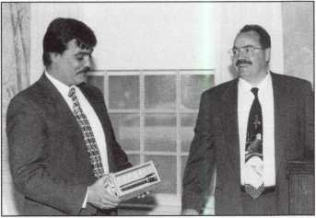

consecutive year Streamlight has donated the $2,000 fund to pay for an officer’s par­ticipation in the week-long continuing edu­cation program, which is sponsored by Pennsylvania State University as a means of providing advanced training skills in law enforcement administration. According to Streamlight President Brand Penney, Hase­nauer was selected from numerous applica­tions based on his record of exceptional ser­vice throughout his 13 year career in the Plumstead Township Police Department. For additional information about Stream- light or the 1997 POLEX program, call (800) 523-7488.

**Detection Systems Makes New Acquisition**

Detection Systems, Inc. announced that is has purchased Digital Audio Limited, more commonly known as “DA Systems” from

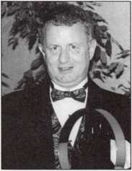

|  |  |
| --- | --- |
|  | Industry |
|  | News |

Numerex Corp. (NMRX). DA Systems is a leading United Kingdom manufacturer of security control equipment with annual sales of $10.8 million. The acquisition pro­vides DS with an important new, in-build­ing wireless radio technology that is believed to be superior to competitive offer­ings. Security systems incorporating this technology use narrow band transmitters and scanning receivers to send signals with­in a premise, eliminating the need for wiring. The DA Systems product is approved for Class 6 use in the UK market, which is the highest level security standard for wireless systems. This new technology is also salable throughout Europe. DA Systems currently has a contract for this equipment with the Irish Telephone Company valued at $2 million. Numerex also licensed DS to be one of two providers of Subscriber Termi­nal Units (STU’s) in the British market. STU’s are derived channel communication devices that transmit alarm signals over the unused bands of standard telephone lines.

As a result, STU’s can send an alarm signal over a telephone line even while someone is speaking on the phone. STU’s are the pri­mary method of alarm signal transmission used in the UK. Detection Systems, Inc. designs, manufactures and markets electron­ic detection, control, and communication for the electronic protection industry.

**ADI Hits 100**

ADI, which opened in 1985 with 12 conve­nience centers, is poised to break the 100 mark soon! The opening of two more con­venience centers, one in Hingham, Mass., the other in Charleston, W. Va., brings the grand total of ADI locations to 98. ADI’s new center is located at 35 Pond Park Road in Hingham, Massachusetts. The phone number for the center, which is managed by Thomas Guerin, is (617) 749-5460. ADI Charleston, managed by Derek Radoski, is located at 735 Watts Avenue in Charleston, WVirginia. You may reach them by calling (304) 344-9642. To reach the ADI location nearest you, please call 1-800-233-6261. ADI, a subsidiary of the Pittway Corpora­

tion is North America’s largest wholesale distributor of low voltage and structured cabling products.

■Executive News **Knight Manager**

Knight Safe Mfg. has announced the return of Art Corona who will take over as plant/production manager. Art has over 30 years experience in design, manufacture, quality control and technical expertise. Art was most recently employed at Armor Safe and at U.S. Security. At Knight Safe, he will be responsible for all phases of production and plant supervision.

**New VP at Silent Knight**

Silent Knight Security Systems of Maple Grove Minnesota is pleased to announce that Stanley S. Dederich has joined the com­pany as vice president of Engineering, Ded­erich has over 20 years of experience in the building controls business, most recently as business unit manager for sensor products at Honeywell, Inc. He has also worked for Pittway, Johnson Controls, and Landis & Gyr. Dederich has a degree in electrical engineering from the University of Iowa and an MBA from Illinois Institute of Tech­nology. Silent Knight is a technological leader in the development of commercial digital fire alarm communications and fire alarm and security control products, dedi­cated to serving wholesale and OEM distri­bution channels worldwide.

**Sanyo Security Expands Sales Team**

Kevin Balcom has been appointed western regional sales manager of the Sanyo Securi­ty Video Products Division, headquartered in Chatsworth, Calif. Balcom brings to his new position more than 14 years experience with PSA-LA, a member of one of the largest dealerships/buying networks in the country. He worked extensively in the field installing security systems and ended up in sales management with the highly success­ful security installation firm. Sanyo Fisher Company, located in Chatsworth, Calif.

markets a complete line of high quality  
multimedia, consumer audio and video,  
security video, office automation and home  
appliance products.

**New Sales Manager**

InfoGraphic Sys-  
tems Corporation  
has recently  
announced the  
appointment of  
Steven R.  
Weholfer as the  
midwest regional  
sales manager.  
Prior to joining

InfoGraphics, Wehofer was area sales man-  
ager for Best Lock Corp., covering the Mid-  
west. Infographics is one of the largest man-  
ufacturers of integrated access control, alarm  
monitoring, facility management, video  
imaging and video bading in North Ameri-  
ca. (see picture).

**Richardson Sales Manager**

Richardson Electronics, Ltd. is proud to announce that Pat Schuch has joined the Security Systems division as regional sales manager for the Central Region. Schuch will be based in the company’s River Grove, 111., facility and will be responsible for man­aging all central personnel and sales activi­ties of the Central Region. Most recently with S&B Distributors of the Midwest, Schuch is an accomplished sales professional who brings Richardson 16 years of proven sales expertise, 10 years in security distribu­tion and management. The Security Sys­tems Division River Grove Facility is a full stocking warehouse and will-call facility providing system design and support for a complete line of CCTV, fire and burglary alarm and access control products.

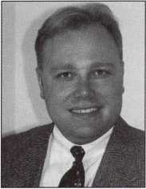

October 1997

Keynotes



Security

Marketplace

**Safe Chariot Model 3000**

Defiant Safe Company is pleased to announce the Safe Chariot Model 3,000. Originally designed to carry loads up to 2,500 pounds, this upgraded unit has a car­rying capacity of 3,000 pounds.

Locksmiths all across the country are increasing their profits with this one-person safe moving system. The tilting bed lowers to ground level for easy loading and unload­ing by utilizing the automatic clutch type winch. Once in the loading position, the winch can then be used for pulling the safe onto the trailer, providing positive control at all times.

The Safe Chariot can be towed with any of your existing service vehicles. There are no hydraulics, batteries, or electrical power hookups required, only a standard lighting plug. With few moving parts, maintenance is extremely low. Low insurance costs and the available lease/purchase plan make this a very profitable piece of equipment.

The compact design makes this unit highly maneuverable. Folding the bed for­ward allows the trailer to be stored in an area as small as 8 feet by 9 feet.

Included in the list of optional equip­ment are electric brakes, extra-load tie-down straps, T6 aluminum floor plating, pallet jacks, and more. Professional Safe Moving classes, designed to train your technicians on the art of single-person safe moving, are also available.

Defiant Safe Incorporated 3130 Towerwood Dr.

(972)243-3711 (800) 225-2984 Fax (972) 241-7669

Reader Service #2

**American Lock**

American Lock Company, a leading manu­facturer of high quality padlocks and acces­sories, introduces Model 2010, a new shack­leless round padlock machined from bars of solid steel. The case hardened, solid steel construction of Model 2010 provides maxi­mum protection against drilling and saw­ing, while its unique locking bolt design



resists crowbar attacks and prying. This 2 3/4 inch round padlock also features an American Lock pick-resistant 6-pin tumbler for added security.

Model 2010, the toughest padlock of its type available to security professionals, fea­tures a rust-resistant, triple plated lock body and a new 2-piece cylinder configuration that is easy service. The new design also provides improved pull strength. New Model 2010 can also be used with Ameri­can Lock steel hasps, Models 825 and 535, to secure doors on garages sheds, and similar storage buildings. For complete information about this new product or any of American Lock’s other padlocks or security accessories for the commercial, industrial, or retail mar­kets, call 1-800-PADLOCK.

Reader Service #3

**M.A.G. Security Starter Pack**

As a first step to shopping home invitations, M.A.G. Security has developed an all-in- one, imaginatively packaged starter kit. The new Home Security Value Pack contains eight popular items related to doors, door jambs, windows and patio doors to help cre­ate a strong barrier to intruders. The conve­nient, easy-to-carry package with handle includes a High-Security Box Strike, Door Chain Guard, Adjustable Strike, Door Viewer, Door Edge Guard, Sash and Sliding Window Locks, and Sliding Patio Door Locking Pin.

The Home Security Value Pack functions as an inviting portable billboard and fea­tures a home security checklist on the back to encourage consumers to survey their homes and return for additional purchases. The handy starter kit suggested list price is $39.18, and the manufacturer anticipates a potential $60 to $80 in add-on sales from repeat business.

M.A.G. Security 15381 Assembly Lane Huntington Beach, Ca. 92649-1141 (714) 891-5100

Reader Service #4

**Activity Verification Lock**

NKL, a leader in the design and manufac­turing of computerized safes has released the AVL, Activity Verification Lock, a product designed specifically for the grow­ing safe retrofit market. This new product offers a cost effective alternative to compli­cated and expensive smart lock retrofits for the first time.

The AVL offers a standard footprint replacement for ease of installation. Advanced features such as programmable time lock, door condition monitoring, armor car override capabilities, and dual keys, programmable time delay, and more are standard with the AVL. The audit trail retains up to 500 activities and it can be easily printed or viewed in the lock’s LCD screen. An additional advantage of the AVL is its ability to utilize all Dallas semicon­ductor keys, such as those used by Mas Hamilton, AuditLok and Vindicator. These features allow for easy integration into exist­ing operations.

The AVL, which is sold on a direct basis to locksmiths nationwide, is available for $198. The basic system controls one prima­ry safe door and is supplied with one master key and two user keys. Extensive advertis­ing and marketing in loss prevention and trade magazines assure that the end users will be aware of the lock and its benefits. This provides the locksmith profession ample opportunity for sales.

AVL is the first of a series of new products geared towards the aftermarket and OEM safe manufacturers worldwide.

NKL Industries (800) 528-9900 Reader Service #5

**Detection Systems, Inc.**

Detection Systems, Incorporated announced that it has been selected by SecurityLink from Ameritech as their standard provider of several categories of commercial security, and fire protection equipment. The equip­ment selected includes smoke detectors and motion sensors. With this new agreement, DS expects annual sales to increase by at

Keynotes

October 1997

least $2.5 million. SecurityLink from Ameritech currently serves more than 400,000 residential and commercial cus­tomers in the U.S. and Canada, with annual sales of $250 million.

Detection Systems, Inc.

130 Perinton Parkway Fairpw't, New York 14450 (716) 223-4060 (716) 223-9180 (Fax)

Reader Service#6

**Executive Apparel**

Security professionals rarely stand still. Run- ning, jumping, or sitting, they’re expected to look cool, calm and authoritative.

That’s a tall order, but it’s all in a day’s work for ExecuFlex blazers and pants, spe­cially developed by executive apparel for men and women in security.

Engineered for comfort and performance, yet styled for a polished appearance, the Execuflex blazer features stretch fabric, plus a stretch back with the exclusive Spring- Back gusset, built right into the full lining for maximum mobility.

Execuflex pants are made from a flexible stretch fabric and feature heavy duty pock­ets; double stitched seat seams, and extra wide belt loops, Execuflex blazers come in men’s sizes 36 to 46 and 48 to 60. Ladies sizes are 4 to 18 and 20 to 30.

Executive Apparel, Inc.

231 East Luzerene St.

Philadelphia, Pa. 19124 (215) 455-2100 (215) 455-7035 (Fax)

Reader Service **#7**

**Securitron**

Securitron Magnalock Corp. has broken ground on a major expansion of its head­quarters and manufacturing facilities in Sparks, Nev. The expansion will expand its existing facilities from 36,000 to 65,400 square feet with more than two-thirds of the expanded space for manuifacturing and warehouse.

Securitron Magnalock Corporation is the leading manufactuer of electromagnetic

|  |  |
| --- | --- |
|  | Security |
|  | Marketplace |

locking systems and associated items for the access control security industry.

Securitron Mark Henderson (702) 355-5625 (702) 355-5636 (Fax) [info@securitron.com](mailto:info@securitron.com) (email)

Reader Service #8

**Security Door Controls**

Security Door Controls (SDC) Entry Check 990 Access Management System is an eco­nomical multi-door control and monitoring network system. The distributes intelli­gence of the SDC 990 (each reader stores its own program) insures a highly reliable and functional system capable of utilizing both single stage and two-stage readers without requiring a personal computer. In addition, to providing easy, low-cost installation with centralized database programming, the SDC 990 supports up to eight reader and/or pin- pad configurations including Wiegand, Proximity, and Magnetic Stripe technolo­gies.

The Entry Check 990 Access Manage­ment System supports up to 1,000 cards, each with individually selected PIN num­bers (programmed for automatic expiration). Other features include; batch loading, dele­tion of cards, eight system time zones, plus 24 hour/7 day timer zone, programming from one master location, battery backup for database protection, real-time clock and supervised inputs for door monitor status and Request to Exit.

Security Door Controls

3580 Willow Lane

Westelake Village, Ca. 91359-6219

(805) 494-0622

(805) 494-8861 (Fax)

Reader Service #9

Literature

**Spanish Language Catalog**

ADI is pleased to introduce its newest Span­ish language catalog. It features the latest in CCTV Access Control, Fire, Burglary, and Sound and Communications equipment from over 300 manufacturers. Featuring

more than 150 pages of 1,500 products, the ADI catalog is the most comprehensive in the industry. The catalog, delivered totally in Spanish provides a variety of products with photographs, comparison tables, quo­tations, and informative articles, as well as new section entitled “Protection for your Exterior.”

ADI is committed to providing all the tools and resources that today’s installing dealer needs to succeed in the security and low voltage marketplace. To request your free copy of ADI’s Spanish language Cata­log of Products, please call your local branch at 1-800-233-6261. With over 98 locations in the United States, Canada,

Puerto Rico, and Mexico, ADI is North America’s largest wholesale distributor of security and low voltage products.

ADI

180 Michael Dr.

Syosset, NY 11791 (516)921-6700 *Reader Service #10*

**New Application Manual**

A new 3 2-page manual covering popular applications for overhead holder and closer combinations is now available from Glynn- Johnson. The illustrated manual gathers into a single publication the latest sizing and compatibility information needed to apply Glynn-Johnson overhead holders and LCN closers to the same opening. In addi­tion, to showing suggested overhead and closer combinations and mounting arrange­ments, the manual includes sizing charts to guide in selecting the right model holder for the door size and hinging. A full-page chart provides compatibility information for a wide range of popular holder/closer com­binations. Copies of the new Glynn-Johnson Applications manual are available on request from Glynn-Johnson representatives or from the customer service department. Glynn-Johnson

P.O. Box 6135, Indianapolis, In. 46206,

(800) 525-0336 (800)-525-0337 (Fax)

Reader Service #11

October 1997Keynotes \ 17

Tools For The Electric Locksmith

If you are a locksmith  
who wishes to venture  
into the booming field

of electronic access control you must be prepared to  
make a few investments. You will need to invest some  
time and money for training. (The ALOA Convention is  
a fine place to make this investment.) You may need to  
invest licensing fees and added insurance premiums.

And you will to need invest in a few specialized tools.

The good news is that there are only a couple of tools you need to add to your kit, and they aren’t very expen­sive at all. Here are my suggestions.

Wire-working tools. Electric locksmithing means working with wire, cutting it, twisting it, bending it and stripping the insulation off of it. There are lots of pliers made for electrical work but only two are really necessary for the small gauge wire you will encounter. A small diagonal cutting pliers (nickname: dykes) is the best tool for cutting wire, especially in close quarters.

My preference is a 4-inch version, any brand. You should also purchase a good multi-purposed tool like the Channel Lock 908. This tool performs five useful tasks. You can bend and shape wire with the tip and you can cut wire with a blade located near the pivot. A wire stripper section makes it easy to peel insulation off with­out damaging the copper conductor. Need to shorten a small bolt without messing up the threads? Use the bolt cutter portion of the tool. The remaining part of the tool is designed to attach crimp-on wire connectors firmly and neatly.

Wire Pulling Tools. A second task you’ll need help with is pulling wire through walls and ceilings. Once again, there are several spiffy new tools available.

In time, you may invest in several of them. For starters, though, you need a fish tape. The fish tape is a length of steel ribbon that is slightly more malleable than spring steel With practice, you will be able to push a fish tape up or down inside a sheetrock wall, guide it over the rafters in an attic and slip it into the cavity behind a metal door jamb. In the meantime, you will think of all kinds of colorful names to call it when it just won’t go. All I can say is, “be patient.” You will master this skill in time. It’s easier than impressioning a key, if that’s any consolation.

Fish tapes are available in a handy dispenser body. I highly suggest that you blow the extra five bucks and get this type. A fish tape without a dispenser has a way of getting loose and wreaking havoc as it tries to straighten itself out.

Electrical Measurements. Your final investment

in electric locksmithing is a multimeter, or V.O.M. The multimeter performs a number of electrical tests that you will need to do, especially when you are trou­bleshooting. Specifically, this instrument measures AC volts, DC volts, resistance (ohms) and possibly mil- liamps.

Multimeters are available in “Digital” and “Analog” versions. Analog meters have a needle that moves over a set of printed scales. You read this meter by observing the point on the appropriate scale where the needle comes to rest. Although this is the type of meter I use, I must confess that I can think of no reason to recommend it over a digital meter. It is harder to read and lacks sev­eral neat features that even inexpensive digital meters possess.

A digital meter displays the reading in a numeric dis­play, usually a liquid crystal display (LCD). Instead of having to count notches on a scale and calculate the value, the digital meter tells you that it is measuring “13.92” volts or 1976” ohms. My experience in teaching basic electricity classes has been that new “electricians” feel much more comfortable with a digital meter.

Many digital meters have “auto-ranging.” This means that you do not have to set the meter to an appropriate range before performing the test. On my meter, for example if I preset it for “up to 15 volts” and then stick my probes into a 115 volt wall outlet my meter will overload, or possibly burn out. With an auto-ranging meter, you simply set it for the appropriate test (i.e. AC volts or OHMS) and it does the rest.

Many digital meters also offer an audible continuity test. Continuity is basically the same as a resistance test, but instead of determining the amount of ohms of resis­tance, you simply want to know if you have a complete or closed circuit Since you are often performing this test on the top step of a ladder (you know, the one that has the warning label on it) and you are holding the meter way above your head, up in a suspended ceiling, it is often not convenient to read the display. That’s when the audible continuity check pays for itself.

You can spend hundreds of dollars on a multimeter. But for the work you’re going do you shouldn’t have to spend much over $50. In fact, your entire electric lock­smithing tool package should run you $100.

Considering the rewards that await you in the lucrative market that’s a pretty sound investment.

About the Author: Paul Chandler, CRL, is the manager of the Electronic Security Department for I.D.N-ACME in Houston, Texas.

by Paul Chandler, CRL

Keynotes

October 1997

A

n important part of designing a CCTV system is  
determining what areas you want each camera to

observe. In other words, what do you want to see? You  
may want to watch a large area, like a parking lot. With  
proper positioning and a wide angle lens you may be  
able to see the whole parking area. However, if a car  
thief enters the lot and starts slim-jimming a Lexus, he  
will appear so tiny on the monitor that you might not  
be able to discern what he’s up to. And forget about  
making a positive ID of the perpetrator based on your  
videotape.

One solution to this dilemma is to use two or more

cameras, each designed to observe a different perspecti

of the scene. Hence, you might have one wide angle

view of the entire parking lot, two cameras with norrr al

lenses providing detail of smaller areas and a fourth w:

a telephoto lens to record license numbers of cars as ti

pass through the gate.

Another way to combine general area surveillance

with detail and identification is to use camera positioi

ing equipment and power zoom lenses.

Camera positioning is called “pan” and “tilt.”

Panning refers to moving the camera from side to sid<

or horizontally. Tilt is the term for vertical movement,

looking down or up. Panning could be likened to shall

ing your head “no” and tilting is comparable to noddij

your head “yes.” To accomplish pan and tilt the camei

is mounted on a motorized base, which is electrically

controlled from the monitoring location.

With pan and tilt, the person monitoring your sysi

can “follow” a suspicious character as he walks around

Most positioning systems also offer scanning. When  
grammed to scan, the camera is moved horizontally

(panned) continuously back and forth. This can be a use-  
ful mode when you need to observe a large area while  
still capturing detail. A camera equipped with a scanner  
can be outfitted with a longer (more telephoto) lens,  
hence providing more detail. As the camera moves, it  
takes in the entire area, but not all at once.

In selecting a pan/tilt unit you must consider the size  
and weight of the load it will be moving. This includes  
both the camera and any housing you may use to protect  
the camera. Using an undersize unit will result in pre-  
mature breakdown. There is no problem with using an  
oversize unit except for cost.

The spec sheet on your pan/tilt will provide the maxi-  
mum rotation horizontally and vertically that the device  
can travel, as well as the speed with which it can move.  
Note too the electrical power requirements. Pan/tilts  
will have to be provided with their own power supply.

Suppose you are watching a scene and suddenly see  
someone acting suspiciously. You want to get in closer to  
see what she’s doing. That is where a power zoom comes  
in handy. A zoom lens is one that can be transformed  
from one focal length to another. For example, a 3.5 - 8  
mm ,1/3 inch lens can go from being wide angle to  
slightly telephoto. The person monitoring the video can  
press a button and hone in on the object of interest.

Both pan/tilts and zoom lenses require that a control

THE A B C 'S OF CCTV

BY PAUL f. [HANDIER . GRL



panel be located near the monitor. Combination con-  
trollers are available to do both functions. Multiple cam-

jera controllers allow you to select which camera you

I want to manipulate without disturbing the others. A  
special type of controller uses a system called telemetry  
to operate multiple cameras over a common two conduc-  
tor cable. Telemetry systems are capable of operating  
positioning devices and zooms located greater distances  
away from the control unit.

Panning, tilting and zooming can make a surveillance system more effective and a lot more fun to watch than stationary cameras. Nonetheless, these systems should be used selectively. For example, if the system is not usually going to be monitored by a live operator, but rather pri­marily installed to be recorded, all that special equipment is wasted. Even where there will be a person watching the monitors all the time, camera positioning and zoom lenses are pretty expensive toys. Often you can obtain similar results for less money by using two or three fixed cameras. I suggest that you plan your system both ways and offer the customer the choice of pan/tilt/zoom or multiple fixed cameras. As you do more installations, you will get a feel for those situations where positioning equipment is worth the extra dollars. Like other CCTV equipment, the prices are dropping and the features are multiplying. Opportunity is knocking.

About the Author: Paul Chandler, CRL, is the manager of the Electronic Security Department for l.D.N-ACME in Houston, Texas.

October 1997

Keynotes

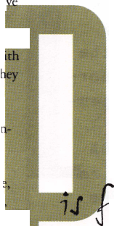

■

Thanks to

on I the orLd

of I new people

our g r o 3 i n

zation.1

being subm

§■ Id a ■

**^id** iom

ms an  
a r tm

members w

progressive organ

p applications a rle

d elect

rospec-li veclie its all L

i ng their

_

rflii ca l ly,

over the  
neighbor-

govcinment^gen-

r a |t e p u re n a s i^J

a ccenkM

d e . You

A

m zaH

|  |  |  |  |  |  |  |  |  |
| --- | --- | --- | --- | --- | --- | --- | --- | --- |
| t | ion |  | has | definite l | y | ent | ered th | e |
| II | inf | 0 | mat | ion age ! " |  |  |  |  |
|  | Bes | ; i | des | the more | s | ;i gni | ficant | ma r- |
| k | e t i | n | g f u | nctions o | f | the | ALOA W | eb |
| S | i t e | f | how | ever ther | e | are | specia | L |
| r | eso | u | rces | which a r | e | a va | i lable | to |
| m | emb | e | r s o | nly. One | 0 | f th | ese fea | t ures |
| i | s t | h | e on | -line, re | a | l ti | me "cha | t" |
| f | eat | u | re w | hich ALOA |  | call | s. |  |
| ll | Loc | kC ha t | | ." The ne | w | i n t | e ra c t i v | e |
| s | oft | w | are | which run | s | t h i | s f ea t u | re is |
| a | pa | c | kage | called " | i | Chat | ." This |  |
| a | r t i | c | L e i | s written |  | to f | ami liar | i ze |
| m | emb | e | r s w | it h this | s | ta te | -of-t he | -art |
| P | rog | r | am a | nd invite |  | lock | smiths |  |
| w | o r L | d | wide | to meet | 0 | ne a | nother | a s |
| w | a s | n | ever | before p | 0 | ssi b | l e. The |  |
| f | i r s | t | par | t of "Loc | kCha t | | ," in t | h i s |

issue, will go over a basic defin­ition of the feature and the dif­ferent types of clients that are used to access LockChat. Next month, we'll go into browser access to LockChat and logging in to the feature. Future articles will deal with other aspects of ALOA's on­line services.

20 | Keynotes

October 1997

*1*

Ic ha t

BY KIN BOWERS, CML

What is iChat?

iChat is a very powerful and fast program that allows real-time “chatting” within the confines of a web page.

It is the leader in web-based chat because of its ease of operation as well as its friendly user interface.

The Java Developer s Journal has called iChat “the most advanced software package available for Website Administrators today.” Even Fortune magazine has recog­nized iChat as a “cool company” that provides innovative and advanced business solutions and connectivity with its software.

Because of its outstanding design, user face and fea­tures, iChat has been adopted by many of the leaders of the Internet industry, including Universal Studios, Pathfinder (the Time, Inc. family of magazines and media), Netscape and Yahoo. All of these corporations are using iChat on their websites for not only visitor interaction, but a way to keep in touch with clients and employees who travel or are based elsewhere.

The new iChat program now represents the best solu­tion to the needs of ALOA because it has many powerful features and a more attractive design than offered by the first version of the ALOA chat. Once the initial “getting familiar” phase passes, users should find that this program is head-and-shoulders above anything else available today. How does iChat work?

iChat operates through your web browser and through the use of a client.

What is a client?

A client is a tool that your browser uses to access the iChat program. It is similar to using a key to open a



door. Without the key, you cannot get in.

Clients are not complicated at all. Most of them take the form of a “plug-in,” or a helper application that your browser needs to access such things as real-time audio or video. It is a small package that downloads to your com­puter and then installs itself into your browser. To use it requires no effort on your part. Whenever the browser encounters a need for the plug-in or client, it automati­cally launches it without missing a beat.

Why do I need one?

You cannot use iChat without one.

What kind of clients are there?

Lets talk about the different kinds of clients that are used to access iChat.

1 **|** J ava

Java is an elegant solution because to utilize it your browser requires no “plug-in” to download. Its already in the browser as part of the browsers’ standard package. However, it should be noted that Java will only work on a 32-bit operating system. What does that mean? If you are running Windows 95 or the Macintosh operating system, you can run Java. If you are running Windows 3-1 or 3.11, you cannot. Java only works on a 32-bit operating system. Java is enabled in the Windows 95 versions of Internet Explorer and Netscape navigator. If you have the ability to run Java, it is the fastest option because it requires no “plug-in” to download.

In the Java client, the commands used in chatting are in a frame located in the far right corner of the screen. Each of these commands can be used except “Ask a ques­tion.” This option is enabled only when an event is occurring which means when a celebrity chats on the Internet. The message passes to a moderator before being passed along to whoever is chatting. For this reason, the “ask a question” function will never be active, unless ALOA wishes to bring a “celebrity” so to speak to par­ticipate in a live chat. There are two icons appearing in the same frame as the “iChat” logo.

The to the left is a “map” option to see other rooms (Presently, there are only two rooms, both of which are unrestricted, so this command will appear to do nothing. As this feature becomes more familiar to members, more rooms will no doubt be added.) There is also an icon for a help file which brings up useful information that can answer nearly any question that a user might have. Reading the help file is strongly suggested, as 99 percent of the potential questions a user might have is right at his or her fingertips.

You can see who else is in the room by checking a list of users logged in to the chat room. This list is located next to the command list. By clicking on a name and then making a right click with your mouse, you will receive a list of options such as “Send a Private Message” and “Who is?”. The “Who is?” feature accesses informa­

tion that user entered when he registered for the LockChat.

**2|Netscape plug-in**

The iChat plug-in for Netscape is a very nice client that provides all of the features the chat has to offer. This plug-in is for users of 16-bit operating systems (Windows 3.1, 3.11) that cannot use Java. It is also for those who want an alternative to Java. Either way, it provides full functionality to the user. You can download it at <http://www.ichat.com/download/index.html>.

The plug-in is about one megabyte in size and will require a moderate amount of time to download, but once installed, chat begins immediately.

**3|ActiveX control**

ActiveX is used by Internet Explorer by default. This means that no matter what selection you have made, Internet Explorer always looks for an ActiveX control if its available. Unlike the Netscape plug-in, the ActiveX control will not work on a 16-bit operating system (Windows 3.1 or 3.11). It only works on a 32-bit operat­ing system (Windows 95, Macintosh). This means that users of Internet Explorer using Windows 3.1 will have to use the HTML client. This client will be discussed later.

The functionality of the ActiveX control is exactly like the Netscape plug-in as discussed earlier.

**41 HTM L client**

This is a poor cousin to the other clients previously dis­cussed. However, a web browser can access this option, This is basically a bare-bones, stripped down version of iChat that allows users to interact with each other, but without any of the features or commands that are avail­able in the aforementioned clients. This should always be the last resort when trying to access iChat.

Next Month: Browser Access to LockChat and Logging In

About the authors: Kim Bowers, CML ([advansee@e-tex.com](mailto:advansee@e-tex.com)) a past ALOA Director, is president of Kim Bowers and Associates and Advanced Security Concepts Marketing (AdvanSec), pro­viding Web Site Design, Internet Services and Consulting

iChat is the Leader in web- based chat because of its ease of

operation as well as i t s

friendly

user

interface.

October 1997

Keynotes

b y

S a I

D u I c a m a r o

C M L

he New 1998 Chrysler 8-Cut System

Chrysler automotive locks have gone through an inter­esting evolution over the years. From the 1930s on, Chrysler locks were mainly pin tumbler. The keyways changed a number of times from the 1930s to the 1950s, but the ignition, door and trunk locks found on Chrysler and Dodge vehicles were of the pin tumbler variety. For a short stretch of time from 1959 to 1967, Chrysler trunks had sidebar locks while the ignition and door locks remained pin tumbler. In 1968, the trunk returned to the pin tumbler design.

Starting in 1969, a span of about 20 years saw consis­tency in keyway and code series. The primary key used the EP code series with the Y152 key (EZ or Curtis key number), and the Y149 secondary key used the ES code series. Chrysler keys had five cut positions and six depths. Although the key blanks and key cutting speci­fications remained consistent in that time period, the locks themselves went through a number of changes. In that length of time, both the door and trunk locks were strictly pin tumbler. Most of the ignition locks were also pin tumbler, but when Chrysler went to a tilt steering column that was basically the same as the one used in GM vehicles, they also went to a sidebar style ignition lock. The sidebar locks were only used in the tilt columns. The ignition locks found in standard steering columns remained pin tumbler. The Chrysler pin tum­blers are shown in figure 1.

The key cutting specifications were the same for both the sidebar and pin tumbler locks. For a Chrysler vehicle equipped with a tilt wheel, the Y152 primary key still used the EP code series and the same (primary) key worked both the ignition and the door locks. The igni­tion locks required a special sidebar tumbler kit, while the door locks used the same type of pin tumblers used in the trunk locks. Chrysler sidebar tumblers are shown in figure 2.

Regardless of being sidebar or pin tumbler, Chrysler auto locks were always matched with the primary key operating the ignition and door locks and the secondary key operating the trunk and glove box locks. Although I had earlier indicated that Chrysler auto locks were either pin tumbler or sidebar, glove box locks were an excep­tion. Glove box locks for as long as I can remember have been disc tumbler locks. I don’t know how far back it would go, but I’d guess that Chrysler glovebox locks of long ago may have had pin tumblers.

Sidebar locks are not as easily impressioned as pin tumbler locks, so impressioning a Chrysler tilt column ignition lock was not usually an ideal option. From the standpoint of fitting keys for the sidebar/ pin tumbler

lock combination, you could still impression the (pin tumbler) door lock or remove the ignition lock from the steering column and read the code number stamped on the body of the sidebar ignition lock.

In 1989, Chrysler introduced a new system that used a seven cut double bitted key, and replaced all the pin tumbler locks with disc tumbler locks. If my memory is correct, the very first locks had all the tumblers loaded from one side of the plug. It was changed shortly there­after so that the tumblers were loaded alternately from the top and bottom of the plug. The odd numbered tumbler positions had all the disc tumblers loaded from one side and the even numbered tumbler positions from the opposite side of the plug.

The new system went into most of the 1990 model year product line. The Y154 double sided key had seven cuts, but no single lock in the car had seven tumblers. Like many of the import cars, Chrysler had one key that could operate all the locks on the car. To limit access, however, a valet key system was used. That allowed a master key to open all the locks, while a valet key would open only the door and ignition.

Photo 1 shows the Y154 (STRATTEC #594145) key blank at the right and the valet key blank (STRATTEC #321566) at the left. Except for the rubber head and the inscribed words “Valet Key,” they are basically the same

CHRYSLER PIN - .020 Depth Change  
1969- 1990

C

l

i QOQflfifl I g g g g g g

0

1

A **BCDEFGH I JK**

A-320169 Retainer

Spring  
Tumbler #1

B- 46772 C-83180 D-83176 E -83177 F-83178

Figure 1

Tumbler #2 Tumbler #3 Tumbler #4

IGNITION

G-83179 Tumbler #5 H-83184 Tumbler #6 I - 320484 Retainer J - 320701 Retainer K-320159 Retainer

DOORS-DECK

CHRYSLER SIDE BAR - .020 Depth Change  
1970 - 1990

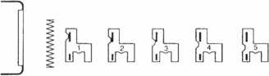

ABC D E FGH

A - 320501 Retainer B - 46648 Spring C-321001 Tumbler #1 D-321002 Tumbler #2

E-321003 Tumbler #3 F- 321004 Tumbler #4 G-321005 Tumbler #5 H- 321006 Tumbler #6

Figure 2

TILT IGNITION

Keynotes

October 1997

key blank. The key has no shoulder but instead is tip stopped. The tumbler posi­tions, however, are referenced bow to tip.

The ignition lock had tumblers in the first six cut positions. The door locks had tum­blers in the first five cut positions. The trunk lock had tumblers in the last five cut posi­tions, while the glove box lock had only three tumblers in the last three cut positions.

The difference between the master key and valet key was not the keyway (which was the same for both) but the lack of the correct tip cut on the valet key. Since the door and igni­tion locks had no tumbler in the seventh cut position, the missing cut would not prevent a valet parking attendant from using the valet key to open the car door or start the car. Since both the glove box and trunk had a tumbler in the seventh position, it seems that a valet key lacking the proper cut depth in the sev­enth position shouldn’t operate those locks. The valet key shouldn’t have fit the other locks, but often it did. Insufficiently tight tolerances allowed a good number of Chrysler cars to have all the locks operate with the valet key. A change was in order.

For 1993 model Chrysler cars, a number of changes took place with the introduction of the Y155 key (STRATTEC #595895) shown in photo 2. The angle on the tip of the key was changed, and the key cuts were shifted closer to the bow of the key. Also changed was the keyway and matching grooves on the key. There were still only seven key cuts on each side, but the less steep angle at the tip end required the repo­sitioning of the cuts. The ignition lock now had tumblers in all seven positions. The door and trunk locks had tumblers in the last five positions, and the glove box lock had tum­blers in the last three positions.

The keyway change in the Y15 5 key was the response to the failure of the earlier valet key system based on the Y154 key. Instead of relying on different key cuts, the master and valet keys were differentiated by the physical keyway. The thicker valet key could only enter the door and ignition locks. A much tighter keyway prevented the valet key (even though the key cuts were identical to the master key) from even entering the glove box and trunk locks. For the Y155 (master) key blank, excessively deep grooves ran the length of the key blade (in the cen­ter) on both sides of the key.

While one problem was solved, another one was created. There was no way that a valet key would operate the glove box and trunk locks. It couldn’t even squeeze into those locks. The new problem was the extremely thin (in the middle) Y155 master key blank. Since that key was used more

often than a valet key, car owners were breaking keys left and right. Almost from the start, its fate was already determined. It had to be replaced.

The 1994 model Chrysler cars saw the introduction of the Y157 (STRATTEC #596504) key. The valet key system was

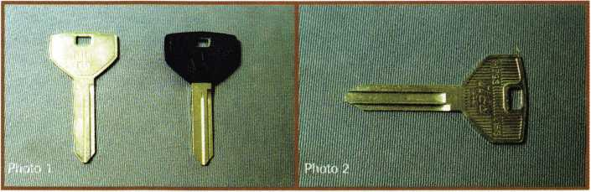

1998 Chrysler Lock & **Key Specifications**



STRATTEC

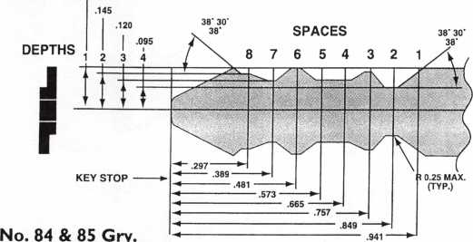

‘M’ series key codes MOO I-M2618 HPC Code Card CXI02

Figure 3

1998 Chrysler Astrattcc

**Tumbler Positions ^**

|  |  |  |  |  |  |  |  |
| --- | --- | --- | --- | --- | --- | --- | --- |
|  |  | All | Models | |  |  |  |
| 1 | 2 | 3 | 4 | 5 | 6 | 7 | 8 |
| Ignition X | X | X | X | X | X | X | X |
| Door | X | X | X | X | X | X | X |
| Deck | X | X | X | X | X | X | X |
| I/P: |  |  |  |  |  |  |  |
| Paddle |  |  |  | R | X | X | X |
| Twist Style (LH,JA,JX) |  |  | R | X | X | X | X |
| Squeeze |  |  |  | X | X | X |  |
| Console/stowage |  |  |  | R | X | X | X |
| Seat Back |  |  |  | R | X | X | X |

Figure 4

October 1997

23

Keynotes

position cut immediately precedes the previ­ous number one position. All the cuts that follow descend one position. The old num­ber one becomes number two. The old num­ber two becomes number three, and the same applies to the remaining five cuts.

The chart in figure 4 shows the new tum­bler arrangements. Only the new style side- bar ignition lock will have tumblers in all eight positions. The door and trunk (deck) locks remain the same as the pre-1998 locks with seven tumblers in each one. The only missing tumbler position in those locks will be the new number one position.

Photo 4 shows sample plugs for earlier disc tumbler style ignition locks. They have only seven tumbler slots, with three tum­blers loading from this side and four loading from the opposite side. Similar views of the

new sidebar ignition plugs are in photo 5. These plugs have eight tumbler slots, with four tumblers loading from both sides. The sidebar itself can be seen on the left side of the plug (for both). A disc tumbler lock and a sidebar lock are compared side by side in photo 6.

Different style Chrysler lock tumblers are compared in photo 7. They are all #4 size tumblers. The tumbler to the left is an origi-

again based on the keyway, but both the valet and master key blanks were sufficiently strong to avoid easy key breakage. It remained a seven cut key, but now the igni­tion, door and trunk locks all had seven tumblers. Only the glove box lock had fewer tumblers. I believe it remained the last three tumbler positions as was the case in earlier years.

Ignition Lock Changes for 1998

A significant change has occurred for 1998 model Chrysler cars. A sidebar lock will now be found on Chrysler ignitions. Besides being of a sidebar design, the new Chrysler ignition lock will have eight tumblers. It appears, however, that the key blank will not change.

In photo 3, a replacement Y157 key blank is at the left and an 8-cut key for the new Chrysler sidebar ignition lock is at the right. A chart illustrating where the addi­tional cut was placed can be seen in figure 3. The cut positions identified as 2 through 8, were previously cut positions 1 through 7 (for the pre-1998 seven cut key). Because the key is tip gaged and the tumbler positions are listed bow to tip, the new number one

24

***Keynotes***

October 1997

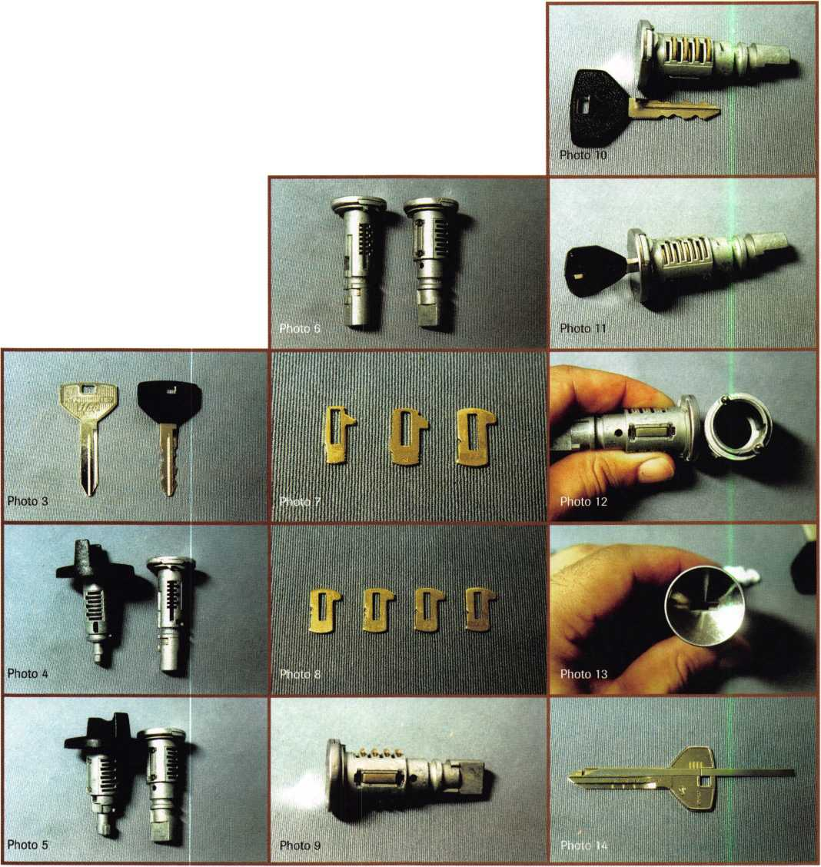

nal style disc tumbler. A more current (and larger) version disc tum­bler is in the middle. Finally, at the right is a sidebar tumbler. The small slot in the middle (left side of tumbler) interacts with the side- bar. The sidebar tumbler strongly resembles an ordinary disc tumbler, but (as you will see later) the sidebar tumbler functions in a very dif­ferent way. One each of the four different size sidebar tumblers are shown in photo 8. The sizes left to right are: #1, #2, #3 and #4.

Photo 9 shows the sidebar lock plug with all eight tumblers loaded. If it wasn’t for the obvious sidebar, it might appear to be a disc tumbler lock. With the key just below the plug, in photo 10, you can see how the key cuts and tumbler positions line up. In photo 11 with the proper operating key inserted, the sidebar pulls inward and unlocks. Notice that the tumblers are not all even with the outside surface of the plug. That is just one clue that (unlike a disc tumbler lock) the outside surfaces of the tumblers do not act in any way to lock up the cylinder. Only the sidebar secures the lock.

The other clue that the outside surfaces of the tumblers don’t lock up the cylinder can be found in photo 12. Look inside the circular cavity of the lock shell, just to the right of the lock plug. Notice that in the inside circumference of the shell that there is only a narrow slot for the side bar. There is absolutely no place for the outside sur­faces of the tumblers to extend into the shell to lock or secure the plug. In fact, that inside surface will act to completely squeeze the tumblers far enough into the plug so that the outside surfaces of the tumblers are completely contained within the plug. The inside sur­face of the shell pretty much does what my thumb and index finger are doing to the tumblers in this photo.

Sight reading the positions of the tumblers through the keyway will not be effective with this lock. Photo 13 shows (in a keyway view) that all the tumblers are positioned the same, regardless of the tumbler size. This also means that a disc tumbler reading tool like an EEZ Reader would not work to either read or decode the tum­blers in the ignition lock.

A Y157 EEZ Reader decoding tool is shown in photo 14. Although this tool will not be effective on the new sidebar ignition lock itself, the tool can still be used to decode a door or trunk lock. Since either lock has seven tumblers, only one tumbler identity will be missing and preventing you from operating the ignition lock. By progressing the missing tumbler position one depth at a time, it should require little additional effort to generate a fully functioning key to operate all the locks in a newer Chrysler automobile.

STRATTEC manufactures Chrysler auto locks and makes service kits to code both the disc tumbler and sidebar locks. STRATTEC products should be available at most any reputable locksmith supply company.

1About the author. Sal Dulcamaro, CML, has been in the lock-

smith business for over 22 years. He is the president of All Pro Security, Inc. in  
Clintown Township. MI, and has been an ALOA member for 15 years. A  
past president of the Locksmith Security Association of Michigan. Sal currently  
serves as editor of the association’s newsletter. Additionally, he was recently  
awarded his second straight Keynotes, Author of the YeaP’ award.

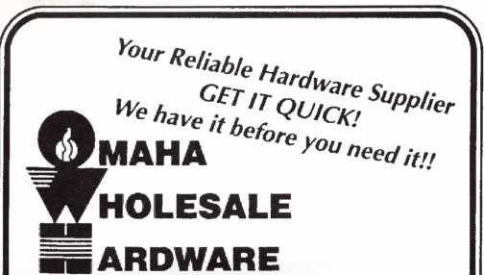

* LCN
* Von Duprin
* ILCO
* Sargent & Greenleaf

(Arm-A-Door)

* Roton
* Detex
* Simplex
* Norton
* Stanley
* Rixson
* Glynn-Johnson
* Adams Rite
* Jackson
* Master Padlock
* Folger Adam
* Locknetics
* Rutherford **(EFF-EFF)**
* Telkee

To Order Call Toll Free

Phone: 800-238-4566 • Fax: 800-538-4566



Call Or Write for our FREE Full Line Catalog

Omaha Wholesale Hardware

P.Q. Box 3628 • Omaha, Nebraska 68103



Reader Service #12

**Who Says There’s No Such Thing as**

Easy Money?

***1-BOO-UNLOCKS***.

Nationwide Automated Dispatch Network

Introducing f-BOO-UNLOCKS. , the nation's first and only network of quality assured lockout service providers and automated dispatch service. Here's how it works.

This advanced AT&T/ULI technology gives you an awesome advantage over your competition. Any lockout in your exclusive and protected territory is automatically routed to you faster than greased lightning. The 1-800- UNLOCKS automated dispatch service turns your phone into a 24 hour cash machine. Its that simple. You get the benefit of exclusive use of a powerful and extremely memorable toll free telephone number, co-op advertising for your local market, and professionally produced yellow page, radio, television and direct mail advertisements that are certain to build and grow your business dramatically.

Licensed territories are going fast. And once they are gone, they're gone. Call immediately to receive your free application to become a quality 1-800-UNLOCKS service provider

Call NOW to reserve your territory before your competitor does! 1-888-865-6257, 24 hours.

Reader Service #13

October 1997

Keynotes



The question continually arises in the industry about the value of original equipment (OE) parts compared to less expensive non-original copy parts. This question cannot be answered in one or two sentences, since there are places in the market for both original and non-original parts. Many factors need to be considered far beyond the price difference, especially with regard to automotive lock parts. Everybody likes the idea of getting a lower price. But is a lower price always to your benefit? Sometimes it is, and sometimes it isn't. More important than price is value for money, which in addition to price must also be measured by considering quality, availability and width of the product range. Value is more important than ever in today's enviro- ment of automotive lock service. In this article, I will examine the various ingredients of value for money.

**or**

**not**

Width of the product out of range

Not too many years ago, it was much easier to buy automotive lock service parts than it is today. After all, only two ignition locks were needed to service most General Motors vehicles beginning in 1969 and used on millions of vehicles for over 20 years there­after. On the import side, only four igini- tion lock cylinders were needed to service millions of Datsun/Nissan vehicles from 1970 through the early 1980s. Those days are gone. Today’s locksmith needs access to more and more different parts every year to be able to service all of the different makes and models of vehicles on the road. There is no way that these requirements can be ful­filled by copies of original equipment prod­ucts.

There are over 2,000 different part num­bers for Asian, European, and American Ford vehicles listed in the 1998 ASP catalog that is currently being printed. A similar range of OE parts for General Motors, Chrysler, Ford and other brands is offered by STRATTEC. Millions of dollars of tooling and dies would be required to copy all of the products required in today’s market. Many of the part numbers sell only a few pieces each year, copying all of these items would simply not be practical. Since the original equipment factories are already making the parts available to the car manu­facturers, the same parts can usually be made available to locksmiths, regardless of popularity. This becomes increasingly important with the increase in the range of different parts required to service the many variations of cars on the road today.

For example there are 13 different Toyota models offered in the North American mar­ket in 1997. There are 14 different iginition locks required to service all of these models. Of these 14 different iginition locks, none were used before 1991. Six were first used in 1993, one in 1994, three in 1995, and one



Keynotes

October 1997

in 1997. While there are millions of Toyotas on the road using these 14 different locks, the quantity of cars using each different lock is not so large. Even the popular Toyota Corolla range uses four different iginition lock variations: sedan with and without tilt steering, and station wagon with and with­out tilt steering. So because of this none of the 14 variations would generate enough sales volume to justify copying. Could that be what Toyota had in mind?

Product popularity is nothing more than a roll of the dice. For example the service parts for a Toyota Corolla are more popular than the parts for a Toyota Supra. On any day the chances are better that you will be asked to service a Corolla than a Supra, sim­ply because there are more Corollas on the road. But it is equally important for us to supply the service parts for the Toyota Supra as for the Toyota Corolla. A customer with a Supra is just important as customer with a Corolla. A professional locksmith should be prepared to service any car, not just the pop­ular models.

Availability

Locksmiths should be thankful for the wide range of original lock service parts available through the STRATTEC distribution sys­tem. No other original equipment car lock manufacturer in the world has supported the locksmith industry over the years to the extent of STRATTEC. Some original equip­ment car lock manufacturers are very much opposed to service parts being sold by any­one other than the offical car dealer system. These companies often do whatever they can to hinder rather than help the locksmith. A good example of this is that for many years it was against the law in Germany for a locksmith to even a duplicate a 2-track or 4- track style car key such as used on Mercedes, BMW and others. American locksmiths often don’t realize how lucky

they have been over the years.

While ASP buys lock service parts from many different original car lock manufactur­ers around the world, there is very little understanding of theAmerican locksmiths’ needs by these factories. One exception is ASPs partnership with Hurd Corporation. It was not many years ago that Hurd was com­pletely removed from the locksmith market. But the partnership between ASP and Hurd has been very valuable for both companies. Hurd’s production capabilities, and use of Ford original specifications and tooling are combined with ASPs customer base, mar­keting, warehousing, and quick shipping to bring a more complete Ford product range to the locksmith.

Of course the availability of a complete range of service parts is meaningless unless the distributors can provide quick delivery to the locksmith. And the ever increasing range of products required to service all of the vehicles in use today puts additional pressure on the distributors. Distributors must now invest more than ever before in inventory value, shelf space and adminstra- tive labor in order to properly sell a complete range of automotive lock service parts.

Unless the distributors can recieve sufficient return on these investments, there is no incentive to provide the level of service that the locksmiths need.

ASP is now beginning its 18th year in business. Through the years have had several distributors who were highly specialized in supplying the full-range of automotive lock service parts and supplies. Some of these dis­tributors have been highly successful. But others failed, usually for the same reason.

The companies that failed usually offered their best selling items at huge discounts, and could not generate enough revenue from the slower selling items to stay in business. Over the years there have also been some companies who have thought they could

challenge ASPs market position by import­ing a few popular locks and selling them at low prices. These ventures have never been successful. They most likely failed for the same reasons as the distributors. The bottom line is that a product line must be profitable for a company to have the incentive to offer it, or as in the case of some companies, to stay in business.

Quality

Although a copy part may look identical to an original equipment part, there could be hidden differences between the parts. If the copy part is manufactured with inferior quality materials it is not an equal product. The production cost of a lock can be lowered by up to 50% by using less expenisve lower quality zinc diecast material of a grade not approved by the car manufacturers. While the original equipment products must use the car manufacturer’s specifications, no such restriction is placed upon copy products.

Also there could be design changes within a production run that would automatically be carried over to original equipment products but would not necessarily be picked up in the copy products.

Of course this does not mean that all copy locks are bad. But don’t forget that risks are involved. A good rule of thumb is to consid­er the price. If the part is too much cheaper than an exact competitive product, watch out. Unless a company is selling at unrealis­tically low prices for the sole purpose of increasing market share, some of the value must be left out. If a low price sounds too good to be true, it probably is.

Back to the issue of price

In a pure price comparison, copy parts will always win. It does not matter how much original parts cost, copy parts will always be cheaper. Since the locksmith industry is very fortunate to have good availability of origi­

nal equipment car lock service parts, the only reason to buy copy parts is for the lower price. But anyone who believes that the pub­lic buys only on price needs to read on.

The ASP philosopy has always been to use the car dealer’s prices as the benchmark for evaluating the value of our parts and ser­vices. Although we do not have any statis­tics, we estimate that the car dealers are sell­ing between 80 percent and 85 percent of the replacement locks used in market. Futhermore, we believe that this percentage is even higher for many of the import brands of car brands in ASP range. This means that as a locksmith, your main competition in the car lock servicing business is the car dealer, not other locksmiths.

Car dealers have always had the reputa­tion of being the most expensive place to get your car serviced in both parts and labor cost. So why are they getting such a large percentage of the business? First there is no question that the dealer will have access to the correct parts required to do the job. Second the dealers use only original equip­ment parts often perceived by the public to be better quality than copy parts. Finally, the dealer’s service personnel are perceived to have a greater level techincal knowledge about the brands of cars they sell and service. These factors must be more important to most car owners than price. People want the job done right at a fair price, not necessarily the lowest price.

When it comes to transmissions, fuel injection, on-board computers, etc, the facto­ry-trained mechanics at the car dealer may have an advantage over independent mechanics. But professsional locksmiths are more highly skilled at car lock servicing than practically any factory trained general auto mechanic. Locksmiths are also often able to complete a job more quickly than the car dealer can. With these advantages over the car dealer, why dilute your advantage by

October 1997

***Keynotes*** | 27

using anything less than origi-  
nal equipment quality lock ser-  
vice parts?

A lower price that helps you

make more profit is to your benefit. A lower  
price that devalues a product or service is  
damaging to the industry. Let s say that you  
been paying $10 for a particular product  
that you can sell for $20. The math is pretty  
simple, you can make $10 per unit. But  
what if your cost is suddenly lowered to $5  
each. On the surface that sounds like a pretty  
good deal, and it would be if you were the  
only one getting the lower price.But if the  
lower cost was available to everyone, it is  
highly doubtful that competitive forces  
would allow you to continue to sell the  
product for $20. Itwould be more likely that  
the market price of the item would be deval-  
ued to around $10, which means that you  
would make only $5 per unit. This means  
that you would have to sell twice the volume  
to make the same profit. It is unlikely that  
would happen with any service part, since  
the demand forservice parts is completely  
unrelated to the price of the part. This an  
example where a lower price devalues a  
product and is damaging to the industry.

What does this all mean?

Are you satisfied with your availability of automotive lock service parts? If you think things could be better, maybe you should examine your buying habits.

If quick availability of a complete range of automotive lock parts from your local dis­tributor is important to your business, then you must support that distributor as your primary source for these items. Like it or not, the only thing that will give your local distributor the incentive to properly stock the automotive products is if it can be prof­itable and offer a reasonable return on invest­ment. If your preferred distributor is not up to par on automotive products, tell your rep­resentative that you want buy your automo­tive products from his company and what you need him to do in order to make that happen.

How can you help your distributor con­tinue to be responsive to your needs? The best way is to give him your full support and make it worthwhile for him to have the



28

October 1997

items available for you. A distributor needs the profit from the sales of the popular items and give your primary distributor needs the profit to help support his stock of slower moving items. If you intend to shop around for the best price on the popular items and give your primary distributor only the crumbs, don’t expect this situation to last very long. Unless the distributor sees a prod­uct range generating a profit and a reason­able return on investment, he certainly won’t be very interested in keeping it around.

How does this relate back to the original question of OE parts compared to lower priced copy parts? It all goes back to prof­itability and incentive. A distributor who is committed to proper representation of auto­motive lock service parts must support the original equipment parts and lower priced copy parts. There is little incentive for dis­tributors to have a duplicate stock of original equipment parts and lower priced copy parts. In fact, it is a disincentive for a dis­tributor to substitute sales of top quality original equipment parts with lower priced copy parts.

Automotive lock service parts are not price sensitive items. Unlike impulse con­sumer items where a special price might generate more sales from people who would otherwise not buy the product, service parts are ultimately sold to the consumer only as they are needed. People do not get the impluse to replace a lock on their car when the original lock is working just fine.

What is ASP doing to help?

ASP is developing a new high speed delivery program to give every authorized ASP dis­tributor instant access to every part number in the ASP range. Distributors will still be expected to keep in stock at least the approx­imately 150 most popular A rated items, or the approximately 500 different A and B rated items, depending upon the stocking program chosen by each distributor. But with now over 2,000 different part numbers in our range, most of these sell at the rate of only a few pieces a year nationwide. Since it is not practical for most distributors to stock a large number of slowing moving items, ASP is making these items available for immediate shipment, either directly to the

locksmith or to the distributor’s warehouse, whichever is better for the locksmith. Items will be delivered in three days or less at no extra charge. Guaranteed two-day or next day delivery options are available at fixed extra charges so there are no surprises for anyone.

Choose Value

Your buying habits for automotive lock ser­vice parts should be a business decision con­sidering value added that extends far beyond price. You can choose immediate savings by shopping around for the best prices, insist­ing on lower priced copy parts and trying to beat your distributor out of every last penny. But if you choose this route you must realize that in the long term this may be more expensive to you in the form of a lower ser­vice level. And I believe also that you will find that any savings you receive will be much smaller than you expect. And those savings could be more than eaten up by los­ing only one or two jobs because you could not get the correct parts quickly.

There is a definite value for your money achieved by supporting the companies who provide a complete range of service parts at your fingertips. Your support of both OE manufacturers and the distributors who sup­port the OE manufacturers gives those com­panies the incentives they need to provide you with an uninterrupted supply of the parts you need. Your support also gives those companies the incentive to continue to invest in improving their service to you. If you don’t believe this has any value, think about how much more difficult your work would be without a wide range of service parts.

I believe that it is a much smarter busi­ness decision to fully support your preferred distributor in order to guarantee the level of service and availability of parts that you need for your business to be successful. Remember there is no free lunch, and as the old oil filter commerical says, “you can pay now or pay later.” I would prefer to pay now, because you never know what the cost will be if you wait until later.

About the Author: R. A. Logan is president of ASP, Inc. and A.L.O.A. member no. 4735.

Keynotes

CLICKER

mj3S

DISEASE  
id Other Automotive

dies

by A I Davenport CML

**Clicker Disease.**

Is that a new fungus or bacteria? Nope, nothing that needs antibiotics for treatment. With the advent of remote locking and unlocking devices (we call them “clickers” around here), door locks on some vehicles are virtually, if not totally, unused. When an emergency (such as a dead bat­tery) pops up, the locks have become so corroded, or the grease in them so hardened, that they will not work. Many times casual lubrication will not free them up, so the panels and locks must be pulled, disassembled, and cleaned. I’ve had several customers scream “bloody murder” when quoted a price for their continual use of their clickers.

Trunk Release syndrome is a problem closely related to this.

**Trunk Release Syndrome.**

The result is the same—a corroded lock that will not work with a key—with a few extra wrinkles.

The trunk release may be mechanical or electro­mechanical. With the electromechanical, replacing a battery or a fuse will often get you back into the trunk for cleaning of the mechanical lock. With the cable release systems, however, a breakdown often leaves you with a headscratcher. You have to come up with a bypass method or, worse case, destroy the lock. This type of situation forces locksmiths to be diplomats. How do you nicely tell a customer, “You screwed up!”?

**Solenoid Sickness.**

Some of the more fun oddball problems deal with solenoids. These wonderful little doodads have a mind of their own, especially when below par engi­neering meets erratic electrical supply. The result is not funny to people who have been locked out of or even locked in their vehicles—such as Toyotas, BMWs and others. The most annoying of these problems to many customers is having the vehicle decide to lock itself because of a slammed door, a glitch in the computerized system, or for no appar­ent reason. Chrysler even had a problem with some vans where the solenoids would continually lock

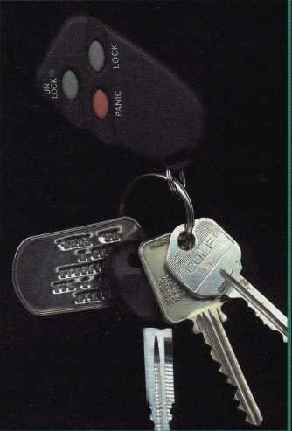

and unlock the vehicle as it  
was parked or even as it  
was driven down the road.

It would be funny if it  
were not so annoying.

The next illness is the  
“twist er ears if ya wan’ ‘er  
to go” malady, otherwise  
known as Earitis.

Some of Ford’s 10 cut  
ignitions have ears that,

after some use, spin round and round on the end of  
the cylinder plug. The lock will still work as long  
as the ears are lined up with the keyway to put the  
key in or take it out. I have tried many solutions to  
fix this, but the only lasting fix seems to be to  
replace the cylinder with a new lock. Some cus-  
tomers balk at the price, and I guess they get used  
to straightening the ears every time they put in the  
• key.

**Mad Car Disease.**

And finally, as if we “Lock Doctors” didn’t have enough fun and games with some of the aforemen­tioned symptoms, there comes the car that you have to sneak up on to open. Opened a Lexus yet? Yes, you have to sneak up on these suckers and be very quick when you do open it. This nasty little car relocks itself in 0.3 seconds. If you do not pull up on the handle within that period, you have to use your tool again to unlock the car. It’s similar to trying to feed an infant with the child spitting it right back out.

Locksmithing has become more fun over the years with the advent of such technology. Kind of makes you wonder what new strains they’ll have for us in the future!

*About the author: Al Davenport, CML, #12319 has been in the locksmithing business for 16 years and has been a contributing writer for* Keynotes *since 1992. He has his own business in Godfrey, III., where he resides with his “lock nurse ’ wife,*

*Linda.*

e 1998 Auto Lockout Outlook

Probing around blindly in a  
new car cavity with a Slim  
Jim “until you hook onto  
something” is a very danger-  
ous thing to do.

Though the process may  
still get some cars  
unlocked, the “unlocker”  
could be in for a very  
expensive liability lesson  
when they hit an unin-  
tended target.

SRS, SIPS, ITS and LEPS

For the last decade or so,  
the vehicle manufacturers  
have been on the fast track  
related to technology.  
Supplemental Restraint  
Systems (SRS) first  
appeared as steering  
wheel-mounted airbags  
and eventually spread to  
the passenger side airbags  
now found on most vehicle

as standard equipment.

First introduced by Volvo in 1995, the  
idea of the Side Impact Protection System  
(SIPS) is being expanded to new levels.

In 1998, the BMW 7-Series SRS and  
SIPS is joined by the Lower Extremity  
Protection System (LEPS) and Inflatable  
Tubular Structures (ITS). All of these gov-

ernment-mandated devices are meant to  
help protect us from each other.

Side impact airbags or SIPS do just what the name implies, and ITS units are smaller, tube-shaped airbags positioned in the upper framework above the door itself. The general idea is to protect your head in a collision. Activation occurs in conjunction with the SIPS but the bags deflate very slowly. And just so your legs don’t feel snubbed, Lower Extremity Protection (LEP) is being researched to produce airbags that spring from the lower dash area. Don’t laugh, prototypes are already in testing in some European vehicles.

by Tom Gillespie, C M L

Coming Soon Although the current list of vehicles with SIPS (see sidebar) is confined to luxury and exotic vehicles, that’s all about to change. In the 1998 model year, we will see SIPS available (optional for some) on such familiar cars such as Toyota Corolla/Chevy Prizm, various Ford models and other more common “every­day” cars.

The things you find inside a car door cavity today are vastly different than in years past. Some components are intended to prevent the use of auto opening tools. These and other parts can easily be disconnected or damaged by an errant car opening tool during the opening proce­dure. The cost of repairing or replacing these items can be extreme.

Other Components In addition to airbags, a few of the things you could encounter with your car opening tool are: Fiber-Optic Data Cables, Fully Shielded Door Latch Units, Lock Linkage Rod Covers, Automatic Relock Systems, Sensors, Covered Bell Cranks, Armored Linkage Cables, Computer Circuits, Electric Lock Solenoids, and various Wiring and Connectors.

The chances of doing damage increases every year. As you know, there are various costs associated with doing damage. This results in a situation that can spell disaster for the uninformed lockout technician.

Faced with the prospects of increased difficulty and liability on a car opening, you need a reliable source to go to for the technical information and specialty tools to get the job done right, on your first attempt. Unless you know exactly where to bypass a system, you could spend a lot of time and money in a vain and frustrating attempt to unlock a car. Remember, it’s supposed to be a profitable part of your business!

Inspection Lights Why do you need a light? In addi­tion to seeing what to go for, you can see what to stay away from with a professional car opening inspection light. PRO-LOK offers two distinctly different types of probe lights. The HardBody lights are machined from high grade aluminum and finished in a durable gloss black powder coat. These lights feature a unique “switchless” design.

When it comes to blinding brightness, there is no comparison to the halogen bulb on the Super Probe, this

Keynotes

October 1997

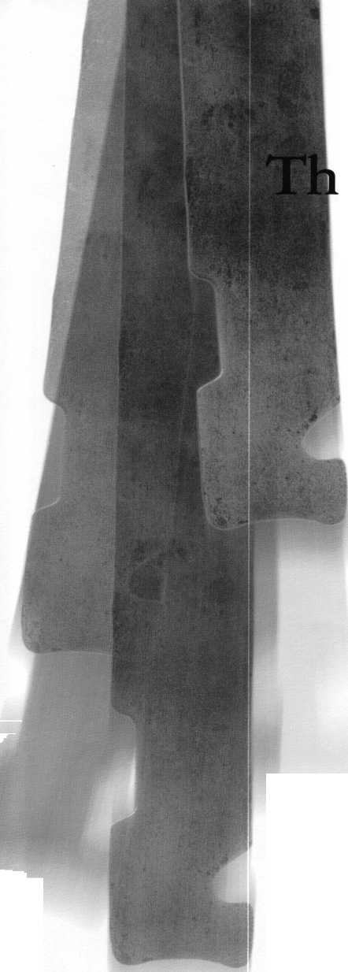

light will give you unparalleled visibility inside a car door, even in the sunlight.

**Reference Manuals** Professional auto opening reference manuals are another important item that should be part of your total tool package. Unless you already know it all, they’re full of valuable information to allow you to do the job professionally.

The five locksmiths on PRO-LOK’s staff combine their knowledge and experience to research the detailed information in the pro­fessional auto entry manuals and annual updates. Important technical details change constantly, so its vital to be able to rely on the specific details that apply directly to the vehicle you are called to open.

**Details, Details** The more specific informa­tion on each vehicle that you have at your fin­gertips, the sooner your job will be completed.

Many locksmiths depend on these car opening books because each page provides: Vehicle ID Color Photo, Picking Direction, Linkage Type, Tool Part Number, Tool Illustration, Wedge and Light Placement, Specific Opening Details, Opening Measurements, Tool Position Color Photo, Door Cavity Color Photo and Alternate Opening Methods.

Having the lock type, linkage style and picking direction at hand gives you what you need to accomplish the job quickly. An

alternate method of entry will give you a dif­ferent approach to use if you don’t have the suggested tool with you at the time.

**Extra Information** In addition to actually getting the car open, many of the “simple” car opening jobs end up requiring you to fit a key. Code series, code cutting information, key blank cross references, replacement lock num­bers, and other vital facts are needed on these occasions and are included in the manuals.

Having these details appear on the same page as the vehicle opening information makes your job easier. Each page of the car opening book also provides: Code Location on the Car, Code Series of each Model, Reed Code Book Section and Page Number Reference, 1200CM Code Card Number, Auto Security Products or STRATTEC Replacement Lock Numbers, and Key Blank Numbers, for STRATTEC, Ilco, Ilco EZ, Silca, Jet and Curtis.

**In Living Color** This is the only car opening book on the market that presents the pletho­ra of accurately researched and easy to use information in full color! The biggest benefit is that you see things as they appear.

The realistic appearance of these color photos allows you to instantly lock in on the information you need; vehicle identification, tool positioning, door cavity structure, link­age component placement, tool usage and

system attack points are readily visible and understandable to you.

Professional car opening books are valu­able research tools full of helpful informa­tion. These dynamic books have evolved into the locksmith’s industry’s favorite resource for dependable lockout information.

**Tool Time** The standard of quality that you require for your tools should be high. Look for: wire tools that are formed from oil-tem­pered steel rod, double heat-treated and then plated with a high-gloss zinc finish; burr-free stainless steel flat tools; durable heavy duty cloth pouches; and unique wedge designs. These combine smoothly with the high intensity inspection probes to give you the professional quality tools you need to get the job done.

The over 100 years of locksmith experi­ence of the owners and technical staff of PRO-LOK results in a company to offer a one-stop source for your auto opening needs.

For more information, simply call pro-lok at 714-633-0681 for a current catalog and a list of national, regional, and local locksmith distributors.

About the author: Tom Gillespie, CML has spent ***28*** years in the locksmithing industry and is the marketing manager for PRO-LOK.

SIPS = Side Impact Airbags

One of the biggest changes to car doors this year is the growing use of the Side Impact Protection System or SIPS. Commonly known as side-impact airbags, there is a variety of system designs and types already on the market. Some manufacturers put the side airbag in the door cavity while others put it in the seat frame, with sensors in the door cavity, seat trim panel or door pillar area. So far it’s not known if it’s possible to actually deploy an airbag or trigger a sensor by hitting it with a lockout tool. Be very aware that as the model year continues, more cars will be fitted with these devices. Always follow specific unicoking details and directions. Here is a list of cars with SIPS as of March 1997

|  |  |  |  |  |
| --- | --- | --- | --- | --- |
| Make | Model |  |  |  |
| Audi A8 | 1997 | Front/Rear | Seat Frame | Door Cavity |
| BMW 5Series | 1996+ | Front (opt.) | Door Cavity | Door Cavity |
| BMW 7 Series | 1997 | Front/Rear | Door Cavity | Door Cavity |
| Cadillac Catera | 1997 | Front Only | Door Cavity | Door Cavity |
| Cadillac Concours | 1997 | Front Only | Door Cavity | Door Cavity |
| Cadillac Deville | 1997 | Front Only | Door Cavity | Door Cavity |
| Lexus LS400 | 1997 | . Front Only | Seat Frame | Lower DoorPillar |
| Mercedes E-Class | 1997 | Front Only | Seat Frame | Door Cavity |
| Mercedes S-Class | 1997 | Front Only | Seat Frame | Door Cavity |
| Mercedes SL Class | 1997 | Front Only | Seat Frame | Door Cavity |
| Mercedes SLK Class | 1997 | Front Only | Seat Frame | Door Cavity |
| Volvo 850 | 1995+ | Front Only | Seat Frame | Lower Seat Frame |
| Volvo 960 | 1996+ | Front Only | Seat Frame | Fower Seat Frame |

Automotive Lock Tools and Tips

ver the years, automotive lock servicing has become almost a special­ized subcategory of locksmithing. These days, to provide full auto lock service, you need to be an auto mechanic, electronics technician and a skilled locksmith. Not only are skills and knowledge required, but you have to lay out a pretty good investment in equipment and supplies. I remember barely more than 10 years ago that if someone called about a problem with a GM ignition lock, I could just about go out to the job with two differ­ent ignition locks (with a total wholesale cost of less than $15) and not worry about asking what model or year the vehicle was.

I don’t know how many different GM ignition locks are used now, but the cost of each ranges from pretty cheap to very expensive. Unless you special­ize in auto lock work, it is hard to justify an invest­ment in all the different tools and equipment, not to mention the even greater investment in key blanks, locks and parts. I know many locksmiths who have gotten out of auto lock work entirely, and **by Ss\ Dulcamara, CML** others who have dropped everything else to special­

ize in auto lock work alone. There is a middle ground that lies between not touching auto locks at all and being a full service auto lock shop. That middle ground is fairly wide, depending on how deeply you want to stay in auto lock work (without being able to do it all). The areas of auto lock work that you don’t do, you can always refer to your fel­low locksmith that has decided to provide full ser­vice. After all, he or she could use a bit of that extra referral work to pay for all that expensive equip­ment and supplies that you didn’t want to buy.



***Keynotes***

October 1997

This article is by no means a treatise on the subject of auto locksmithing. Such a work would take volumes and volumes. Instead, I will try to cover a variety of informa­tion that can help you do a lot of auto lock work without an overly huge investment of money.

Lock Repair and Servicing

For locksmiths who would want to continue in auto lock work but want to get out of the more expensive and lia­bility prone (but potentially more profitable) areas of auto lock work, major repair and service is often the first area of work to go. The introduction of air bags (in the steering column and now in the door panels) opens a locksmith to a much greater liability risk when servicing locks in the doors or steering column. Even if you are one of the locksmiths who still removes and reinstalls air bags (in order to get to the locks), you had better make sure your liability insurance coverage is in order. We are dealing with some serious life safety (and legal liability) concerns if an air bag fails and you are considered responsible.

Not all steering columns with air bags are off limits to the locksmith who is steering clear of air bag related service. Quite a number of cars have locks that are ser­viceable and removable without having to touch the air bag. The introduction of a variety of modular lock units allows lock removal without air bag removal.

Other than liability, the other reason many locksmiths will reduce their involvement in major repair and service is high inventory costs. Not only are many auto locks and parts fairly expensive on an individual basis, but the sheer numbers of locks and assorted servicing parts to cover the endless models and brands of cars is absolutely staggering. If you have customers who will allow you time to order the parts you need to do a job, you can avoid spending all your available cash on potentially slow moving stock that will collect dust on your shelves.

There is a potential up side to reducing your involve­ment in auto lock work. I mentioned earlier that certain areas of auto lock work are more expensive to get into and have potentially greater liability. Because of that, they are usually the highest costing services that a cus­tomer will have to buy. That makes them a considerable profit source for the locksmiths who provide the services. Many auto locksmiths do auto lock service exclusively. If you are not inclined to go after the major auto lock work, you could do yourself a world of good by contact­ing the locksmith who does auto lock work only, and set up a referral arrangement. If you send him/her the auto

jobs, he/she will send the  
(also profitable) access control  
or other security work to you.

Lock Decoding and Code  
Work

Lock decoding is accom-  
plished in a variety of ways  
depending on the car and  
type of lock with which you  
are dealing. Availability of  
codes will always be a major  
consideration when deciding  
how to go about making a  
key.

Let’s review codes.

Automotive locksmithing  
probably represents most of  
the work that we locksmiths  
do with codes. To do code  
work, you must have a reli-  
able source for the common  
(and sometimes uncommon)  
lock codes. They could be  
printed codes or even codes  
on computer disk. If you  
don’t already own them, you  
could be looking at a good  
sized investment. Depending  
on how extensive you want  
your codes to be (and whether  
they are printed or computer-  
ized), you could be looking at  
a cost of a couple of hundred  
dollars to over a thousand

dollars. It may seem expensive, but if you do a reason-  
able amount of code work, those jobs should pay for the  
codes in a relatively short time.

You also need code cutting equipment. If you have a motorized code machine like the HPC or the Framon (or computerized machines), you are able to cut keys by code. Auto code work is a special case, though, and mobility of your code cutting equipment could be important. In that case, you may want to consider one of the punch (or clipper) type code machines.

Once you have the code books (or programs) and code machine, you have to find out the key code. There are a number of ways to get a key code for a customer’s car locks. The easiest way is if the customer bought the car

***Unless you specialize in auto lock work, it is hard to justify an investment in all the different tools and equipment, not to mention the even greater investment in key blanks, locks and parts.***

October 1997 Keynotes

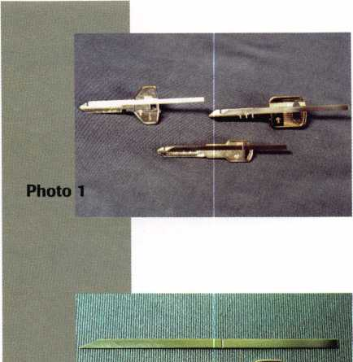

new and saved the  
code tags. Another  
option for a cus-  
tomer who has lost  
the code numbers (or  
never had them), is  
to contact the new  
car dealer who sold  
the car originally  
and get the codes  
from the dealer.  
Depending on how  
old the car is, the  
dealer may or may  
not still have the

codes on file. Even when the codes are available from the  
dealer, they are not always correct. Some of the road ser-  
vice programs (that auto companies include with a new  
car) will also retain key code information and reference it  
by the V.I.N. Toll free numbers are available to contact  
many of the road service companies.

Another possible source for code numbers is the car locks themselves. In recent years, fewer and fewer car companies have put code numbers on the locks. If you run into older cars, though, there will be a greater chance of finding a code number on a lock. Many auto lock service books indicate the cars that have code num­bers on locks, and which locks on the car that have code numbers on them.

Decoding Car Locks Without Code Numbers

There are two very general categories of car lock decod­ing when you don’t have a code number. They are, very broadly, decoding a lock after physically removing it from the car, and decoding a lock while it is still attached to the car. In each of these two categories, there are numerous decoding techniques, so I won’t go into all of them. Instead, I will explain a variety of ways to fit keys to car locks. Many of the techniques can be used whether or not the lock is still connected to the car. Some techniques will require the lock to be removed.

Special Techniques for Disc Tumbler Locks

As more and more car locks are of the disc tumbler vari­ety, locksmiths can take advantage of certain lock decod­ing methods that work with disc tumbler locks. One method for decoding a disc tumbler lock is called sight reading. A standard disc tumbler can be visually identi­fied in the keyway by how high or low it is positioned. The further down in the keyway that the tumbler goes, the deeper the cut is required to operate the tumbler. Sight reading takes a great deal of practice, plus good

eyesight and the ability to judge position looking into a keyway. There is a much easier alternative to sight read­ing, that uses the same basic principles (in regards to disc tumbler positioning) with much less skill required. Photo 1 shows three different examples of tools called EEZ Readers, available from H. E. Mitchell Co. These particular tools are for the Chrysler Y157 keyway, Ford 8-cut and new GM double sided key (for GM cars that have disc tumbler door locks). This is just a small sam­pling. They make many other ones, including EEZ Readers for import car locks.

Photo 2 shows a close up of the tool for the Chrysler Y157 keyway. The EEZ Reader is made up of two parts. The modified key blank is called the key tool, and the narrow spring steel part is called the slide tool. The slide tool fits inside the milled cutout of the key tool. The notched cut at the tip end of the key tool traps and iso­lates individual disc tumblers. The notch is deep enough to allow any size disc tumbler to drop down as far as it normally sits in the keyway. The tapered end of the slide tool slides under the isolated disc tumbler to feel how far down it is. That position is revealed by the etched mark on the slide tool lining up with one of the four indicator marks on the bow of the key. The slide also works to dis­engage the trapped disc tumbler for either decoding another tumbler or to remove the EEZ Reader from the lock.

The EEZ Reader is incredibly easy to use and has numerous advantages over standard sight reading. One important advantage is that you can use this method even if you have less than impressive eyesight. You don’t have to try to look deep into the keyway or manipulate tumblers in the front to get a clear view of tumblers fur­ther back in the lock. The indicator marks on the bow of the key are very easy to see, plus they allow you a much more precise judgement of the tumbler size. EEZ Readers can be used with the locks still on the car. If someone takes the locks off and brings them to your shop, you can also use the tool to decode the locks with them on your work counter.

Auto Pin Tumbler Locks

For years and years, Ford and Chrysler cars used mostly pin tumbler locks, before replacing most of them with disc tumbler or sidebar locks. There are some useful lock decoding techniques that you can use when you run into those pin tumbler locks. Figure 1 shows a representation of the pin stack combinations used in Ford pin tumbler locks since 1965. Notice the use of balanced pin stacks. The short #1 bottom pin is matched with a long #1 top pin. As the bottom pins get longer going from #2 through #5, the top pins get proportionally shorter. The



Keynotes

October 1997

same principle applied to Chrysler pin tumblers.

When dealing with commercial style pin tumbler  
locks (with a single size top pin and bottom pins of vari-  
ous lengths), decoding can involve measuring the  
lengths of the bottom pins to determine the key cuts.  
The same procedure will work with automotive pin  
tumbler locks. You can, however, measure the top pins

instead for the auto locks and determine the  
key cuts. I will give you the measurements  
for some Ford and Chrysler pin tumbler  
locks.

The Ford pin tumbler locks that used the  
H50 and H51 keys had a .020 inch incre-  
ment between depths. The locks had five pin  
chambers and five different sizes of pins. The  
top pin lengths are as follows: 1) .226, 2)

.206, 3) .186, 4) .166, 5 ) .146. If you were  
to disassemble a 1975 Ford door lock and  
measure a top pin as .186 inch, you would  
know that a #3 cut depth would be required  
for that pin position. The advantage of mea-  
suring the top pin is that you don’t have to  
remove the bottom pins. The other advan-  
tage is that if you happened to remove the  
top pins only to measure and decode, but  
accidentally mixed up the order of the five  
top pins, you would have a second chance to  
determine the pin arrangement by measur-  
ing the bottom pins. Of course, you had bet-  
ter be careful with them, because there is no  
third chance. The bottom pin lengths for the  
same Ford locks are: 1) .145, 2) .165, 3)

.185,4) .205 and 5) .225. The total pin  
stack in any chamber will always be .371  
inch.

Chrysler pin tumbler locks that used the  
Y149 and Y152 keys also had a .020 inch  
increment between depths. These locks had  
five pin chambers and six different sizes of  
pins, and they were found in Chrysler auto-  
mobiles from 1969 to 1989- The pin sizes  
are as follows. Top pins: 1) .218, 2) .198, 3)

.178,4) .158, 5) .138 and 6) .118. Bottom  
pins: 1) .148,2) .168,3) .188,4) .208,5)

.228 and 6) .248. The total pin stack per  
chamber would be .366 inch.

I recently came across a 1967 Chrysler door lock, which also had pin tumblers. The depth increment in that year was .025 inch and there were only five sizes of pins. I couldn’t find any charts with the pin size specifications, so I had to measure the pins in

that lock and do a little math to compute the sizes of pins that weren’t in that lock. The following dimensions are just estimates on my part, but they should be within three or four thousandths of an inch of the actual dimen­sion. For all I know, they could be right on the money, but I won’t bet on it. These are the dimensions that I came up with for the 1967 Chrysler door lock. Top pins:

FORD PIN TUMBLERS .020 Depth Change

QQflflQ 9 Q Q 0 0

A-320126 Retainer B - 46652 Spring C - 83231 Tumbler #1

D - 83232 E- 83233

Tumbler #2 Tumbler #3

F - 83234 G - 83235

Tumbler #4 Tumbler #5

H -320849 Retainer

IGNITION - DOORS-DECK

Figure 1

GM PROGRESSION CHART- (for use with glove box locks)

Instructions: When the last four cuts ( X X X X) of a GM key are known, add the four digits

together. If the total is an even number, use the even chart. If the total is an odd number, use the

odd chart. Then progress t**he** first two cut p

|  |  |  |  |  |  |
| --- | --- | --- | --- | --- | --- |
| 3rd | EVEN CHART | | | ODD CHART | |
| Position | 1st | 2nd | 3rd | 1st | 2nd |
| Cut | Key | Key | Key | Key | Key |
| 1 | 1-1 | 2-2 | 3-1 | 1-2 | 2-1 |
|  | 1-3 | 4-2 |  | 2-3 | 3-2 |
|  | 3-3 |  |  | 4-3 |  |
|  | 5-3 |  |  |  |  |
| 2 | 1-1 | 2-2 | 3-1 | 1-2 | 2-1 |
|  | 1-3 | 3-3 | 4-2 | 2-3 | 3-2 |
|  | 2-4 | 5-3 |  | 3-4 | 4-3 |
|  | 4-4 |  |  | 5-4 |  |
| 3 | 1-1 | 2-2 | 3-1 | 1-2 | 2-1 |
|  | 1-3 | 3-3 | 4-2 | 2-3 | 3-2 |
|  | 2-4 | 4-4 | 5-3 | 3-4 | 4-3 |
|  | 3-5 |  |  | 4-5 | 5-4 |
|  | 5-5 |  |  |  |  |
| 4 | 1-3 | 2-2 | 4-2 | 1-2 | 3-2 |
|  | 2-4 | 3-3 | 5-3 | 2-3 | 4-3 |
|  | 3-5 | 4-4 |  | 3-4 | 5-4 |
|  | 5-5 |  |  | 4-5 |  |
| 5 | 1-3 | 3-3 | 5-3 | 2-3 | 4-3 |
|  | 2-4 | 4-4 |  | 3-4 | 5-4 |
|  | 3-5 |  |  | 4-5 |  |
|  | 5-5 |  |  |  |  |

Figure 2

***Keynotes***



October 1997

GM PROGRESSION CHART- (for use with fuel lid locks)

Instructions: When the first four cuts (X X X X ) of a GM key are known, add the four digits

together. If the total is an even number, use the even chart. If the total is an odd number, use the **odd chart. Then progress the last two cut positions.**

|  |  |  |  |  |  |
| --- | --- | --- | --- | --- | --- |
| 4th | EVEN CHART | | | ODD CHART | |
| Position | 1st | 2nd | 3rd | 1st | 2nd |
| Cut | Key | Key | Key | Key | Key |
| 1 | 1-1 | 2-2 | 3-1 | 1-2 | 2-1 |
|  | 1-3 | 3-3 |  | 2-3 | 3-2 |
|  | 2-4 |  |  | 3-4 |  |
|  | 3-5 |  |  |  |  |
| 2 | 1-1 | 2-2 | 3-1 | 1-2 | 2-1 |
|  | 1-3 | 3-3 | 4-2 | 2-3 | 3-2 |
|  | 2-4 | 4-4 |  | 3-4 | 4-3 |
|  | 3-5 |  |  | 4-5 |  |
| 3 | 1-1 | 2-2 | 3-1 | 1-2 | 2-1 |
|  | 1-3 | 3-3 | 4-2 | 2-3 | 3-2 |
|  | 2-4 | 4-4 | 5-3 | 3-4 | 4-3 |
|  | 3-5 |  |  | 4-5 | 5-4 |
|  | 5-5 |  |  |  |  |
| 4 | 2-2 | 3-1 | 4-2 | 2-1 | 3-2 |
|  | 2-4 | 3-3 | 5-3 | 2-3 | 4-3 |
|  | 3-5 | 4-4 |  | 3-4 | 5-4 |
|  | 5-5 |  |  | 4-5 |  |
| 5 | 3-1 | 4-2 | 5-3 | 3-2 | 4-3 |
|  | 3-3 | 4-4 |  | 3-4 | 5-4 |
|  | 3-5 |  |  | 4-5 |  |
|  | 5-5 |  |  |  |  |

Figure 4

SQUEEZE GLOVE



1989 -1992 595939 - Chrome 594965 - Black

1993

596263 - Chrome 596264 - Black

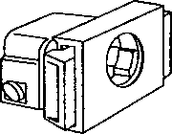

609797 - Black Non-Locking 700924 - TWL Blue Locking

1) .215, 2) .190, 3) .165, 4) .140 and 5) .115. Bottom pins: 1) .143, 2) .168, 3) .193, 4) .218 and 5) .243. My estimation for the total pin stack is about .358 inch, but the actual total could be more or less.

Progression Techniques

Many different automobiles are set up so that the operat­ing key has more cuts in the key than there are tumblers in any particular lock. Often times, having just one lock will not provide you with enough information to gener­ate a key that will operate all the locks. It is possible to decode one lock with most of the tumblers in it, and

then try a series of cut combinations to determine the remaining unknown cuts.

Take, for example, the new 1998 Chrysler locks. With the help of an EEZ Reader, you can decode the seven tumblers in the door lock. With only one cut missing for a complete key, you can start with a #1 depth in the first tumbler position and progress to each depth deeper until the lock finally turns. Progression with only one missing cut is almost effortless. If two or more cuts are missing it can be a bit complicated.

Figure 2 shows what I consider the most valuable pro­gression chart that I have used over the years. For the single sided 6-cut GM keys, sometime in the early 1970s, GM had the secondary (oval head) key operate the door, trunk and glove box locks. If a customer lost a door key, you had limited options for fitting a new one. Sidebar locks are not easily picked or impressioned, so (unless you had a remote trunk release) the trunk lock was usually not an option. You could fit a key from the door lock, but you’d have to pull a door panel to get the lock out of the door. Then, of course, there was the glove box lock.

The glove box lock is an interesting option. Except for a few Cadillacs and other high-end GM vehicles a number of years ago, glove box locks have only four tumblers. That is not quite enough to generate the six cuts required to open the door or trunk locks. Up until 1975, the glove box locks had the code number stamped on them, so all six cuts could be determined anyway. After the code number was removed, things would have been a bit more complicated if someone hadn’t devel­oped an easy and effective progression chart. Based on some key combination rules discovered in the GM codes, many unnecessary cut combinations were eliminated. As a consequence, you could decode the four tumblers in the glove box lock and (with no more than three key blanks) determine the missing two cuts, without remov­ing or disassembling any other locks on the car.

The two main rules that make the chart possible are: 1). There is a two depth maximum between adjacent cuts, and 2). The combined total of all six digits of the key cut combination should always add up to an even number. I’ll give an example of how to use the chart.

The chart is divided into two sides, the even chart and odd chart. The even chart is applied when the total of the known digits is an even number. All two number combinations on that side combine to be an even num­ber. Combining the known value with the unknown value combines an even number and an even number. Two even numbers added together always equal an even number, which means that the six digit total would be an even number. That follows the rules for those GM

Keynotes

October 1997

codes. The odd chart is applied when the total of the known digits is an odd number. All two number combi­nations on that side combine to be odd. Combining the known value and unknown value combines an odd num­ber and an odd number. Two odd numbers added together also equal an even number, which again follows the rules.

I’ll start with all six cuts that we hope to discover from the chart. Our hypothetical GM car has a door key with the cuts: 443234. We’ll say that the key is lost and that the customer does not know that key cut combina­tion. If I took the glove box lock out and decoded it, I

would get the following: 3234. The blank spaces are

to indicate that the glove box is missing the first two tumblers. The first thing I do is to add the total of all four known digits. 3+2 + 3+4= 12.

The combined total is 12, which is an even number. That means that I’ll be using the even chart. The first column of the overall progression chart is labeled “3rd Position Cut.” Since the first two cuts are blank or unknown, our 3rd position cut becomes “3.” We find the row headed by the number three. Our possible cut combinations can be found in the three columns of the even chart identified as, 1st Key, 2nd Key and 3rd Key.

I would start by taking a blank GM key of the proper keyway for the lock, and I would then make the four known cuts with my code machine. They would be: _ _3234, as mentioned above. I would then look in the box next to the number three (for 3rd Position Cut) and find that I have up to five different two digit combina­tions possible for the first key. Being that a #1 cut on a GM key is essentially no cut, the first combination listed of 1-1 is already on the key I cut with the last four dig­its. I would insert the key into a door or trunk lock and attempt to turn the key. Since it is not the correct cut combination, it would not turn. I would try again.

Take note that the order of the cut combinations allows you to repeatedly cut the same key over and over to minimize wasted key blanks. The next possible com­bination is 1-3. Since only the second digit has changed, I can re-cut the same key by cutting the second position from a #1 depth to a #3 depth. I would again try the modified key in the lock and try to turn it. I would repeat the procedure until I reached the last combination listed in the box for “1st Key.”

Since none of the combinations listed in the box for 1st key are the correct ones, we would start again with a new key. The four known cuts would be made first, then I would make the first two position cuts starting with the first combination of cuts shown for 2nd key. That cut combination is 2-2. That wouldn’t work, so both the first and second position cuts would be made deeper.

The second combina-  
tion for the 2nd key  
would be 3-3. Since  
that wouldn’t work, I  
would try the last com-  
bination listed in the  
box, which is 4-4. After  
re-cutting both first  
and second positions,  
the modified key would  
have the cuts 4-4-3-2-  
3-4. If you look back to  
what I indicated would  
be the proper key cuts,  
you’ll see that I have  
just matched it with  
the combination just  
listed. In this case I  
have a working key  
with only two keys  
used. Depending on the  
tumbler combinations,  
it could have taken as  
many as three keys.

That is the most you  
would normally ever  
use with the even chart.

The odd chart gives you  
a working key with no  
more than two key  
blanks used.

Figure 3 is a very  
similar chart. Instead it  
works when the first  
four cuts are known, as  
opposed to the chart we  
just reviewed that  
works when the last  
four cuts are known. It  
is mostly the fuel lid  
locks that have this

tumbler arrangement. If you search all the GM codes,  
there are a few codes that violate the rule that the total  
of the digits be an even number. It would be rare for you  
to run into a car with such a code. The two charts  
should be more than 99% effective on the GM cars that  
you deal with.

A fairly complicated progression sequence is used for 10-cut Ford keys. On those Ford automobiles, the door lock is disc tumbler and the ignition is sidebar. The door lock will only give you six cuts. That means that you would end up progressing four tumbler positions. With

October 1997

Keynotes

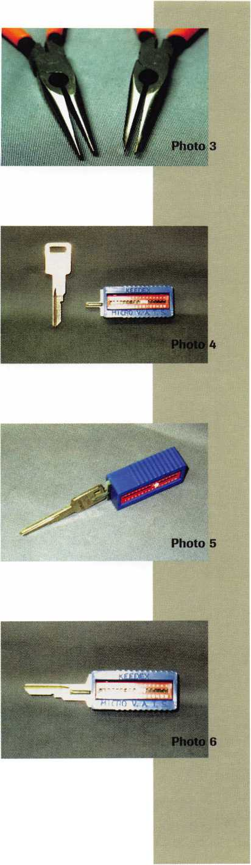

Photo

Photo 8

Photo

Photo 10

that method you could use up to 13 Ford key blanks cut­ting both sides on each.

Tools

Tools can be a major investment when it comes to auto lock servicing. In a vari­ety of categories, there are lower and higher priced tools that accomplish a similar task. Sometimes the more expensive tool has no major advantages but is still dramati­cally more expensive than a more reason­ably priced tool. In other cases, the more expensive tool is much better. If you can do without all the bells and whis­tles of the more expensive tool, how­ever, you can still get the job done on a budget.

If you look at fig­ure 4, you’ll see a certain type of Chrysler glove box lock. There are GM iflS gl°ve box locks with I 1 nBH the same basic

design except for

' HHH keyway and tumbler arrangement. It has a squeeze type latch retractor. The cylinder plug snaps in for assembly. Removing the plug, however, can be a trick. Two plastic prongs on the lock body hold the plug in place. Both prongs have to be spread apart to pull out the cylinder plug. I don’t run into them that often, so I’d usually struggle with an assortment of flat screwdrivers or poke tools to spread the prongs in order to remove the plug. There are a cou­ple of tools available to simplify plug removal.

Previous to the last time I worked on one of these

locks, I swore I’d buy one of those tools. I was tired of fussing and jabbing my fingers trying to get them apart. And then I forgot about it until the next time I needed one of those tools. I wasn’t looking forward to the inevitable struggle. They say necessity is the mother of invention. Well, I figured out a solution. Photo 3 shows a standard pair of long nose pliers on the left and my modified version on the right. I just ground down the tips until they were narrow enough to fit behind the plastic prongs on the lock. I used my tool to reach behind both prongs at the same time. I spread the han­dles and the prongs separated, releasing the plug. Problem solved.

Diving into the VATS Without Getting Soaked

The GM system known as VATS or PASS uses an elec­tronic device somewhere in the dashboard to interrogate the resistance of a pellet embedded in the neck of the ignition key. With 15 possible resistance values, a wrong pellet will prevent the car from starting, even if the mechanical key cuts are correct and the key turns.

In the nearly 10 years that VATS has been around,

I’ve had fewer than a half dozen customers even inquire if I could make a copy of their key. With a cost of almost $8 per key blank, you could put out quite a lot of money just stocking one of each. If you stocked one of each, it would be over $100. If you stocked two of each, it would be well over $200. If you add the double sided key version, you’re talking serious money.

Keedex makes a device called the Micro VATS Interrogator, shown in photo 4. Its the smallest and least expensive VATS interrogator that will work with stan­dard metal keys. Photo 5 shows how the metal key slips into the device. Metal contacts on each side, where the resistor pellet would normally make contact, are insulat­ed from the inserted metal key. The blank key shown fully inserted in photo 6, would be replaced by a proper­ly cut key. The resistor value can be selected to try and start the car. Like any other interrogator, you should wait for about four minutes before trying again with a differ­ent resistance selection. If you have to go through all 15 settings, you could spend almost an hour interrogating the system. Once you find the correct resistance value, the car will start. An adaptor for the double sided VATS keys is shown in photo 7. A standard double sided metal key is inserted into the adaptor in photo 8. The key is fully inserted into the adaptor in photo 9, with the con­tacts positioned where the resistor pellet would normally be. The double sided key in the adaptor can then be inserted into the Micro VATS Interrogator unit, as in photo 10, to create whatever resistance value is needed. Unlike some of the larger interrogator units, there is no

38 | Keynotes

October 1997

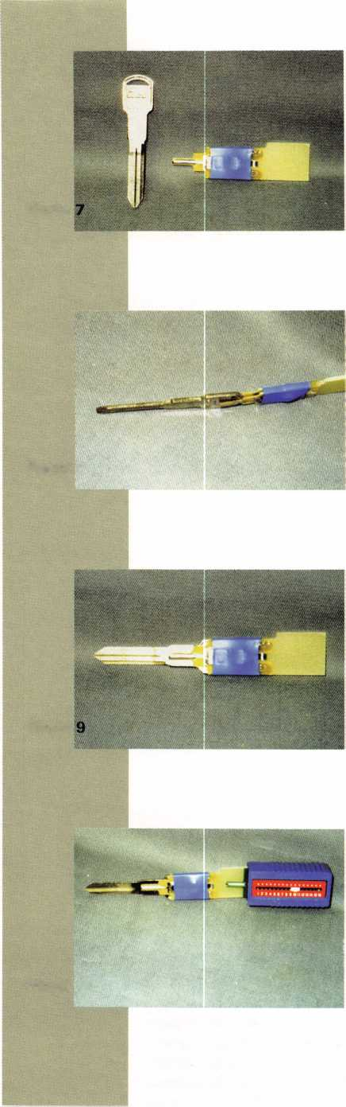

built in timer. You’ll have to keep track and count the four minutes yourself.

This could be an inexpensive way to get your feet wet when it comes to the ability to service VATS, without getting soaked with the cost of stocking all the different key blanks. Because of its use of a standard metal key, it is possible to use the interrogator unit to decode the correct resistance value and start the customer’s car. Once the car is started, you can slip the unit off the key (still in the igni­tion lock with the car running) and the customer could drive home. Now you’d have to warn the customer that the mechanical key alone will not start the car again, but it could give you time to pick up one or two of the correct resistance VATS keys and avoid stocking all of them. You could then drop off the key that you make (with the correct cuts and correct resistance value) or the customer could come back with another car to pick it up. Not every customer would go along with that scenario, but it could allow you to consider working on VATS without all the investment up front.

There is so much more than I have room to write about here. My main message is that when it come to automotive locksmithing, it isn’t just all or none. There is a pretty good sized middle ground. For more information on the EEZ Readers, contact: H. E. Mitchell Co., 118 S.E. 8th Ave., P.O. Box 14009, Portland, OR 97214. Phone: 800/626-5625. For more information on the Micro VATS Interrogator and adaptor, contact: Keedex, Inc., 12931 Shackelford Lane, Garden Grove, CA 92841-5108. Phone: 714/636-5657. FAX: 714/636-5680. e-mail: [info@keedex.com](mailto:info@keedex.com). Internet address: <http://www.keedex.com>

i!

* About the author.: Sal Dulcamaro, CML, has been in the lock-

smith business for over 22 years. He is the president of All Pro Security, Inc. in  
Clintoum Township. Ml, and has been an ALOA member for 15 years. A  
past president of the Locksmith Security Association of Michigan. Sal currently  
serves as editor of the association's newsletter. Additionally, he was recently  
awarded his second straight Keynotes, “Author of the YeaP’ award.



. SE WVTW

rou

• • • •

D

on’t let the dark forces of

ignorance defeat you. Right in  
this galaxy you can tap into the

source—the free Consumer  
Information Catalog. It lists free and  
low-cost federal publications on such *  
stellar topics as saving money, buying  
a house, educating your children,

• getting federal benefits, eating right

and staying healthy,



So dispel

* the darkness and get the source. Call toll-free 1-888-8 PUEBLO for your free Catalog. Or write:

**Consumer Information Center  
Dept. Source**

**Pueblo, Colorado 81009 \***

•

Or set your coordinates for the Consumer Information Center web site:

**[www.pueblo.gsa.gov](http://www.pueblo.gsa.gov)**

* **A public service of this publication and the Consumer Information Center**

**of the U.S. General Services Administration. •**

October 1997 Keynotes | 39

Automotive

Locksmithing:

Quality counts more than ever

**The real danger to locksmiths from the new technology is the growing but not-so- obvious need to use quality parts to ensure customer satisfaction.**

“Technology is making auto locksmithing too compli­cated.” How often have we heard this? While it is true that locks and keys are more complex, locksmiths are able to keep up with these changes because the informa­tion they need is available from OEM manufacturers like STRATTEC. The real danger to locksmiths from the new technology is the growing but not-so-obvious need to use quality parts to ensure customer satisfaction.

Those locksmiths who don’t see the need, or those who ignore it, could find themselves in trouble.

Today s high-tech auto locks use electronic compo­nents that leave little room for error in production and installation. Cutting corners in the manufacturing process can create products that don’t perform well or have a limited life span, and that ultimately leave your customers dissatisfied.

Of course, advanced locks and keys are more expen­sive to produce, so they cost more to buy. And that’s where locksmiths come face to face with the quality issue, perhaps without even realizing it: Should a lock­smith purchase OEM service parts or spend a little less for off-brands?

Auto locksmiths have to make that decision for them­selves, but several factors should be considered.

First, locksmiths know that they’re getting quality when they buy OEM products. The fact that the majori­ty of locks survive for the life of the vehicle without a problem is strong evidence of the high quality of the original equipment.

Original equipment manufacturers must meet extremely high standards set by the automakers. STRATTEC products, for example, must pass strict quality testing procedures required by GM, Ford and Chrysler, who know their reputations could be harmed by inferior parts on their vehicles.

The manufacturers of off-brands face no such quality demands by the automakers. The off-brands might look similar. And they might seem to fit and work, but do they really? If so, for how long?

Manufacturers know that quality counts. That’s why generic brands offer products patterned after original equipment. These manufacturers then compare the qual­ity of their products with those of the OEM parts while selling them at a lower price.

Such tactics raise questions: If these off-brand prod­ucts are so good and so inexpensive, why aren’t they original equipment for the automakers? And locksmiths are left to wonder if they are getting the most up-to-date

designs, or if they’re buying earlier versions already improved upon by the automakers and OEMs.

Locksmiths who use hardware that fails will pay con­sequences. If things go wrong soon after servicing, the locksmith will have profit-eating call-backs. Do it a few times with a regular customer, and that business will soon belong to someone else.

It is cost that leads some locksmiths to put quality and their business at risk. These locksmiths believe that by using off-brands they can increase their profits or attract business by being less expensive than the competition.

In fact, many locksmiths are probably hurting them­selves by charging too little for their services. Think about how much vehicle owners pay, and fully expect to pay, for other car repairs, such as suspension or exhaust system work. Why shouldn’t locksmiths charge more than they do for installing high-tech, high-quality igni­tion and security components?

Servicing high-tech locks requires professional exper­tise, of course, so OEMs provide training. STRATTEC, for example, is conducting seminars at 35 locksmith conferences around the country this year. The company also provides service manuals and other technical litera­ture, and we’re working on even more types of support for the future.

Quality service can also be seen as the ability to handle calls for most any make and model of vehicle, and OEMs offer a clear advantage here. STRATTEC, for example, offers a wider product line than any other manufacturer with more than 2,000 different parts in its inventory.

And STRATTEC has distributors located throughout the United States waiting to help locksmiths.

In short, customers expect a locksmith to provide quality work that lasts as long as the vehicle does. You can help ensure your future by providing the customer with quality, and you can start by asking your distribu­tor for OEM parts by name.

For more information, please contact Ron Perszewski, Sargent & Potratz Integrated Marketing Communications, 414/789-0900.

I About the Author: Fred Kosloske is the

Aftermarket Sales and Service Manager for STRATTEC  
Security Corporation.

401

Keynotes

October 1997

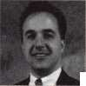

BY..J-n**M**..**SF**.ROnfi**Y**

Nothing can create more trouble for a commercial lock­smith than file cabinet, desk and furniture locks. For cabinets or furniture with existing locks, determining the lock manufacturer and obtaining the necessary ser­vice parts is a time consuming and expensive battle. Even with a visible code, the proper key blank and bit­ting are often elusive. And, when facing furniture with­out existing locks the job may seem all but impossible.

To make such work profitable, it is up to the lock­smith to create a system that turns time consuming, low profit work into quick, easy cash. The working concept here is - “system” - a step-by-step, systematic ||§|Sp approach to addressing a common problem or application. The greatest advantage to adopt- w\\ ing a system is time savings.

On a typical job involving installation of a new lock, time is spent on the following: 1) site evaluation; 2) research on various locks and locking mechanisms; 3) obtaining avail- jP|yfj. ability and pricing on needed components ——and specialty tools; 4) quoting the customer;

5) order parts and tools; and 6) return to site to complete job. This is not including the amount of time needed to correctly complete a custom installation.

By applying a standardized system or pro- gram to furniture lock work, there is an over- Skmlm all reduction in the amount of time and

money invested in research, specialized locks and new tools. In most instances, the job is evaluated, quoted and completed on the first visit to the job site. This, of course, means m developing a system that caters to your cus­tomer base.

Developing A Cabinet/Furniture Lock Installation System

Developing a standardized furniture lock installation system involves three steps or components: 1) locks, 2) tools, and 3) installation.

Locks The locks, by far, are the most important, as their selection determines the tools and installation requirements. For my customer base, I found that cam locks covered roughly 85 percent of the cabinet/furniture lock installations. They are inexpensive, easily keyed alike or keyed differently, easily installed, and come in a variety of lengths and functions.

I found the SK6050 Cam Lock Kit by All-Lock to be about the most comprehensive cam lock kit available. It contains a variety of cam lock components, allowing the locksmith to custom fit a lock application without wast­ing and ordering unnecessary parts. It includes various length cam locks; a selection of straight, offset and hook cams; stop cams, spur washers, spline fillers, lock wash­ers, sem screws and other necessary components.

The All-Lock cam locks in the kit include a selection of the C8400 (5/8”), C8500 (7/8”), C8600 (1-1/8”), and the C8700 (1-3/8”). These locks include a keyed plug.

***Keynotes*** | 41

October 1997

1. All-Lock’s SK6050 offers a compre­hensive line of cam lock components.
2. All-Lockis SK6070 Cam Lock Service Kit, used for pinning the All-Lock, as well as other brand, cam locks.

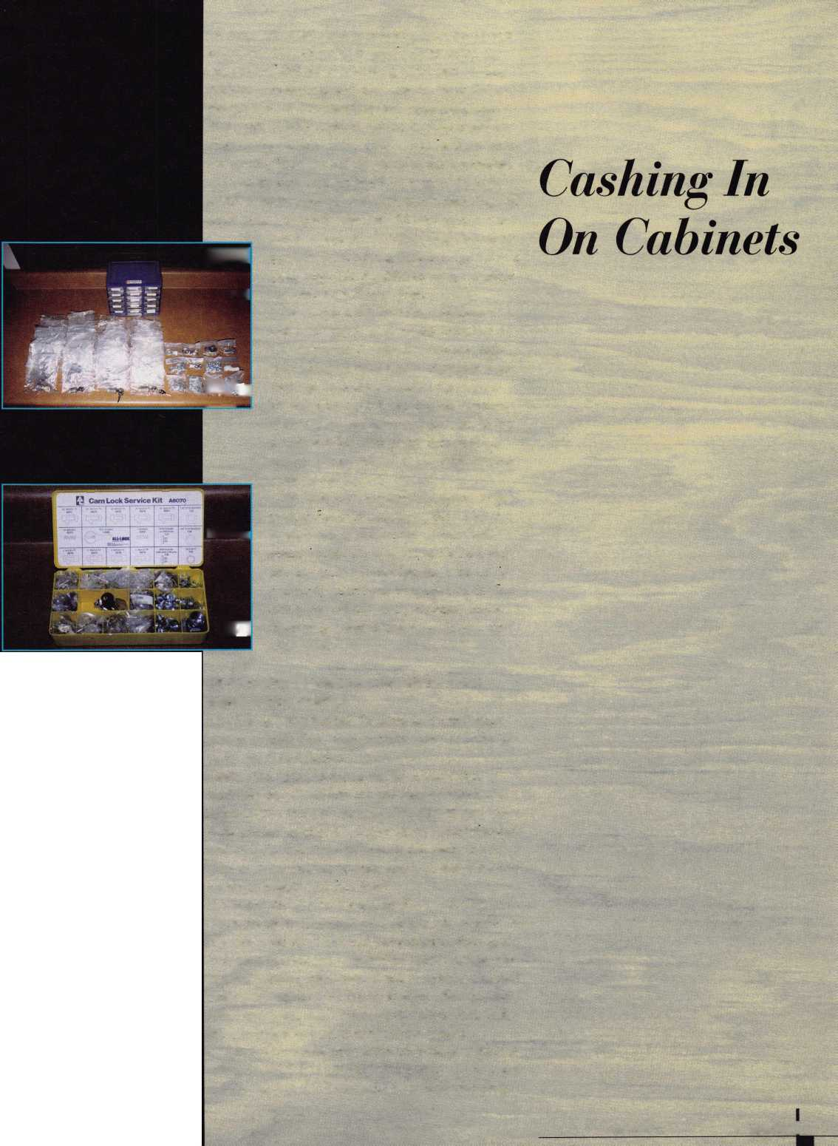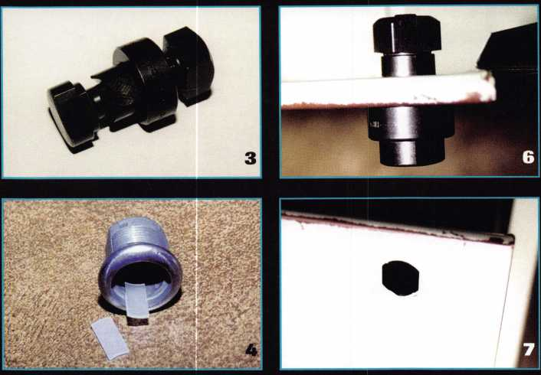

1. Few specialty tools are needed for cam lock  
   installation. Aside from standard hand tools, a  
   3/4” hole saw and HPC’s HDPS-4 Double D  
   Punch, shown above, are about all that’s needed.
2. Adding these spline fillers to the tumbler  
   wards changes the key removable function of the  
   cam lock.
3. The stop cams determine direction and degree  
   of rotation of the cam. All-Lock provides 90° and  
   180° stop cams. Installation of the cams deter-  
   mines the direction of rotation.
4. Measuring from the back of the lock face to  
   the front of the straight cam [A) determines the  
   length of the All-Lock Cam Lock [four lengths  
   available). After the proper length cam lock is  
   chosen, offset cams (B1 and B2) of varying offset  
   lengths can be used to get the correct fit. The  
   perfect combination of cam lock length and cam  
   allow approximately a 1/8” gap between the cam  
   and strike CC).

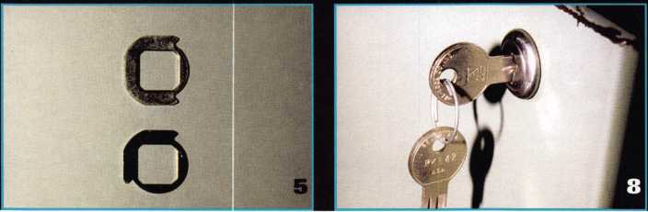

7 The horizontal mounting location is determined  
by aligning the center of the lock with the center  
of the strike/latch [A). The vertical mounting  
location (B) must allow for at least 7/16” between  
the edge of the strike/latch and the body of the  
lock case (C). The actual mounting location then  
determines the correct cam length (D).

8. Using HPC’s HDPS-4 Double D Punch & Die  
to install this All-Lock Cam Lock.

the accompanying case and two keys.

For storing, all the components are placed in a plastic, 15-drawer storage unit. The unit stores easily and solidly in most service vans, allowing an organized work station wherever you go. Plus, all locks use the All-Lock L54B key blank, a commonly stocked blank. (See photograph 1.)

If only single cam locks are desired, All- Lock provides the above locks in individual lock service packages. Known as “99” Kits (C8499B, C8599B, C8699B, and C8799B), each package includes the necessary compo­nents (stop cams, straight and offset cam, spline fillers, etc.) for creating a cam lock that fits most applications.

For pinning or keying the cam locks, All- Lock’s SK6070 Cam Lock Service Kit is used. It contains all the components neces­sary for keying and rekeying the All-Lock, and various other brand, cam locks. (See photograph 2.)

Tools One of the great advantages with this particular lock selection is that the tools needed for installation are few and inexpen­sive. In fact, outside of a few standard hand tools, the only specialized tool purchases are a 3/4 inch hole saw and a Double D punch and die. (See photograph 3.)

A Keynotes October 1997

To make installation as simple and stan­dardized as possible, I created a small cam lock installation tool box. The box contained the following:

* 6 foot Tape Measure
* Speed Square
* Adjustable Wrench
* Round Wood File
* Round Metal File
* Double D Punch & Die (HPC HDPS-4) (For metal cabinets and drawers)
* y4 inch Hole Saw (For wood applications)
* 1/8 inch Drill Bit (for pilot holes)
* 1/2 inch Drill Bit (Starter hole for Double D Punch & Die)

Installation As stated earlier, the lock selec­tion determines the tool and installation requirements. And, because all of the locks we have chosen are cam locks, the tools and installation are consistent from job to job. This consistency reduces not only installa­tion time, but reduces the possibility of cost­ly installation errors. Remember, consistency breeds familiarity. The more familiar one is with a product and its installation, the less likely there is for errors.

Installation of the All-Lock cam lock is based on two criteria: 1) Environment and 2) Function.

Lock function is determined by the cus­tomer and by the environment. There are two basic cam lock operations or functions: key removal position and cam rotation.

Key removal position is typically decided by the customer, and includes key removable in locked position only, and key removable in locked or unlocked positions. This func­tion is determined by the position and installation of the spline fillers into the lock case’s tumbler wards. It should be noted that key removable in locked position only, can only be accomplished when using a 90 degree cam stop. (See photograph 4.)

Cam rotation is usually a function of the environment, and includes rotation direction and degree of rotation. Both direction and degree are controlled by the stop cam. All- Lock provides two stop cams, a 90 degree and 180 degree rotation. Direction, left swing or right swing, is determined by how the stop cam is mounted on the back of the lock. (See photograph 5.)

The environment determines not only the physical placement of the lock, but also the length of the lock and the type and length of cam. In looking at the environment, three dimensions are important - depth, vertical location and horizontal location.

For cam locks, the depth determines the length of the lock and the style of the cam. In determining the depth, a strike or latch must first be determined. In most instances a supporting cross member in the cabinet can be used. In some instances a simple piece of angled metal can be installed.

To determine the length of the cam lock and the style cam, mea­sure the distance starting from the face of the cabinet drawer to the backside of the strike or latch. With the proper combination of lock length and cam, approximately 1/8 inch clearance between the face of the cam and the strike/latch should exist. In most instances, a straight cam works. In others, an offset or bent cam makes a more appropriate installation. In a few applications, a hook cam may be more appropriate. All-Lock provides over 10 offset or bent cams of varying lengths and angles, and seven hook cams of varying length. See the All-Lock Cam Lock catalog for details.

With the cam lock length and cam style chosen, the vertical and horizontal locations are now determined. These measurements are used to locate the installation position of the lock, as well as the cam length. It is important at this time to identify any possible obstructions to the installation - i.e. cabinet brackets or slides, file folder frames, etc. Remember to account for the length and rotation of the cam.

To begin, align the horizontal coordinate with the vertical center- line of the strike. In cases where a supporting cross member is serv­ing as the strike/latch, the cam lock can usually be installed any­where along the length of the cabinet or drawer. If a strike/latch is to be installed, the horizontal position must align with the center of the strike/latch.

Once the horizontal location is determined, the vertical location is determined. As a rule of thumb, the edge of the strike/latch should clear the outer edge of the lock case by 1/16 inch to 1/8 inch. As the radius of the All-Lock cam lock is approximately 3/8 inch, the dis­tance from the edge of the strike/latch to the center of the cam lock is a minimum of 7/16 inch. Again, the exact measurement is deter­mined by the environment. Straight cam lengths of up to two inch­es, and Offset and Hook cam lengths of up to 1 1/2 inches are avail­able from All-Lock, making for a variety of placement options. See All-Lock Cam Lock catalog for details.

[The description of the horizontal and vertical measurements are based on a strike/latch that is placed on a horizontal axis. In some installations, a strike installed on a vertical axis may be more feasi­ble. In this case, simply follow the above guidelines by exchanging the horizontal and vertical directions.]

Now, the system is set. When the opportunity arises, a new lock can be easily and quickly installed in most desk/cabinet/furniture applications.

First, locate the position of the strike/latch. This gives us the length of the lock and the style of the cam. Second, based on the position of the strike/latch, determine the horizontal centerline of the lock s mounting location. Third, based on the strike/latch dimen­sions, determine the vertical centerline for the lock’s mounting loca­tion. Drill and mount the lock. (See photograph 8.)

For more information on Cam Locks, or to obtain an All-Lock Cam Lock catalog, contact All-Lock Company at (800) 647-4926.

About the Author: Tom Seroogy is product manager at ALL-LOCK.

ALOA Members only

AT&T offers members of Associated  
Locksmiths of America, Inc. an **additional** 5%  
**discount** on your business long distance. You  
can literally **“profit by your associations**Call 1 800-722-7756 ext. 737F to sign up now.

Alter

Reader Service #14

NEW ILCO DISTRIBUTOR!!

Monday Security Corporation  
**1**-**800**-**886-6721**

Contact Laura for details  
on dealer discounts

We carry almost every make  
and model of new and  
used safe deposit locks,  
and safe parts, specializing  
in the antique parts.

Have you received our  
catalog?

Reader Service **#15**

October 1997

Keynotes

by Sal Dulcamaro, CM L

Let There Be (Inspection) Light

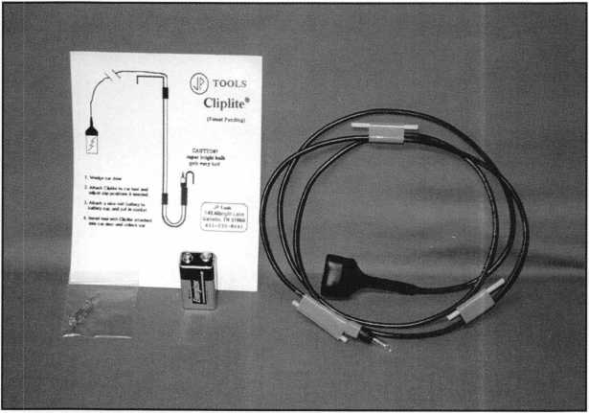

A

t the recent ALOA  
trade show, I saw a  
number of interesting

new items. One item in particu-  
lar caught my eye because of its  
simplicity and low cost opera-  
tion. This interesting new item  
in photo 1 is called the Cliplite.

It is an inspection light designed  
for use in car openings.

There are quite a few different  
brands (and styles) of inspection  
lights similar to the Cliplite  
available from various sources.

The Cliplite is particularly  
unique, compared to the rest,  
when it comes to maintenance.

It is powered by a single nine

volt battery and has no switch to wear out. Many other  
similar inspection lights use a variety of power sources,  
all with their own advantages and disadvantages. I think  
its most interesting feature, though, is its light bulb.

If you look at photo 2, you may think that your eyes are deceiving you. Look again. I kid you not, that is a Christmas tree light bulb. If you’ve seen some of the car opening inspection lights, you may know that when you break a light bulb, the replacement will sometimes cost more than $10. Also, if you don’t keep a spare light bulb on hand, your local store will not usually carry the replacement bulbs in stock. It could be very inconve­nient for you, waiting until your ordered replacement arrives in the mail. I think that a replacement Christmas

light bulb might cost about a dime, and just about any­body has an endless supply of them stashed away with the Christmas ornaments. Unless of course, it happens to be during the Christmas season, and then you’ll find them virtually everywhere.

Using the Cliplite

As I had mentioned earlier, the Cliplite is a very sim­ple contraption. In photo 2 you can see the Cliplite and a nine volt battery. The battery is not included when you order the Cliplite, but nine volt batteries are quite obvi­ously available at most stores. Two spare light bulbs are included, but it shouldn’t be too difficult to find a whole bunch more somewhere around your house. Even if you

Keynotes

October 1997

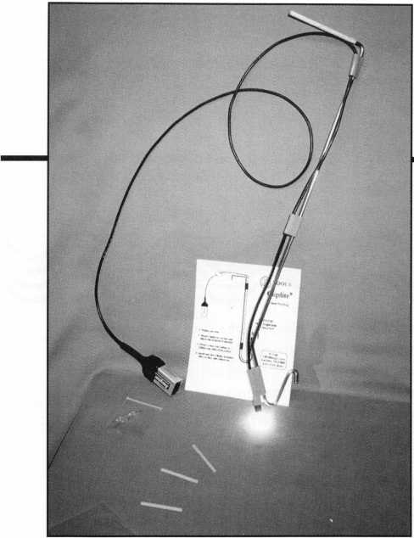

don’t have them at your own house, I’m sure many of your neighbors do.

What you see in photo 2 is basically a length of wire with a battery connector at one end and a light bulb at the other end. Spaced along that length of wire are three clips. You can see three short lengths of wooden dowl- ing, clipped one in each of the three clips. The pieces of dowling are about 1/8 inch diameter thick. That is just slightly under the thickness of your typical car opening tool. The pieces of dowling should be pulled out of the clips, so that the clips can be attached to your car open­ing tool.

Photo 3 shows the wire of the Cliplite stretched out and clipped to a car opening tool. The three clips are spaced apart and are positioned to attach along the length of the opening tool regardless of the contour or configuration of it. One of the clips is at the end of the length of wire that makes up the Cliplite. That allows you to position the light bulb as close as possible to the opening end of your car opening tool. Depending on where you want to cast the light inside the door panel, you can pretty much clip the bulb end of the Cliplite anywhere you want along the length of the tool.

The base of the light bulb is about 5/16 inch in diameter. That’s a bit thicker than your average car opening tool. When you wedge open the gap between the window and the door frame for tool insertion, you will need to spread the gap a bit more to accommodate the additional width of the light. With a few excep­tions, most other car inspection lights also require a larger gap to insert the light into the door panel. Since the light is clipped to your opening tool, the light will follow the tool wherever you move it.

The instruction sheet suggests that the light bulb will get fairly hot. You may decide to insert the tool (with Cliplite attached) before you connect the nine volt battery. If you leave the battery off during insertion, you will be able to put your hand near the end of the tool where the light bulb is attached without burning your fingers (not that it necessarily gets hot enough to actual­ly burn your fingers).

Once the tool (and Cliplite) is in the door, you can attach the battery (as in photo 4) and brighten up the inside of the door panel. There is a decent length of wire from the topmost clip to the battery connector. You should be able to put the connected battery in your pocket to keep it from swinging freely and accidentally bumping into the customer’s car door.

The light bulb is surprisingly bright. I know that they always seemed to be pretty bright when I saw them on Christmas trees, but a preconceived notion had me thinking that they couldn’t be bright enough. It just seemed that a 10 dollar light bulb had to be so much brighter than a 10 cent light bulb. I think you’ll find that these Christmas tree light bulbs are up to the task. I guess more expensive doesn’t always mean better.

The Cliplite has its limitations, the same as any other brand of car opening inspection light. It can light inside a door panel and still not help you in any significant way to open a car door. Some car doors have lock linkages that are completely out of view when looking into the door panel through the gap between the window and frame. You could have 1,000 watt halogen bulbs light­ing the inside of the door panel, and you’d only have a much brighter view of nothing. When there is some­thing inside the door panel to see, however, the Cliplite will do a pretty good job of brightening your view.

For additional information about the Cliplite, contact:

JP Tools, 149 Albright Lane, Gallatin, Tenn. 37066. Phone: 800/270-6355 or 615/230-8641

El

%About the author: Sal Dulcamaro, CML, has

been in the locksmith business for over 22 years. He is the presi-  
dent of All Pro Security, Inc. in Clintoum Township. Mich.,  
and has been an ALOA member for 15 years. A past president  
of the Locksmith Security Association of Michigan. Sal currently  
serves as editor of the association’s newsletter. Additionally, he  
was recently awarded his second straight Keynotes,' Author of  
the Year” award.

October 1997

Keynotes

Surfin’ The Net-ALOA Style

By Claire L. Cohen, CML

In the May ’97 issue of Keynotes, Kim Bowers, CML, publisher of the ALOA Web site, wrote an article intro­ducing the members to ALOAs newest member benefit: ALOA on the World Wide Web ([www.aloa.org](http://www.aloa.org)). This article triggered my interest, and I decided to take a closer look to see how this could be of benefit to me and my locksmith associates. The following are observations as I started this article.

Only after I spent a few hours exploring did I finally appreciate all of the time and effort that has gone into the ALOA Web site creation. This is the result of many months of development. It consists of over 40 pages of very useful information with links to other areas of inter­est to locksmiths. Most of the Web site is complete; however, some sites are due to be completed shortly. There are planned enhancements for other sites. As future member needs develop, or as specific requests from the membership are received, changes will occur.

Whether you have access to the Internet or not, it is important to know more about this valuable resource. If you are not on-line, perhaps a friend could spend some time showing you the ALOA site. Learn and explore! It is important to remember that even though you may not be online, many of your customers and potential customers are. You may be able to educate your cus­tomers by allowing them to learn more about ALOA through this Web site.

One of the purposes of this Web site was to enhance communications between members all over the world to make communications to the ALOA office fast and effi­cient. No letters that require stamps, no applications to mail—just quick and easy E-mail to the ALOA office, members, manufacturers and distributors who have E- mail. What could be faster or more efficient?

After accessing the ALOA homepage, the following options are available:

* Insert ALOA Homepage Here
* About ALOA
* Visitors Pages
* Locksmith Search
* Member Pages
* Set-up Help

At the bottom of the homepage is ALOAs E-mail address. A “click” on this address can put you in touch

with the ALOA office. What a fast and efficient way to write a quick note to the ALOA office, informing them of a change in address, an upcoming educational event that your local association or chapter is sponsoring, or even a comment or suggestion for ways to improve the Web site.

After making a selection, it is quite helpful to go to the Site Map to start exploring areas of interest to you. Often overlooked is an extensive on-line help system. After visiting a site, the software keeps track of site names you have visited by turning another color.

“About ALOA” Pages

This area on the site contains the main description of the Associated Locksmiths of America, including its history. This would be a great print-out for your customers.

Also, potential customers could be encouraged to access the homepage to learn a little about a locksmith who is a member of ALOA, and about the accreditation and certi­fication process. Perhaps you could use a small portion of this in a letter of introduction for you and your company.

This site contains a listing of the PRP mandatory and elective categories. If you speak before a citizens group or write an article in a local paper about choosing an ALOA certified locksmith, you may want to use some of this information.

This area also lists the benefits of membership and a monthly message from the ALOA president. This would be great material to show a fellow locksmith considering membership in ALOA. If you recruit a member, they can fill out the application on-line (See Visitors Pages— ’’Join ALOA”). Don’t overlook the message from the president—keep yourself up-to-date on your industry.

In this section, there are also the ALOA Model Policy Standards, Version 1.0 (3/13/93). You will also find a listing of ALOA board members, including trustees and chairmen of international affairs. If you have a particular concern, you may want to write to members on this list.

The “Visitors Pages”

This area contains the lead article from the current and past issues of Keynotes. What a fast and east way to find what the focus was in each issue.

If you are a member in good standing, you can have

October 1997



your E-mail address or Web site linked to this section. This site has a listing of organizations and professional associations, association members and member links.

PRP Report, updated on a regular basis by the PRC chairman, will allow you to find out what’s new. Also, see the list of fellow lock­smiths with new certifications—or see yours. Want to know about upcoming ACE classes? The chairman of the Education Committee will keep you informed on classes scheduled. You can have your asso­ciation classes publicized in this area too.

Check out the employment site. These are not just one-liners.

Find out what opportunities are available to you. Included in this listing are the dates of posting. Not only can you find employment sources, but you can also place your “help wanted” or seeking posi­tion ads here.

Coming soon to the Visitors Pages are The Lock Museum and SAVTA sites. This should be some interesting surfin’.

“Locksmith Search” Pages

Instant Marketing! Potential customers can go to this site and locate an ALOA locksmith in their area. The advanced search allows browsers to search by last name, first name, certification, business name, city, state or country. Not a penny spent on advertising—cus­tomers will find you. Using the advanced search feature will allow you to quickly find the address/phone number of a fellow member— even if you do not know their full name or address.

Also, your customers will be able to learn more about ALOA accreditation and certification. For those of you seeking certification, there is a listing of the current mandatory and elective PRP cate­gories.

“Member” Pages

In order to enter the member site area, you must first type in a login and password. The login is: aloa. The password is: lockup97.

After entering the site with the above information, you must reg­ister. This is done by giving your username and a new password. You will receive a “validation key number” through your E-mail address. This validation key will enable you to enter the Member Page area.

The events area contains a calendar of upcoming industry events, such as conventions and trade shows. It also shows location and gives a contact phone number. There is even a listing of future ALOA con­ventions up to the year 2001. Click on this site to keep your calen­dar up-to-date. Publicize your association classes here, too.

Industry News includes topics of interest to all locksmiths. Learn what suppliers are carrying new lines, new product announcements, change of address for lock manufacturers, local association reports, new officers and much more.

Viewing Convention News allows members to find out details of the ALOA convention; information such as travel accommodations, trav­el agent information and other useful bits of information are includ­ed. There is an overview of the convention city and information you can use when planning a trip to the convention. Also, you may use this site area to register on-line for the convention. What a time sav­ing convenience.

Member Page links can be utilized if your business or organiza­tion has a homepage or E-mail address. You can add a reciprocal link on this page. This is a great way to find another security profession, organization or vendor.

The Legislative site contains the ALOA legislative committee weekly report on legislation. It also has a state-by-state listing.

ALOA has arranged with a monitoring service to have weekly reports of the most up-to-date information available, including newly submitted legislation and movement on any bill as it has potential affects on the lock industry. Weekly reports include bill number, synopsis, status, introduction date and sponsor.

In the Members Only section, as mentioned earlier, you must login and type your username and password. Once in this area, you must choose between the Message Board and Lock Chat.

Trying to sell a piece of equipment, looking for a particular class to be taught, etc.? Post your notices to the Message Board. Are you looking for a particular lock? Enter the Technical Assistance area to ask a question, or try to answer a fellow locksmith’s questions. Once in the message area of your choice, if you posted a message, you can delete it. You can reply to a message or post a new message. The power of the Internet and the ALOA Web site gets you in touch with locksmiths all over the world, where you are able to exchange ideas and share information. Select “Lock Chat” to enter another area of the ALOA Web site. You can become an interactive part of this chat session, or you can host a chat session on a particular subject.

Set-Up Help

Here are some very interesting links. Check out the frequently asked questions. This may assist you in surfin’ the ALOA site. Learn the language of the net with “Net Lingo.” There is a great deal of useful information to surf in this area—this can be valuable to you for future surfin’.

Here are some other interesting features I learned about the site:

* Some sites are updated on a daily/weekly basis.
* Extensive “help” screens are available.
* You can order merchandise on-line sold by the ALOA virtual store. Note that this is a “secure Web site.”
* Clicking on the AdvanSec logo allows you to gain access to a book entitled The Business of Security, written by Kim Bowers, CML.
* Chat sessions can be set up for a particular time or a particular subject.

You can copy some of the graphics and/or text and use it in your own publications.

Browsing the site, you will notice that some areas are “coming soon.” I look forward to more exploration in these areas. Earlier, I mentioned that the site may change, based on input from the mem­bership. As I surfed the sites, there were suggestions that I feel would be valid, I will pass these on to ALOA. Member input will enhance the value of this site. It is only through the member response that we can customize this site to meet our needs. Try surfin’ the web—ALOA style. Harness the ALOA Web site and make it work for you.

iAbout the Author: Claire L. Cohen, the second woman to become

a CML, has been in locksmithing since 1977 and has been writing articles for  
Keynotes since 1987. She is an active member of the Locksmith Association  
of Washington, D.C., where she has taught many classes.

October 1997

Keynotes



**Associate**

Members

|  |  |
| --- | --- |
| Manufacturers | American Security Products  11925 Pacific Ave.  Fontana, CA 92337-6963 (800) 423-1881; FAX (909)685-9685  0 ^ |
| A & B Safe Corp.  171 S. Delsea Dr.  Glassboro, NJ 08028 (800) 253-1267; FAX (609) 863-1208  0 (0 0 0 | Arrow Lock Company  10300 Foster Avenue  Brooklyn, NY 11236 (718) 257-4700; FAX (718) 649-9097  0 0 0 0 |
| Adesco Safe Manufacturing Co.  16720 S. Garfield Ave.  Paramount, CA 90723 (800) 821-6803; FAX (310) 408-6427  0 | Auto Security Products (A. S. P.)  P.O. Box 10  Redmond, WA 98073-0010 (425) 556-1900; FAX (425) 558-1205  0 0 |
| ASSA Inc.  10300 Foster Ave.  Brooklyn, NY 11236 (800) 235-7482; FAX (718) 257-2772  ® | Baton Locks & Hardware Co.  14275 Commerce Dr.  Garden Grove, CA 92643 (714) 265-3636; FAX (714) 265-3630  (01 (0 |
| Abus Lock Company  3555 Holly Lane North  Plymouth, MN 55447-0507 (800) 352-2287; FAX (612) 509-9939  © | Chicago Lock Company  10100 88th Ave.  Pleasant Prairie, Wl 53158-0069 (800) 445-3204; FAX (414) 947-7178  ® |
| Adams Rite Manufacturing Co.  P.0. Box 1301  LaPuente, CA 91749-1301 (562) 699-0511; FAX (562) 699-5094  0 0 | Corbin Russwin Architectural Hardware  P.O. Box 25288  Charlotte, NC 28229 (800) 543-3658; FAX (800) 447-6714  101 0 0 (0 |
| Adrian Steel Company  906 James St.  Adrian, Ml 49221  (800) 677-2726; FAX (517) 265-5834  © | Curtis Industries  6140 Parkland Blvd. Ste. 300  Mayfield Heights, OH 44124-4103 (800) 555-5397  0 0 |
| Alarm Lock Systems, Inc.  345 Bayview Ave.  Amityville, NY 11701 (800) ALA-LOCK; (516) 789-3383  ® | DETEX  302 Detex Dr.  New Braunfels, TX 78130 (800) 729-3839; FAX (210) 620-6711  0 0 0 0 |
| All-Lock Company  900 Ravenwood Dr.  Selma, AL 36701  (334) 874-9001; FAX (334) 874-6011  0 0 | Don-Jo Manufacturing, Inc.  P.O. Box 929  Sterling, MA 01564 (508)422-3377; FAX (508) 422-3467  0 0 |
| American Lock Co.  3400 West Exchange Road  Crete, IL 60417-2099 (708) 534-2000; FAX (708) 534-0531  ® ® | Door Controls International  2362 Bishop Circle East  Dexter, Ml 48130  (800) 742-3634; FAX (800) 742-0410  0 0 0 0 |
|  |  |



Associate members of the Associated Locksmiths of America (ALOA) manu­facture or distribute materials or equip­ment, or provide services, for the securi­ty industry. Many have donated money, services and equipment to ALOA in addition to their annual dues. Their sup­port of ALOA projects enhances overall membership benefits and we encourage our members to patronize these firms. If you know of a potential candidate for associate membership, please contact the ALOA Sales staff at (214) 827-1701. Associate member dues are $500 per year and entitle the payor to use the ALOA logo, and selected discounts on ALOA products and services.

Legend

**© Alarms:** Personal, vehicle, electronic, fire, burglar, and exit

**®** Bank security equipment

**© Automotive:** Lockout equipment, key chains/rings

**© Builders Hardware:** Door closers, furniture/decorative hardware, viewers, emergency exit devices

© Business/Technical & Educational:

Books, reference guides, publications, computer software

**® CCTV/Photo Imaging:** Cameras, monitors, photo ID equipment, cables

**® Electric/Electronic Security:** Card access control and readers, surveil­lance, electric/magnetic locks and strikes, keypads

**® Lock Devices:** Auto locks, cylinders, emergency exit/entrance control, locks (various types), strikes

**® Tools & Supplies:** Key blanks, cutters, picks, rings/hooks, custom van/truck supplies

© Safes/Vaults

© Other



Keynotes

October 1997

|  |  |  |
| --- | --- | --- |
| Emtek Products, Inc.  15250 E. Stafford St.  City of Industry, CA 91744 (800) 356-2741; FAX (800) 577-5771 | llco Unican  400 Jeffreys Road  Rocky Mount, NC 27804 (919) 446-3321; FAX (919) 446-4702 | Lori Lock  P.O. Box 1040  Southington, CT 06489 (860) 621-3605; FAX (203) 621-5972 |
| 9 9 | ^ @ (p <£) (H ^ | 9 9 |
| ESP Lock Products, Inc.  375 Harvard Street  Leominster, MA 01453 (508) 537-6121; FAX (508) 537-1699 | Industries, C.L. Inc.  9730 Gouin Blvd. West  Pierrefonds (PQ) H8Y 1R5 (514) 683-6282; FAX(514) 683-9015 | Lucky Line Products  7890 Dunbrook Rd.  San Diego, CA 92126 (619) 549-6699; FAX (619) 549-0949 |
| • | 9 9 | 9 |
| Federal Lock Company  14247 E. Don Julian Rd.  City of Industry, CA 91746 (800) 682-9851; FAX (708) 378-4767 | International Electronics, Inc. (LE.I.)  427 Turnpike St.  Canton, MA 02021 (800)343-9502; FAX(617) 821-4443 | M.A.G. Engineering & Mfg. Inc.  15261 Transistor Lane  Huntington Beach, CA 92649 (714) 891-5100; FAX (714) 892-6845 |
| • | 9 | 9 9 9 |
| Folger Adam Security, Inc.  16300 W. 103rd Street  Lemont, IL 60439  (630) 739-3900; FAX (630) 739-6138 | Jet Hardware Mfg. Co.  800 Hinsdale Street  Brooklyn, NY 11207 (718) 257-9600; FAX(718) 257-0973 | MARKS USA  5300 New Horizons Blvd.  Amityville, NY 11701 (516) 225-5400; FAX (516) 225-6136 |
| • 9 | 9 | 9 |
| Fort Lock Corp.  3000 N. River Rd.  River Grove, IL 60171 (708)456-1100; FAX (708) 456-9476 | KABA High Security Locks  P.O. Box 490  Southington, CT 06489 (860) 621-3601; FAX(860) 621-9727 | Master Lock Company  2600 North 32nd Street  Milwaukee, Wl 53211 (414) 444-2800; FAX (414) 449-3114 |
| (Q) <|^ (0 (J^ (j} | 9 | 9 9 |
| Gardall Safe Corporation  P.O. Box 30  Syracuse, NY 13206 (315)432-9115; FAX (315) 434-9442 | Kenstan Lock Company  101 Commercial St.  Plainveiw, NY 11803-2412 (516) 271 -2700; FAX(516) 271 -2759 | Medeco Security Locks  P.O. Box 3075  Salem, VA 24153  (540) 380-5000; FAX (540) 380-5010 |
| • | 9 9 | 9 9 9 |
| Grobet File Co. of America  750 Wasahington Ave.  Carlstadt, NJ 07072 (800) 962-7242; FAX (800) 243-2432 | KEY-BAK; Div. of W. Coast Chain Mfg. Co.  1460 S. Balboa Ave.  Ontario, CA 91762 (909) 923-7800; FAX0O9) 923-0024 | Meilink Safe Company  111 Security Parkway  New Albany, IN 47150 (800) 634-5465; FAX (800) 896-6606 |
| • | 9 9 9 9 | 9 |
| H.E.S., Inc.  2040 W. Quail Ave.  Phoenix, AZ 85027 (602) 582-4626; FAX (602) 582-4641 | Knaack Manufacturing Co.  420 E. Terra Cotta Ave.  Crystal Lake, IL 60014 (800) 456-7865; FAX(815) 459-9097 | MUL-T-LOCK USA, Inc.  300-1 Route 17 South Suite A  Lodi, NJ 07644  (800) 562-3511; FAX (201) 778-4007 |
| HO# | 9 | 9 9 9 |
| Highland Glen Products, Inc.  218 Parkdale Ave.; P.O. Box 924  Buffalo, NY 14213 (716) 883-1110; (800) 248-KEYS | LCN Closers (Division of Ingersol)  121 W. Railroad Ave.  Princeton, IL 61356 (815) 875-3311; FAX (815) 875-3222 | National Cabinet Lock  200 Old Mill Road, P. O. Box 200  Mauldin, SC 29662 (864) 297-6655; FAX (864) 297-9987 |
| 9 • | 9 | 9 |
| Hill Security Products  711 East Walton Avenue  Spokane, WA 99207 (509) 487-1142; (800) 722-1142 | LAB Security  700 Emmett St.  Bristol, CT 06010  (800) 243-8242; FAX (203) 583-7838 | The National Locksmith Magazine  1533 Burgundy Parkway  Streamwood, IL 60107 (630) 837-2044; FAX (630) 837-1210 |
| 9 | 9 | 9 |
| HPC, Inc.  3999 N. 25th Avenue  Schiller Park, IL 60176 (847) 671-6280; FAX(847) 671-6343 | La Gard, Inc.  3330 Kashiwa Street  Torrance, CA 90505 (310)325-5670; FAX (310)325-5615 | Newman Tonks  805 N Buckman St.  Shepardsville, KY 40165 (800) 826-5792; FAX (800) 777-8229 |
| 9 9 9 | 9 | 9 9 |
| Hurd Corporation  503 Bohannon Rd.  Greeneville, TN 37744-1450 (423) 787-8800; (423) 787-8817 | Locksmith Publishing Corp.  850 Busse Hwy.  Park Ridge, IL 60068 (847) 692-5940; FAX (847)692-4604 | NKL Industries Ltd.  1111-13 Cavalier Blvd.  Chesapeake, VA 23323 (800) 528-9900; (757) 485-0271 |
| 9 9 9 | 9 | 99 9 9 |
|  |  |  |
| 1!S!§| |  |  |

October 1997

***Keynotes***

|  |  |  |
| --- | --- | --- |
| Prime-Line Products Company  5405 Industrial Pkwy.  San Bernadino, CA 92407 (800) 255-3505; FAX (909) 880-8968  0 0 | Trine Products Corporation  1430 Ferris Place  Bronx, NY 10461  (718) 829-4796; FAX (718) 792-9127  0 0 0 | Boyle & Chase Inc.  P. 0. Box 74  Accord, MA 02018-0074 (800) 325-2530; FAX (617) 335-5342  0 (0 (0) |
| ROFU International Corp.  2004-B 48th Ave.; Court E  Tacoma, WA 98424 (800) 255-7638; FAX (206) 922-1728  © | U-Change Lock Industries  1640 W. Hwy. 152  Mustang, OK 73064 (405) 376-1600; FAX (405) 376-6870  0 0 0 | Clark Security Products, Inc.  4775 Viewridge Ave.  San Diego, CA 92123-1641 (800) 854-2088  0000000000 |
| Rutherford Controls Inc.  2697 Internal Pkwy, Bid 5 #100  Virginia Beach, VA 23452 (757) 427-1230; FAX (804) 427-9549  © | Vindicator Corp.  3001 Bee Caves Rd.  Austin, TX 78746-5561 (512) 314-1200; FAX (512) 314-1270  0 0 0 0 | Cook’s Building Specialties  2441 Menaul Blvd. NE; P.O. Box 37320 Albuquerque, NM 87176-7320 (505) 883-5701; FAX (505) 883-5704  0 0 0 0 0 |
| Sargent & Greenleaf, Inc.  P.0. Box 930  Nicholasville, KY 40340-0930 (606) 885-9411; FAX (606) 887-2057  0 0 0 0 | Weiser Lock Company  6700 Weiser Lock Blvd.  Tucson, AZ 85746  (520) 741-6338; FAX (520) 741-6363  0 0 | DiMark International  3117 Liberator St., Unit A  Santa Maria, CA 93455 (800) 235-2435; FAX (805) 928-8034  © © |
| Schlage Lock Co.  1915 Jamboree Suite 165  Colorado Springs, CO 80920 (800) 847-1864; FAX (800) 452-0663  © © | Wilson Safe Company  3031 Island Avenue/P.O. Box 5310 Philadelphia, PA 19153 (215) 492-7100; (800) 345-8053  0 | Dire’s Lock & Key Co.  2201 Broadway  Denver, CO 80205 (303) 294-0176  0 0 0 0 0 0 0 0 0 0 0 |
| Schwab Corporation  3000 Main St.  Lafayette, IN 47903-5088 (765) 447-9470; FAX (317) 447-8278  0 | Yale Security Inc.  P.O. Box 25288  Charlotte, NC 28229-8010 (800) 438-1951; (800) 338-0965  0 0 0 | Doyle Lock Supply  2211 W. River Road N.  Minneapolis, MN 55411 (800) 333-6953; FAX (612) 521-0166  00000000000 |
| Securitron Magnalock Corp.  550 Vista Blvd.  Sparks, NV 89434  (800) 624-5625; FAX (702) 355-5636  © © | Distributors | Dugmore & Duncan Inc.  30 Pond Park Rd.  Hingham, MA 02043 (800) 225-1595; FAX (617) 740-4043  0) 0 (0) 0 0 (0 0 |
| Security Door Controls  3580 Willow Lane  Westlake Village, CA 91361 (805) 494-0622; FAX (800) 959-4732  © | Accredited Lock Supply Co.  P.O. Box 1442  Secaucus, NJ 07096-1442 (800) 652-2835; FAX (201) 865-5031  0 0 0 0 © 0 © | Ewert Wholesale Hardware  4709 W 120th St  Alsip II 60658 (800) 451-0200  0 0 0 0 0 |
| Sentry Group  900 Linden Ave.  Rochester, NY 14625-2784 (716) 381-4900; FAX (716) 381-8559  0 | Ace Lock & Security Supply Co.  565 Rahway Ave.  Union, NJ 07083-6631 (908) 688-7666; (800) ACE-FAX4  0 0 0 0 (0 0 0 0 | Fairway Supply, Inc.  2631 Lombardy Lane  Dallas, TX 75220  (214) 350-0021; FAX (214) 352-4299  0 0 0 0 0 0 0 |
| Silca Key U.S.A. Inc.  400 Jeffreys Rd.  Rocky Mount, NC 27804 (919) 446-3321; FAX (919) 446-4702  0 0 | Akron Hardware Consultants, Inc.  2579 South Arlington Road  Akron, OH 44319  (800) 321-9602; FAX (800) 328-6070  0 (0 0 | Foley-Belsaw Company  6301 Equitable Road  Kansas City, MO 64120 (800) 821-3452; FAX (816) 483-5010  0 0 0 0 |
| STRATTEC Security Corp.  3333 W. Good Hope Rd.  Milwaukee, Wl 53209 (414) 247-3333; FAX (414) 247-3329  0 © 0 | American Security Distribution  4411 E. La Palma  Anaheim, CA 92807 (714) 996-0791; FAX (714) 579-3508  0 © 0 © © 0 © | Fried Brothers, Inc.  467 N. 7th St.  Philadelphia, PA 19123 (800) 523-2924; FAX (800) 541-3489  0000000000 |
| Sully Tools Inc.  3515 Nodding Pine Ct.  Fairfax, VA 22033  (703) 689-3416; FAX (703) 787-0869  0 0 0 | Andrews Wholesale Lock Supply  544 S. 9th St.  Lebanon, PA 17042-6608 (717) 272-7422  0 | HS&S Wholesale Distributors  12915 West 8 Mile Road  Detroit, Ml 48235 (800) 521-2202  0 0 0 0 0 0 0 |
|  |  |  |
| © Alarms © Business/Tech & Ed. ^ _ , _ _  © Bank security equip. © CCTV/Photo Imaging °°S Upp ,eS  ® Automotive © Electric/Electronic Sec. jjk 9 eS 9U tS  © Builders Hardware ® Lock Devices 1 er | | |

50

Keynotes

October 1997

|  |  |  |
| --- | --- | --- |
| Hans Johnsen Company  8901 Chancellor Row  Dallas, TX 75247  (214) 879-1550; FAX (214) 879-1530  gggggggg | McDonald-DASH Locksmith Supply  5767 E. Shelby Dr.  Memphis, TN 38141 (800) 238-7541; FAX (901) 366-0005  00)0000001 | U.S. Lock Corporation  77 Rodeo Drive  Brentwood, NY 11717 (800) 925-5000; FAX (800) 338-5625  0 0 0 0 0 |
| Hardware Agencies, Ltd.  1220 Dundas Street East  Toronto, ON M4M 1 S3 (416) 462-1921  ©glgggggg | McManus Locksmith Supply, Inc.  P.O. Box 9231, 1309 Central Ave.  Charlotte, NC 28299 (702) 333-9112  g <$ g | Webster Safe & Lock Company, Inc.  3020 Millbranch  Memphis, TN 38116 (901) 332-2911; FAX (901) 332-2878  0 0 0 0 000 |
| Hardware Suppliers of America  P.O. Box 2208  Winterville, NC 28590 (800) 334-5625  g g | McMaster-Carr Supply Company  600 County Line Rd,  Elmhurst, IL 60126-2081 (630) 833-0300; FAX (630) 834-9427  0 0 0 0 0 0 | Service |
| IDN, Inc.  1000 S. Main, Suite 280  Grapevine, TX 76051 (817) 421-5470; FAX (817) 421-5468  gggggggggg | Monaco Lock Co.  339-345 Newark Ave.  Jersey City, NJ 07302 (800) 526-6094; FAX (800) 845-LOCK  0 0 0 | Alarm Monitoring Service, Inc.  5021 Fairfield St.  Metairie, LA 70006 (504) 454-2163; (504) 456-8737 |
| Intermountain Lock & Supply Co  2300 W. 2nd Ave., Unit B  Denver, CO 80223  (800) 323-8046; FAX (303) 698-2094  g g g |§ § ^ |0 |j^ ^ § | Omaha Wholesale Hardware  1201 Pacific Street, PO Box 3628  Omaha, NE 68108 (800) 238-4566  0 0 0 | Allstate Insurance Company  2775 Sanders Road, Suite A5  Northbrook, IL 60062 (847) 402-8196; FAX(847) 326-7509  $ |
| Jo-Van Distributors Inc.  929 Warden Ave.  Scarborough, Ontario MIL 4C6 (416) 752-7249; FAX (416) 752-3845  g g g g g g g g g g g | E. L. Reinhardt Co., Inc.  3250 Fanum Road  Vadnais Heights, MN 55110 (800) 328-1311; FAX (612) 481-0166  0 0 0 0 0 0 | GEICO  One Geico Blvd.  Fredericksburg, VA 22412 (540) 286-4399; FAX (540) 286-7106 |
| JLM Wholesale, Inc.  3095 Mullins Ct  Oxford, Ml 48371-1643 (800) 522-2940; FAX (800) 782-1160  (| iD ^ | Security Lock Distributors  40 A Street  Needham Heights, MA 02194 (800) 847-5625; FAX (800) 878-6400  0 0 0 | The Hartford Financial Services Co.  55 Farmington Ave.; P.O. Box 2908  Hartford, CT 06104 (860) 520-2915; FAX (860) 520-2264 |
| Key Sales & Supply Co., Inc.  9950 Freeland Ave.  Detroit, Ml 48227 (313) 931-7720; (313) 931-7758  ggggggggg | Sentry Security Fasteners  8109 N. University  Peoria, IL 61615  (309) 693-2800; FAX (309) 693-2872  © ® | Pine Technical College  1000 4th Street  Pine City, MN 55063 (800) 521-7463; FAX (612) 629-7603 |
| Lockmasters, Inc.  5085 Danville Road  Nicholasville KY, 40356 (606) 885-6041  ^ |0 § |0 | Southern Lock and Supply Co.  Box 1980, 10910 Endeavor Way  Pinellas Park, FL 34664 (800) 237-2875; FAX: (800) 447-2299  000000000 |  |
| Locks Company  2050 N.E. 151 St.  N. Miami, FL 33162 (800) 288-0801; FAX (305) 949-3619  g g g (0 g g g | Stone & Berg Wholesale  99 Stafford Street  Worcester, MA 01603 (800) 225-7405; FAX (800) 535-5625  0000000000 |
| The Locksmith Store Inc.  1229 E Algonquin Rd. Suite E  Arlington Heights, IL 60005 (847) 364-5111; FAX (847) 364-5125  0 || |0 |0 | Strauss Safe & Lock Company  1801 Second Avenue  Des Moines, IA 50314 (515) 288-9571; FAX: (515) 288-9752  0 0 10 10 <0 0 |
| M. Zion Company  17 Murray Street  New York, NY 10007 (212) 349-8677  ^ |0| |0 |0 (0 | Top Notch Distributors, Inc.  3151 Goni Rd.  Carson City, NV 89706-7922 (800) 722-4210; FAX (800) 248-3620  0 0 0 |
|  |  |
| © Alarms ® Business/Tech & Ed. £} _ . „ Q ..  • Bank security equip. © CCTV/Photo Imaging g Safes/Vaults  W Automotive W Electric/Electronic Sec. g other  © Builders Hardware ® Lock Devices | | |

October 1997

Keynotes 51

Buyer’s

Guide



Allstate Locksmith  
Insurance Program

As a retail or mobile  
locksmith, you under-  
stand how important  
it is to rely on a solid,  
reputable company to  
help you with your  
business insurance  
needs. If you have any  
questions about your  
insurance needs in  
general, an Allstate  
Agent can provide  
you with additional

information. To be referred to an Allstate  
Agent, please call 1-800-669-6711.

Reader Service #16

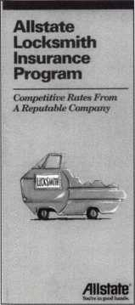

Pewter Keychains

Order pewter keychains direct from the fac-  
tory at our fabulously low wholesale price of  
$2.45 each. We are so confident in our  
product that they are guaranteed. Our high

quality unique  
products are  
what your  
customers are  
looking for  
and are avail-  
able at a price  
everyone can  
afford.

Remember, time is money, so send in your order today to: Milman Manufacturing; Champlain Mall Rd., RO. Box l64l;Cham- plain, NY 12919; (514) 425-5794 or fax (514) 425-5793.

Reader Service #1**7**

Sectorater GM

After removing the ignition lock from a GM auto with VATS to find the numbers stamped on the lock is not a code, the lock must be disassembled to make a key, rekey or repair. The Sectorater GM is a GM igni­tion lock disassembly tool that saves time and money. It works on standard GM plus any lock with a sector gear.

The Sectorater GM holds the lock so the

52 | Keynotes October 1997

steel wedge  
can be  
punched out  
with a 3/32  
pin punch,  
and then it  
presses the

sector gear off in just seconds. A vice is not  
needed.

The milled space on one side allows the  
attachment of a lock casing to the tool with a  
1/4 20 bolt. Simply align the VATS wire  
with this notch, insert the tool in place of the  
ignition lock and use the tool. VATS lock  
and wire does not have to be disconnected  
from column. Simple and fast. Now avail-  
able. Contact A1 Bullard, (520) 790-2290.

Reader Service #18

SPEEDYPIK*

The automatic key ID system. This com-  
pact unit fits inside your IBM compatible  
computer in a 51/4 bay the same as a disk  
drive. The latest addition is a 5,000 key

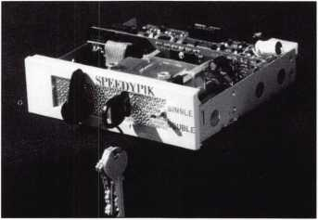

pre-programmed database. Now you can leave the key cutting in the care of an apprentice without a long training period. This will free the locksmith up to do other work. (617) 567-1111; FAX (617) 277- 7777; e-mail: [SPEEDYPIK@juno.com](mailto:SPEEDYPIK@juno.com).

Reader Service #19

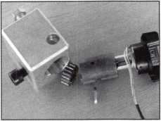

Weight Lock Company

We are a manufacturer and trader for locks and builder hardware from China. The main products include padlocks, door locks, cycle locks, special locks, furniture hardware, door hardware, etc. We hope we can cooperate with manufacturers and traders for these lines from the United States and other

countries. If  
you want to  
won a factory  
and partner in  
China, please  
visit us in  
ALOA ‘97 or

contact us by fax for more information.  
Build a beter future with us in China, the  
United States and worldwide. OEM and  
trial order are welcome. Fax (+86) 574-  
8499239, 7373753.

Reader Service #20

Rockwood

Rockwood Manufacturing’s new “Protection  
Catalog” features its new line of patented

“protection  
products.”  
Made from  
solid stainless  
steel, these  
products safely  
deflect traffic  
such as carts  
and gurneys  
away from exit  
devices and  
other door

trim. For a free catalog and supplier infor-  
mation, call (800) 458-2424 or fax (800)  
922-9212.

Reader Service #21

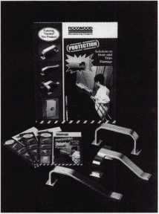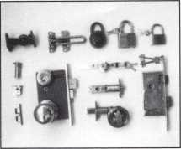

Door Controls Inter-  
national

Door Controls Interna-  
tional announces our  
new champion lever  
trim. UL certified  
ANSI/BHMA 156.3—  
1994, grade 1. The  
08L lever trim is to

work in conjunction with our fire rated  
security alarmed rim exit device, Pannex.  
The vandal resistant lever is available for  
standard or narrow stile doors, and can also  
be supplied with electric release. Phone  
(313) 426-0400.

Reader Service #22

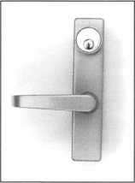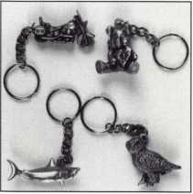

A

Keynotes

Classified



[Dept!

**Classified advertising space is provided free of charge to ALOA members, and for a fee of $.60 per word, $15 minimum for non-members. Classified ads October be used to advertise used merchan­dise and overstocked items for sale, “wanted to buy” items, business opportunities, employment opportunities/positions wanted and the like. Members or non-members wishing to advertise services or new merchandise for sale October pur­chase a “Commercial Classified Ad,” for a fee of $1.30 per word, with a minimum of $40. Each ad will run for two issues. For blind boxes there is a $5 charge to members and non-members. All ads must be submitted in writing to the ALOA office by the fifteenth of the month, two months prior to issue date. Send to Keynotes Classifieds, 3003 Live Oak St., Dallas TX 75204-6186. ALOA reserves the right to refuse any classified advertisement that it deems inappropriate according to the stated pur­pose of the classified advertising section.**

■(Employment

Help Wanted

10/F/3 Are you a promising, career-minded, responsible sales oriented individual with a for­midable track record for creative marketing and good communi­cation skills? This position is for a serious goal-oriented Customer Service Representative who demands the ultimate challenge of work­ing hands-on with customers and is seeking the type of opportunity which will afford the pay they are worth! We offer stability, top pay and out­standing benefits in the Hardware/Security field. Knowledge of Low Voltage/Access Control would be a definite asset. Submit resumes to:

Human Resources 929 Warden Ave.

Scarb, Ontario MIL 4C5, Canada

Wanted

10/F/3 Due to growth of com­mercial business, well-estab­lished Portland, Ore. lock shop is looking for experienced tech­nicians for commercial lock and safe work, high security, and electronic access control work. Excellent salary and benefits.

We need skilled professional security professionals to service our demanding commercial accounts. They must be inter­ested in people and have a com­mitment to quality workman­ship. If interested, please send a resume to:

McMahon’s Locksmiths 401 W Burnside Portland, Oregon 97209 fax (203) 228-1128

Wanted

10/F/3 Colorado’s largest lock­smith company seeks lock­smiths with experience in impressioning, master keying and automotive. Top wages and benefits available for the right persons. Send resume to:

Colorado Security Products, Inc. 5005 South Kipling Unit A-8 Littleton, Colo. 80127

303-761-3899

Wanted

10/F/3 Experienced locksmith wanted, minimum five years experience in all facets of com­mercial and industrial lock- smithing. Safe, alarm and access control experience a plus. Must have a clean driving record, good communication skills, be hard working, and neat in appearance. Salary and benefits commensurate with experience and training. Smoke, drug and alcohol free environment. Fax or mail resume and references to:

R. Haskell

1613 Wade Hampton Blvd. Greenville, S.C. 29609 (864) 332-7314

Locksmiths Wanted

9F3: Are you making your boss rich? We are seeking lock­smiths to become working part­ners in our business, no risk or capital needed, just willingness to work to get the job done— not just put in time and go home. If you ever wanted to work for yourself, but were not sure you should make the move, call us! We own our own building, vans, equipment and have a large customer base already established. Call John at (617) 933-9999 with any questions. All inquiries kept strictly confidential. (Massachusetts area)

Locksmith Wanted

9F3: Experienced in service work. Must have communica­tions skills and clean driving record. Paid vacation, holidays and sick leave. Insurance is also available. Salary negotiable according to experience. We are a 20-year company with two shops and five vans in a growing community. Contact Bill at Bill’s Lock & Safe, North Little Rock, AR, phone (800) 374-4604, fax (501) 376-0046.

Experienced Technicians Needed

9F3: Family-owned since 1911.

Serving middle and east Tennessee, large safe and lock company in Knoxville. We need experienced commercial, indus­trial and residential locksmiths. Must apply background check, work and personal references. Must have a clean driving record. Hard working, neat, honest and good communica­tion skills. Hrs. 8 to 5, Mon.- Fri. Salary negotiable, monthly and yearly businesses, insurance, retirement, paid vacations, holi­days and sick days. Send resume and cover letter to:

The F.M. George Safe & Lock Co., Inc.

P.O. Box 3398 Knoxville, TN 37927-3398

Locksmith Wanted

9F3: Work in sunny Santa Cruz, Calif. Two years minimum experience, safe experience a plus. Work inside and outside. Paid vacations, sick leave, and retirement plan. Medical and dental coverage. Send resume to:

A.A. Safe & Lock Co.

712 Soquel Ave.

Santa Cruz, CA 95062 fax (408) 438-2050

Locksmith Wanted

9F3: Growing company needs locksmith experienced in com­mercial, residential, automotive and safe work. The successful candidate must be familiar with key and access control.

Electrical knowledge is helpful. We offer excellent working con­ditions, fully-equipped van, paid vacation, sick leave, bonus­es and commission. Mail or fax your resume to:

Roberts and Son Lock and Safe

P.O. Box 6025 Mooresville, NC 28115 fax (704) 663-1175

Locksmith Wanted

9F3: Locks & Keys, Inc., in Woburn, Mass, is seeking self- motivated individual for auto­motive and commercial lock- smithing. Must be dependable with good driving record. We will train right individual if lacking experience in automo­tive field. Send resume to John at:

Locks & Keys, Inc.

P.O. Box 222

Woburn, MA 01801

All inquiries kept confidential

Melbourne, Florida

9F3: Experienced locksmith needed for ocean-side communi­ty. Enjoy that Florida lifestyle while earning excellent wages.

Good driving record a must.

Send resume and salary require­ments to:

Action Safe & Lock 3787Aurora Rd.

Melbourne, FL 32934 fax (407) 752-0071

Locksmiths Wanted

9F3: Minimum three years experience in all areas. Rapidly- growing, well-established com­pany. Excellent pay, commis­sion program and other benefits.

Send or fax DMV printout and resume to:

Ken’s Lock & Key 3790 Van Buren Blvd.

Riverside, CA 92503 fax (909) 358-1217

Lock Technician

9F3: Growing mobile lock shop in RTP area (between UNC-

October 1997 Keynotes \ 53

Keynotes

w Classified

Charlotte and Duke Universities) in need of techni­cians or apprentices. Vehicle a must. Tools a plus. Willing to train. Ethics more important than appearance!

Cody Lee Lock & Key Durham, NC (919) 572-6985

Locksmith

9F3: Experienced service techni­cian needed for all phases of lock service. Vehicle and tools provided. Prefer an ALOA-cer- tification for expanding, rep­utable 19-year-old lock service business. Must have previous experience as an outside service technician and a good driving record. Commission, night calls, profit sharing and excel­lent benefits. Salary commensu­rate with ability. Call:

Millhrae Lock (415) 583-5698 (415) 692-0162

Experienced Technician

9F3: Join a fast-growing, 21- year-old firm in America’s num­ber one place to live—Nashua, NH. Top wages in area paid to career-oriented professional, plus benefits and company van. Contact:

New Hampshire Safe & Lock One Factory Street Nashua, NH 03060 (800)838-0152 fax (603) 889-2849 e-mail: [nhsafelock@aol.com](mailto:nhsafelock@aol.com)

Experienced Technicians

9F3: Liberty Lock & Security in Rockville, Md., is seeking qual­ified lead technicians to join a dedicated staff of security pro­fessionals. We are offering top pay and benefits, including vacation, sick leave, bonuses, pension/401k, equipped trucks, tools, a great work environment and excellent support. We are seeking candidates with at least five years experience, a high school diploma (some college or military experience helpful) and dedication to customer service and quality workmanship. Confidentiality assured. Please fax or mail resume to:

Liberty Lock & Security 1205 Taft Street

54 I Keynotes October 1997

Rockville, MD 20850 (301) 424-5625

fax (301) 424-3080

Help Wanted

8F3: Growing, established com­pany seeking professional lock­smiths with at least three years of well-rounded experience. We offer full benefits, fully equipped vans, modern shop and pleasant working conditions in a beautiful seaside area. Must possess clean driving record, neat work habits and be willing to continue learning. Send or fax resumes to:

Rackliffe Lock & Safe 785 Boston Post Rd.

Old Saybrook, CT 06475 (860) 388-1810 fax (860) 388-5143

Locksmith Wanted

8F3: Experienced locksmith wanted: minimum five years experience in all facets of com­mercial and industrial lock- smithing. Safe, alarm and access control experience a plus. Must have clean driving record, good communication skills, be hard working and neat in appearance. Salary and benefits commensu­rate with experience and train­ing. Smoke, drug and alcohol free environment. Fax or mail resume and references to:

R. Haskett

1613 Wade Hampton Blvd. Greenville, SC 29609 fax (864) 322-7314

Locksmith Wanted

8F3: Experienced in service work. Must have communica­tion skills and clean driving record. Paid vacation-holidays and sick leave. Insurance is also available. Salary negotiable according to experience. We are a 20-year company with two shops and five vans in a growing community. Contact:

Bill

Bill’s Lock & Safe No. Little Rock, AR (800) 374-4604 (501) 376-0046

Locksmiths Wanted

8F3: Experienced locksmiths wanted to work in New Jersey, Delaware, and Philadelphia

metropolitan area. Must have vehicle and tools.

(800) 627-1300

■Businesses for Sale

For Sale

10/F/3 Locksmith shop in Southern California. 26 years history of service to Banning/Beaumont area. Full service shop includes inventory, equipment, commercial accounts and 1984 Ford 1/2 ton service van. Owner wants to go fishing. 1800 square foot build­ing also available for sales or lease. Call:

(909) 845-5397

For Sale

10/P/3 Excellent growth poten­tial. Well-established lock and safe company in heart of upper- Midwest. 80 percent commer­cial accounts, two equipped ser­vice vans, inventory, full shop equipment. Commercial proper­ty available. Grosses 183,000 to 200,000 per year. Community and company keeps on growing. Serious inquiries only. Respond to:

Keynotes Classifieds 3003 Live Oak St.

Dallas, Texas 75203

Locksmith Shop for Sale

9F3: Shop for sale in upper Midwest town of 60,000. Business is nine years old, and still growing. Average gross for 1993, 1994 and 1995: $230K; last year: $270K. Three-person operation, but could easily sup­port more. Very little competi­tion, 80 percent commercial and automotive accounts. Two fully-equipped service vans (1200s, Adrian steel cabinets, 110-volt power, etc.). Good lease on shop with option to buy. Buyer must be competent in all aspects of the trade.

Owner will stay on as needed to ensure smooth transition. This is a turnkey operation, and a good buy for the right person. Local banker willing to prepare and finance an SB A loan.

Owner wishes to re-locate out of state. Asking $170K. Includes all inventory, equipment, vans, accounts and a very good repu­tation. No CDs—serious

inquiries only! Call (214) 827- 1701 for details.

Locksmith Business for Sale

9F3: Well-established retail and mobile lock and safe business in northeast Ohio. Respected name since 1971. Growing community with limited com­petition. Two newer fully- equipped vans, inventory, equipment and accounts average gross sales for last three years.

$ 17OK. Selling price $ 11 OK. Respond to:

Gaugler Lock Company 930 Broad Street Wadsworth, OH 4428

Turnkey Lockshop

8F3: Booming Arizona city. Excellent name recognition, location since 1968. Includes inventory, equipment, vehicle (’95 Safari van) and accounts. Owner will train. Serious inquiries please.

Milt or Florence Thompson (520) 836-7662 or

Darrell at AZ-Tech Realty (800) 957-4411

Sunny Southern California

8F3: Successful retail and mobile lock and safe business. Established in 1962. Sale includes: van, inventory, equip­ment and commercial property. Many commercial accounts. Owner will stay during transi­tion.

(909) 658-2777

**■Wanted to Buy/Sell** Complete Key System Service

10/F/3 We will create your mas­ter system, cut your keys, pin your cylinders, ship to you ready for installation. All standard lock manufacturers including Medeco. Call:

(201) 818-0533 or (973) 778- 4021.

Wanted

10/F/3 Looking for the follow­ing: Power Star or Redi Line, HPC 1200, Ilco Tubular Key Machine. Call Robert at (714) 458-7459.

Keynotes

Classified

Wanted to Buy

10/F/3 Ilco Orion KD 55 Sidewinder Key Machine used very little and in new condition. Will let sidewinder keys and guide keys go with it for $1,250 and you pay freight. Larry Wright, Member #9558 592 Green Acres Rd Gaffney, S.C. 29341 (864) 489-8417.

For Sale

9F3: Lectro truck in good con­dition. Call Larry Egelhoff at (317) 547-1717 (days); (317) 846- 7228 (evenings). Lax (317) 547- 1729.

Tryout Keys and More!

9F3: Aero Lock produces only top quality key sets. Computer controlled—code cut. NO DUPLICATES!

Aero Lock

3675 New Getwell Rd #9 Memphis, TN 38118-6053 (800) 627-9433

e-mail: [aerolock@ix.netcom.com](mailto:aerolock@ix.netcom.com) web site: http:[www.aerolock.com](http://www.aerolock.com)

For Sale

8F3: Old key blanks, some no longer manufactured. Originals- -Keil, Stewart, Ilco, Cole,

Curtis, Taylor, JECO and ETAL.

Let us know what you need. A1 Lock (219)269-1782

For Sale

8F3: Two LSDA LS150-26D Leverlock, classroom function, 2 3/4 BS. Used for two weeks. Cylinder not included. $26 each, shipping included. Precision Lock Service (715) 479-4808 trimuse @ newnorth. net

For Sale

8F3: Large accumulation of lock and safe items; tools, machines, literature, safe locks, time locks. For listing, write:

Sale

773 S. Cambridge St.

Wautoma, W1 54982-8106 (414) 787-1088 (after 9 PM) [pex@aol.com](mailto:pex@aol.com) (e-mail)

■Commercial Classified

Business Opportunity

8P3: Own 10 percent of a

growing, full service locksmith company with two Chicago area locations and substantial casino clientele. Well over one million in sales in ’96. For more infor­mation, call (708) 489-1535

Alternative Tools, Inc.

8P3: Do the usual solutions not work in a given situation? Do you need an alternative solution to get the job done quickly with minimal damage? Alternative Tools, Inc. offers tools designed from an alterna­tive point of view. Our tools address the problems encoun­tered in safe work and various lockout situations. Several tools are now available, with more of them “on the drawing board” and coming soon.

Alternative Tools, Inc.

162 Robin Dr.

Loveland, CO 80537

**STOCK THE PATIO DOOR  
LOCK THAT SURPASSES  
ALL OTHERS IN**

DURABILITY

**AND**

QUALITY!

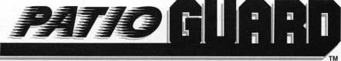

COMBINATION HOOK LATCH & DEADBOLT

n

* **EASY INSTALLATION.**

**SMOOTH OPERATION.**

* **MADE OF STEEL AND ALUMINUM.**
* **ALUMINUM, ANTIQUE BRONZE AND WHITE FINISHES.**
* **NON-HANDED.**

ALSO USED FOR:

Camper Tops, Pocket Doors,

Storm Doors, Cabinets, French Doors,

Mobil Homes and Recreational Vehicles.

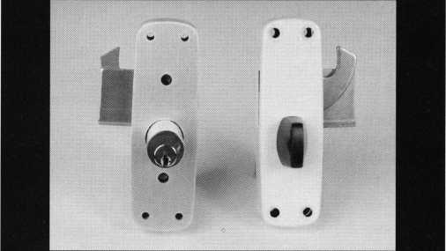

**Call Today For A Distributor Near You**

**1-800-397-4631**

WM4ti 11:1:1

A Division Of

MIWA Lock USA, Las Vegas, NV

Reader Service #23

October 1997

Keynotes

|  |  |  |  |  |
| --- | --- | --- | --- | --- |
| 1 | DD Tl | Report | r Available to locksmiths worldwide ALOA’s proficiency registration pro- |  |
| ] | rKP |  | gram (PRP) evaluates educational and technical competence. For more infor­ |  |
|  | | | David Towell, CML, CMS  Committee Chairman | mation, contact ALOA headquarters at: 3003 Live Oak St.; Dallas, TX 75204; (214) 827-1701; FAX (214) 827-181C^ |

ACE classes are one of the single greatest resources for preparing for the PRP.

**/PRP Dates October 24**

Bellevue, Wash.

Tri-Regional Locksmith Conf.

Dean Nickel, CRL (206) 483-1702

November 2, 1997

Carlisle, Pa.

Central Pennsylvania Locksmiths

Association

Frank Busch

[717] 848-1754

November 8

Phoenix, Ariz.

Grand Canyon Chapter of ALOA John Ilk [520) 474-8879

November 8

Providence, Rl Yankee Security Convention Lee Whitford [800) 209-8266

November 14

Raleigh, No. Car.

North Carolina Locksmiths Assoc. Granger L. Marley, CML (919) 859-6060

December 6, 1997

Marion, Ala.

Alabama Locksmiths Association Larry Warnick, CML (800) 292-5008

January 18

Richmond, Virg.

Virginia Locksmith Assoc.

R. T. Earll (703) 335-0852

January 25, 1998

King of Prussia, Pa.

Keystone Chapter Barry Leas, CRL (610) 272-9292

30-day application period required

This month I’d like to remind you of an ALOA committee other than the Proficiency Registration Committee—the ALOA Continuing Education (ACE) Committee. The reason I’m bringing up those guys is that they are the ones that can help you pre­pare to be part of the Proficiency Registration Program in the first place. ACE classes are one of the single greatest resources for preparing for the PRP If you’re looking at the list on the left and trying to decide if you’re ready to take advantage of those test dates ... well, maybe you should also look at the list on p. 9 to see if any of those classes will help you get ready. It’s no coincidence that many candidates choose to sit for the PRP exam at the end of the ALOA Security Expo each July. That week of classes is one of the most intensive opportunities locksmiths have to update and expand their professional knowledge. So keep your eyes out also for the ALOA ’98 Security Expo brochure.

Most, if not all, of the classes in the 1997 brochure will be available for the June 14- 20, 1998, event to be held in Nashville, Tenn., and there will be new offerings as well. Mark your calendars. We’d like to add you to the list below.

**New Certifications**

CMLs (Certified Master Locksmith)

Glissman, Glenn A., Lodi, Ca.

Seliber, Lloyd, Colorado Springs, Colo.

CPLs (Certified Professional Locksmith) Cembura, Thomas M., Grass Valley, Ca. CRLs (Certified Registered Locksmith)

Barrett, Donald W., St. Clair Shores, Mi. Beahm, L. Paul, Rigby, Idaho Bean, Donald E., Collinsville, II.

Brickler, James T., Cincinnati, Ohio Brooks, William H. Yalesville, Conn.

Curry, Austin R., Tampa, Fla.

Fennel, John D. Salinas, Ca.

Kirby, Sean M., East Moline, II.

Matzkanin, Shubert A., Yuma, Ariz. Overdier, Wayne A., Longmont, Co.

Page, Brad L., Tigard, Ore.

RL (Registered Locksmith)

Lee, Joe J., Philadelphia, Pa.

Richardson, Thomas, Houston, Texas

Sanchez, Richard M., Houston, Texas Williams, Roger G., Samson, Ala.

**PRP History Requests**

If you need information about your PRP his­tory, please wait until after Oct. 1 and then contact the ALOA office at 3003 Live Oak Street; Dallas, Texas, 75204. When you do contact in writing the PRP staff, please ref­erence your current ALOA membership number and/or any old ALOA membership numbers under which you might have taken the PRP evaluation.

**PRP Resource Guide**

One excellent resource in preparing for the PRP is the PRP Resource Guide available from the ALOA office for $18 (which includes shipping). The Guide covers PRP registra­tion procedures, categories, a study guide, sample questions, references to applicable materials in other publications, and a profes­sional glossary of terms.

**Mandatory Categories**

One the first questions asked by some PRP candidates is, “What is the basic information —what are the basic skills—required of a certified locksmith?” For those of you who are new to the process, the PRP begins with 10 mandatory categories. Those are:

* Codes and Code Equipment
* Cylinder Servicing
* Key Blank Identification
* Key Impressioning
* Professional Lock Opening Techniques
* Lockset Functions
* Lockset Servicing
* Basic Master Keying
* Cabinet, Furniture and Mailbox Locks.

I About the Chairman: David

Lowell, CML, CMS, is ALOAs immediate past  
president and an ALOA Trustee. David has  
served on the ALOA hoard for 10 years. He owns  
and operates Phoenix Lock & Key in Arizona,  
and has been an ALOA member since 1981.

56

Keynotes

October 1997



**EXCITING**

**than a I**

u. s. p,g

**SAV I NGS**



ALL RIGHT ALREADY, **so a**

U.S. Savings Bond isn’t the most exciting  
thing in the world. **GOOD FOR  
YOU!** After all, this is your hard-  
earned money we’re talking about. Do  
you really want your investments to be  
thrilling? Breathtaking? **NO WAY.**Wouldn’t you rather have an investment  
that’s guaranteed to grow, one that’s  
backed by the full faith and credit  
of the United States government?

Sure you would.

A public service of this magazine



Take  
Stock

inAmerica

SAVINGS

[BONDS

|  |  |
| --- | --- |
| np 1 | Tips |
| Trade |  |
|  | ^Pon^Jamunno, CML, CPS  Trade Tips Editor |

Broken Machine Screw

The next time you need to remove a machine screw that has been broken or sheared off, try using a left-handed drill bit. These are available from industrial tool sup­ply houses. Get an assortment of sizes. Start by lubricating the screw threads as best you can, then using the smallest size bit that is practical, drill down the center of the screw, if you’re lucky, the drill will catch and back the screw out before you realize what hap­pened. If not, drill down about one eighth inch, then change to a drill bit a size or two larger. This almost guarantees that the drill bit will bite.

Paul Mannen #14948

Editor’s note: Be sure to run your drill in reverse when using left hand drill bits. Another method would be using broken screw extractors, which are more readily available (these don’t always work either).

Ten-cut Tip

When you encounter a situation where a ten cut key ignition has a 5 pin key blank with cuts on the key and it turns on the ignition, remove the ignition switch by turning the lock to the “on” position, push the retainer pin in and remove the lock. Disassemble the plug by turning to the accessory position and align the tail piece to remove from the outer shell. Then, take the plug and inspect for obvious damage before removing the stake retainers from the side bar, which can be pried out and reinstalled easily. After­wards, taking a blank key and by reading the tumblers to cut a proper working key with tumblers aligned to the side bar. Reassemble the lock and make the door cuts on the working key, if it is the original lock that was installed at the factory. Repossessors and auctions are guilty of trying keys they think will start the vehicle and so are some used car dealerships.

Wendell Farrell #07927

Editors note: We have found that in may of the “repo” Fords, we have worked on, the original lock has been drilled out and replaced. In some cases, 5 pin locks have been used to replace the 10 cut locks.

Last month’s Trade Tip winner was Wendell Farrell with “Loose Thumb Turns. ”

**/flow To Become A Trade Tipper**

Each month, the Associated Locksmiths of America (ALOA) holds a “Trade Tips” con­test in Keynotes for ALOA members. In addition to helping other locksmiths by sharing your knowledge, there are three levels of prizes to be awarded:

September 1997 Sargent & Greenleaf 6120 electronic safe lock

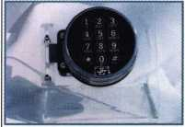

Grand Prize: An expense-paid trip to the ALOA ’98 Security Expo

Each year, the ALOA Publications Commit­tee selects one outstanding tip, the author of which receives a seven-day ALOA con­vention package that includes travel and accomodations.

Authors of any Trade Tip published will still receive $20.

Want to Participate?

Mail your best idea (Including photos,

illustrations or parts, if necessary) to

Keynotes

Trade Tips Editor

3003 Live Oak St.

Dallas, TX, 75204-6186.

All entries are sent to the Trade Tips editor with the author’s identity deleted. The tips must be submitted exclusively to Keynotes and become the exclusive property of ALOA. Tips are judged on the basis of accuracy, professionalism, ethical stan­dards, originality and usefulness.

J

_ About the Department Editor: Tony

Ramunno, CML, CPS, owns and operates Allied  
Locksmiths of Youngstown in Youngstown, OH.  
He has been in the locksmithing business for 25  
years and has been an ALOA member for 23  
years. He also serves as the chairman of the  
Library-Museum Committee for ALOA.

October 1997

Keynotes

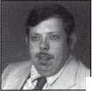

Chapter

News

pjan^amum, CML  
Committee Chairman

How about it? How is your chapter scoring?

October is here and the fall season is upon us! It’s been a great summer and now we must get back to the business at hand. Chapter and association officers alike are busy putting together the next several months of meeting schedules and trying to arrange for speakers and their subject titles. In this column, I would like to bring out some of the aspects of a well-run and orga­nized meeting. Check me out and see how your chapter officers are scoring on a scale of one to 10.

Your chapter meeting should be conduct­ed and run according to the Robert’s Rules of Order. Every chapter should have a copy on hand at each meeting. There should be at least one officer that is well acquainted with its content. This will bring a business-like order to each meeting. It will give members an organized manner to bring ideas and motions to the floor. It will also give direc­tion and rules to guide the group if things seem to be getting out of hand or unruly.

When bringing the meeting to order, it must begin on time every time. If tardiness becomes an expected tradition, members will begin to arrive later and adjust accord­ingly. The chairman should always be fol­lowing an agenda or meeting plan. He or she should start the meeting with the pledge of allegiance. The meeting should be run in a relaxed and orderly plan.

Important issues and operations of the chapter are next. The report of the last meet­ing should be read, so all present will know and be reminded what went on at the last meeting. Then a report from the various committee chairmen on any business con­ducted since the previous meeting. This not only informs the members of what is going on in each committee but it motivates the chairman and his committee toward accountability.

During Old Business, any previously dis­cussed topics can be brought back to the table for discussion (possibly with more additional information or changes). Any idea or subject matter a member wants the group to act upon must be put in the form of a motion. The chairman should lead the dis­

cussion with the intent to bring out the facts and to help form a group opinion. The group must act upon the motion.

New Business, where any new topics or subjects are brought up for discussion, would come next. The group may then act upon this subject matter in the same manner as above.

Good of the order, should be called last. This is the place for members to share per­sonal experiences, technical information and helpful related tips.

That’s the basics of a well-formed meeting agenda. The meeting and excitement level are entirely dependent upon the group of officers you elected and put in charge. How about it? How is your chapter scoring? This information and much more is available to you in the officers’ training course. See ya, next month.



About the Chairman: Dana

Bamum, CML, #05444, operates South Penn Lock & Safe Co. in Media, PA. He also serves on the ALOA Education, Membership and Bylaws committees, as well as having been on the board of directors of the Greater Philadelphia Locksmiths Association (GPLA). Dana has also sponsored many new ALOA members. Dana can be reached at FAX (610) 565-9902 or e-mail him at dlbamum@aol. com.

A

Keynotes

October 1997



“Can we help, Mom? Please?”

The need to help.

Children see it so clearly because their hearts have 20/20 vision.

Childreach sponsorship provides needy children and families overseas with an opportunity for clean water, good nutrition, education, and hope for a better life through self-help programs that really work.

10-

childreach

U S MEMBER OF [H] INTERNATIONAL

To learn more about  
Childreach**,** please call

1**-**800**-**599-9797

or write:

Childreach, Dept. U304  
155 Plan Way  
Warwick, R102886

Childreach was founded in 1937 as Foster Parents Plan.

|  |  |
| --- | --- |
| ALOA | / |
| Extra | \ |



Dept I

**Customized Calendars**

If you’re interested in ordering calendars customized with your lock shop’s name, there’s still plenty of time to order before the new year. There are a couple of designs to choose from, so order early. Refer to your June issue of Keynotes for more details, or for free samples you can call Murphy-Kendall & Associates, 1-800-874-8321.

**In Memory**

Jerry Ierardi of Havertown, Penn, passed away Aug. 1, 1997. The 74 year-old Ierardi had been an ALOA member since 1976.

Frank Reardon recently passed away at the age of 86. Reardon ran Frankey’s Lock and Key service in Osprey, Fla. and had been an ALOA member since 1976.

We will miss these two individuals very much.

**Back Page Solved**

The item shown in the Back Page department of the September issue is a “screw-key” padlock. The photo is not clear but it looks like it was made by Elijah Rickard of Philadelphia. Many of these locks have the manufacturer’s initials, “ER,” stamped on the shackle. There were three or four sizes. The model smaller than this was often used by the Baltimore and Ohio Rail­road and will have “B&O RR” stamped on the shackle. That’s the version I have in my collection. It is 2 3/4 inches wide and its key is 3 inches long, including the bow. It also has a chain and clevis.

The shank of the key is basically a tube with internal threads. The key is screwed into the side of the padlock, pulling back the bolt against spring pressure. Key charges were generated by using different diameter shanks and different pitch threads. I guess you could order them SA, SD, and GGMS’d (screwed alike, screwed different, and great grand master screwed).

In order to meet this print deadline, I have not had time to find the exact patent date for Rickard, but I believe that it was from the 1830s or 40s. Look for an update

in the next issue.

Screw key locks are still made by hand and used today in the Arab world and other parts of the Middle East. They are usually made in the same crude fashion today that they were centuries ago and occasionally are passed off as antiques to the unwary buyer.

Screw key mechanisms are also familiar to restraint collectors. A popular brand of antique screw key handcuff and legiron made in England is Hyatt.

Password Reminder

If you’re looking for our website password, just remember that this privilege is for ALOA members only. First of all, your user name when accessing the restricted portion of the website is “ALOA.” The password is “lockup97.”

Positive ID Policy

Use the following positive identification policy when servicing lockouts:

Notify Caller. When a call comes in to request lockout services, ask the caller if he/she has identification and authority to open the lock.

Complete Form. Upon arrival at the job site, the locksmith should complete an Authorization Form that asks for the name, address, phone number, identification num­ber and property description from the cus­tomer. ALOA provides a model form.

Verify I.D. Verify the customer’s photo-iden­tification card and compare it to the infor­mation provided by the customer. If no photo-ID card is available, ask for some other reasonable form of ID.

Verify Authority. The locksmith should inquire as to what authority the customer has to open the lock, and request to see any reasonable and appropriate evidence that could verify the authority. This may be impossible in some cases.

Ask for Signature. Ask the customer to sign the Authorization Form, which should contain a statement that (a) the information given by the customer is correct, (b) the customer has the authority to open the lock, and (c) the customer shall identify and hold

harmless the locksmith against liability.

The ALOA model form contains this state­ment.

Optional Last Resort. If you have any sus­picions that the customer is giving false information or does not have authority to open the lock, say that you will be happy to open the lock provided a law enforcement officer is present. If the customer agrees, call the police; if not, leave.

File the Form. Keep the Authorization Form on file for a reasonable period of time.

Keynotes ***Advertisers*** Index

|  |  |  |
| --- | --- | --- |
| RS# | Advertiser | Page |
| 14 | AT&T | 43 |
| 100 Jet Hardware Mfa. Co. | | BC |
| 50 | Locksmith Publishing Corp. | IFC |
| 23 | MIWA Lock USA | 55 |
| 15 | Monday Security Group | 43 |
| 12 | Omaha Wholesale Hardware | 25 |
| 24 | STRA7TEC Security Corp. | IBC |
| 1 | Sanzo Specialties | 12 |
| 13 | Unlocks Inc. | 25 |

October 1997

Keynotes L

li

|  |  |  |  |
| --- | --- | --- | --- |
|  | Back | | 4 |
|  | | Page | \ |



Dept



Folkheart Designs © 1997 Leanne French, Grand Forks ND

We’ve gotten some calls asking how the Lock-  
smith Relief Fund campaign turned out. Con-  
tributions of more than $6,000 came in after  
the June 1997 article in Keynotes highlighted  
the plight of ALOA members in flood-devas-  
tated regions of North Dakota. Among the  
many generous donors were:

Northern Prairie Locksmith Association  
Connecticut Locksmith Association  
North Dakota Chapter  
Keynotes Magazine  
The National Locksmith Magazine  
South Jersey Locksmith Association  
David Paulsrud

Ken Sternig, E.L. Reinhart Co, St. Paul, Minn.

Paul Justin, Doyle Lock Supply, Minneapolis, Minn.

Tom Gillespie, PRO-LOCK

John Engel, Chair, Fox Valley Chapter, ALOA

Doug Rude, Chair, Minnesota Chapter, ALOA

G.G. Roraback, LAB Security

Judd Penske, Meilink Safe Company

and so many other locksmiths from all around the

country ...

Keynotes salutes all those who extended a helping hand to their fellow professionals during this crisis.

There are still locksmiths in the area struggling to rebuild, so if you would like to contribute:

The Locksmith Relief Fund Western Bank 7035 10th St. N.

Oakdale, MN 55128 (218) 681-2453

60 | Keynotes

October 1997

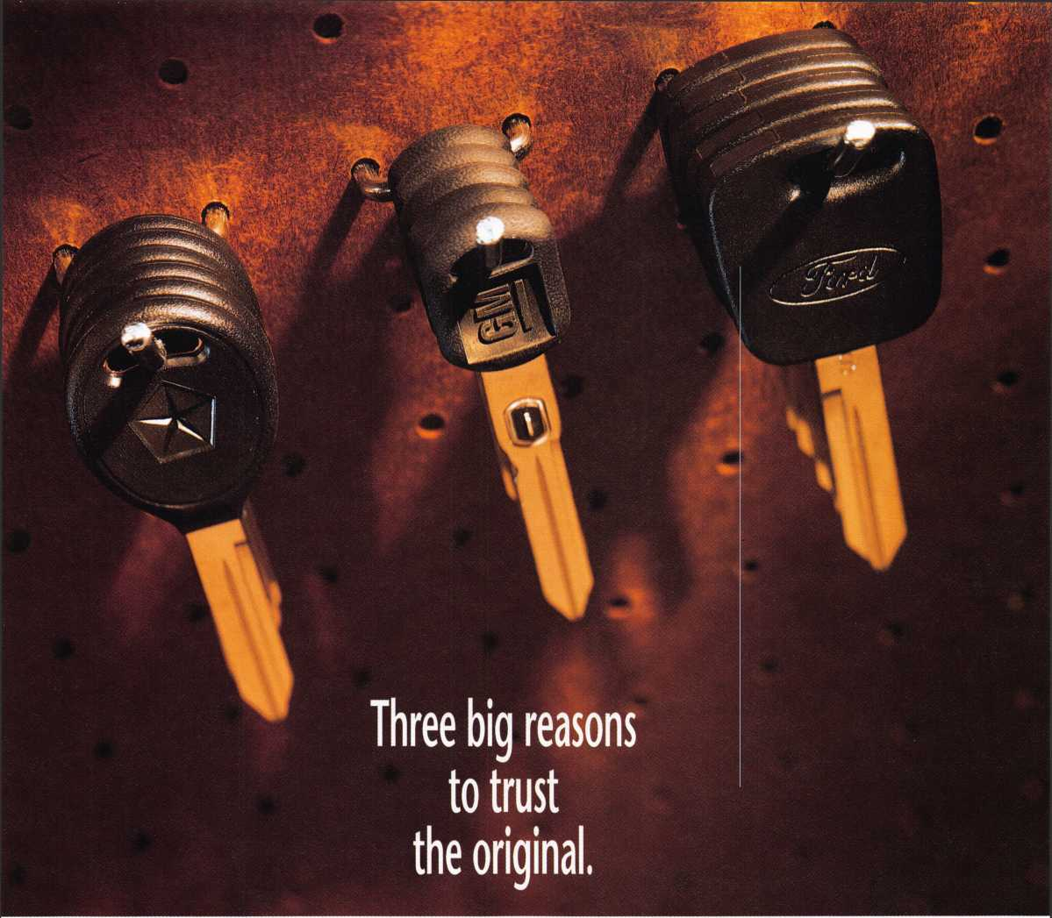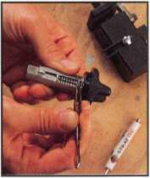

Quality. Availability. Serviceability. That's the big three STRATTEC offers to every customer,  
from Detroit's largest automaker... to locksmiths like you.

STRATTEC is the lock and key supplier for over 80 models—going back more than 15 years.  
So you can offer your customers the security and peace-of-mind they can only get with genuine  
original equipment parts. And whether automotive work is the lion's share of your business or a  
profitable sideline, you get added security, too. The security of knowing you've given your customer  
all the best—doing your best work—installing the very best parts available.

We make fifty million locks every year, to the most exacting standards in the industry...  
and all our know-how goes into every STRATTEC™ part you install. We offer information and training  
to help you stay on top of a rapidly changing business. We want to make it easy to put your trust  
in STRATTEC. Just like your customers trust you.

Call your distributor for all your STRATTEC parts. And for your  
free copy of our Professional's Choice Catalog, with complete applications  
back to the '83 model year, call STRATTEC at 414-479-8038.

STRATTEC

It's your reputation. Trust the original.

©1997 STRATTEC SECURITY CORPORATION. All Rights Reserved.

Free Information - Reader Service Card #24

I



**RE AT KEY BLANKS.**

HARDWARE MANUFACTURING CORI

Y154C-PH

Y154C

Y157C

Y157C-PH

Y155C-PH

Y155C

A Quality Licensed Product.

**SEE THE** QUALITY FOR YOURSELFl

JET HARDWARE MANUFACTURING COI

800 HINSDALE STREET, BROOKLYN, NY 11207

Chrysler is a registered trademark of Chrysler Corporation, USA and is used under license. ©CHRYSLER CORPORATION 1$ Frpp Infnrmatinn - RpaHor Ror\/iro horrl #inn

